University of Science - VNUHCM

Faculty of Information and Technology

Software Engineering Department


Introduction to Software Engineering
Software Requirements Specification

BadminBookingHub - 08

Table of Contents
Objectives 1
1 Member Contribution Assessment 2
2 Introduction 3
2.1 Purpose and Scope 3
2.2 Glossary 4
3 Problem Statement 7
Business Context 7
Current Problems 7
Project Goals 7
Operating Environment 8
Design and Implementation Constraints 8
4 Stakeholders 10
5 Requirements 13
5.1 Functional Requirements 13
5.2 Non-Functional Requirements 18
5.3 Domain Requirements and Business Rules 20
5.4 Acceptance Criteria 24
Test Execution Context & Conventions 24
F01 – User registration & login 24
F02 – Resource catalog 26
F03 – Book & cancel court 26
F04 – Availability calendar 28
F05 – Booking rules 28
F06 – Court management (Admin) 31
F07 – Front-desk operations (Staff) 33
6 Use Case Model 37
6.1 Use Case Diagram 37
Figure. BadminBookingHub Use Case Diagram — Must-have and Should-have Use Cases. Blue indicates Must-have use cases; yellow indicates Should-have use cases. Google Drive Link 37
6.2 Actors 37
6.3 Use Case List 38
7 Use Case Specifications 40
7.1 Use Case UC-01 40
7.2 Use Case UC-02 41
7.3 Use Case UC-03 43
7.4 Use Case UC-04 43
7.5 Use Case UC-05 44
7.6 Use Case UC-06 46
7.7 Use Case UC-07 48
7.8 Use Case UC-08 49
7.9 Use Case UC-09 51
7.10 Use Case UC-10 52
7.11 Use Case UC-11 53
7.12 Use Case UC-12 55
7.13 Use Case UC-13 56
7.14 Use Case UC-14 57
7.15 Use Case UC-15 59
7.16 Use Case UC-16 61
7.17 Use Case UC-17 63
7.18 Use Case UC-18 64
7.19 Use Case UC-19 66
7.20 Use Case UC-20 67
7.21 Use Case UC-21 69
7.22 Use Case UC-22 71
7.23 Use Case UC-23 73
8 Prototype / Mockups 76
9 Requirements Traceability Matrix 88
10 Requirements Review 91
11 AI Usage Log 93

Software Requirements Specification

Objectives
This document focus on the following topics:
- Completing the Software Requirements Specification (SRS) document with the following sections:
  - Problem Statement
  - Stakeholders
  - Functional, non-functional and domain requirements
  - Use case model and use case specifications
  - Prototype / mockups
  - Traceability and requirements review
- Including an AI usage log for this phase
- Understanding the Software Requirements Specification (SRS) document.

Member Contribution Assessment
ID | Name | Role(s) | Contribution (%) | Evidence
24127168 | Lê Trọng Hiếu | PM | 20 | Lê Trọng Hiếu
24127577 | Huỳnh Mạnh Tú | Business Analyst | 20 | Huỳnh Mạnh Tú
24127183 | Trần Duy Khang | Designer | 20 | Trần Duy Khang
24127500 | Nguyễn Đại Phúc | Developer | 20 | Nguyễn Đại Phúc
23127134 | Phan Phú Trọng | Tester | 20 | Phan Phú Trọng

Introduction

Purpose and Scope
Purpose
This Software Requirements Specification (SRS) defines the functional, non-functional, and domain requirements of BadminBookingHub, a web-based badminton court booking and management system. It provides a common understanding of the system requirements and serves as a reference for system design, implementation, testing, and validation.
Scope
BadminBookingHub allows players to search for available badminton courts, view prices, make and cancel bookings, and manage their reservations. It also enables court owners and staff to manage court information, booking schedules, pricing policies, and daily front-desk operations.
The system focuses on seven Must-have features: user registration and login, resource catalog, court booking and cancellation, availability calendar, booking rules, court management, and front-desk operations. Optional features include deposit payments through a sandbox payment gateway, booking history management, email notifications, revenue reporting, and court reviews.
The system excludes native mobile applications, real payment processing, cash payments, other sports, tax management, chat, recurring weekly bookings, food and drink ordering, invoices, social features (matchmaking, find players, teams, tournaments) and production operations after the course ends. The system serves one badminton venue operated by one court owner. Multi-venue platforms (multiple independent owners) and multi-branch management are out of scope.
Intended Readers
This document is intended for the project team, including the project manager, business analyst, developers, designer, and tester, as well as the course instructors and teaching assistants who review and evaluate the project.

Glossary
Term | Definition
Software Requirements Specification (SRS) | A document defining the requirements that a software system must satisfy.
Functional Requirement (FR) | A specification of a function or behavior the system must provide.
Non-Functional Requirement (NFR) | A specification of a quality attribute or constraint the system must satisfy.
Business Rule (BR) | A policy or constraint governing how business operations must be performed.
Use Case (UC) | A description of interactions between an actor and the system to achieve a particular goal.
Player | A registered user with the Player role who can search for courts, create reservations, and manage personal bookings. Authentication is required to create or manage bookings.
Guest | An unauthenticated visitor who can browse court information and view available time slots but cannot create or manage bookings independently.
Walk-in Customer | A customer who arrives at the venue without an existing reservation and may request a booking through Staff without registering an account.
Staff | A user with the Staff role responsible for daily court operations, including managing schedules, processing check-ins, marking no-shows, and creating walk-in bookings.
Admin | A user with the Admin role who is authorized to manage courts, pricing, staff accounts, and booking policies. Multiple accounts may be assigned this role. The Admin can also perform all Staff operations.
Venue | A physical badminton facility containing one or more courts. The current system scope covers a single venue.
Court | An individual badminton playing area within a venue that can be reserved for a specified time interval.
Opening Hours | The configured operating hours during which a venue or court is available for reservations. Bookings must fall within the applicable opening hours.
Booking | A reservation of a specific court for a defined time interval, associated with a customer and a booking status.
Time Slot | A fixed 30-minute interval starting on the hour or half hour. A booking consists of at least two consecutive time slots (60 minutes or more).
Booking Status | The current state of a booking within its lifecycle. Possible values are Pending payment, Booked, Checked-in, Completed, Cancelled, and No-show.
Active Booking | A booking with a status of Pending payment, Booked, or Checked-in. Active bookings reserve their assigned court and prevent any schedule overlapping or double-bookings.
Availability | The condition indicates whether a court can be reserved for a requested time interval, considering opening hours, existing active bookings, and applicable booking policies.
Overlapping Booking | A conflict involving two or more active bookings assigned to the same court whose half-open time intervals [start, end) intersect. Adjacent bookings sharing only an endpoint do not overlap.
Booking Policy | A set of business rules governing reservations, including booking quotas, advance booking restrictions, cancellation deadlines, and check-in requirements.
Booking Quota | The maximum total duration of a Player's upcoming bookings (bookings that have not started yet), as set by the booking policy.
Advance Booking Window | The maximum period before the scheduled playing date during which a reservation may be created.
Cancellation Deadline | The latest permitted time before a booking's scheduled start at which the customer may cancel the reservation.
Price Band | A pricing category used to determine court rental rates based on booking time and day. The supported categories are Normal, Peak, and Weekend, as defined by the pricing rules.
Check-in | The process performed by Staff to record a customer's arrival for a scheduled booking and update its status to Checked-in.
No-show | A booking for which the customer has not checked in within 25 minutes after the scheduled start time. Staff marks the booking as No-show; the system never does this automatically.
Walk-in Booking | A reservation created by Staff on behalf of a Walk-in Customer who arrives without an existing booking. A registered Player account is not required.
Deposit | An advance payment made to secure a booking, if the optional payment feature is implemented.
Deposit Rate | The percentage of the total booking price that must be paid in advance as a deposit, according to the applicable payment policy.
Payment-holding Period | The maximum duration during which a booking in Pending payment status temporarily reserves its assigned court while awaiting payment confirmation. If payment is not confirmed before this period expires, the booking is automatically cancelled.
Refund | The return of an eligible payment amount to a customer following booking cancellation, subject to the applicable refund policy.
Sandbox Payment | A payment transaction performed in a testing environment using simulated payment processing without transferring real money.
MoSCoW | A requirements prioritization technique that classifies requirements as Must Have, Should Have, Could Have, or Won't Have for the current scope.
Acceptance Criteria (AC) | A set of verifiable conditions that must be satisfied for a requirement or user story to be considered successfully implemented.
Requirements Traceability Matrix (RTM) | A matrix that maps requirements to related artifacts, such as use cases, implementation components, and test cases, to verify requirement coverage and traceability.
Upcoming Booking | A booking in Pending payment or Booked status whose start time has not passed.
Court Status | Whether a court is Active (shown and bookable) or Inactive (hidden and not bookable).
Lead Time | The minimum time between making an online booking and its start time.
System User | Any registered user of the system: Player, Staff or Admin.

Problem Statement

Business Context
Many small and medium-sized badminton venues manage reservations through phone calls, Zalo, Facebook, or manual records such as notebooks and spreadsheets. Court availability, pricing, and booking information are often maintained separately, making reservation management inefficient.
Demand is concentrated on weekday evenings (peak hours, 17:00–21:00) and at weekends, when most courts are full. A typical venue has a few courts, one owner who sets prices and rules, and one or two front-desk staff per shift.

Current Problems
Players must call or message the venue to check court availability and prices, especially during peak hours. This process is time-consuming and may provide outdated information.
Court owners and staff face difficulties maintaining accurate schedules, calculating prices, and coordinating reservations. Manual management increases the risk of overlapping bookings, pricing errors, and inconsistent records.
Booking rules, such as how far ahead a player may book, how many hours one player may hold, and how late a booking may be cancelled, are not applied consistently. Some players hold many peak-hour slots, and late cancellations leave courts empty.
Arrivals are not recorded, so customers who fail to attend their reservations leave courts unused and the owner cannot see how often this happens.

Project Goals
BadminBookingHub aims to centralize badminton court booking and management in a single web application. The system will allow players to find available courts and make reservations conveniently, while helping staff and court owners manage schedules, prices, booking rules, and customer attendance. The goals are:
- A player can find an available court and complete a booking in less than two minutes.
- The system never accepts two bookings for the same court at overlapping times, even when two players try at the same moment. The second player is told that the slot is no longer available.
- Prices are calculated automatically from the price list for the chosen day and time, so staff do not calculate prices by hand.
- Booking rules (how far ahead, how many hours, how late to cancel) are applied in the same way to every online booking.
- Staff can check in customers and record no-shows, so the owner can see which customers attended and which did not.
- The owner can change courts, prices and booking rules without help from a developer.

Operating Environment
BadminBookingHub is a responsive web application accessible through current versions of Chrome, Edge, Firefox and Safari on desktop and mobile devices, and it requires an Internet connection. Players use phones or computers; Staff use a computer at the front desk; the Admin (court owner) uses a computer. All times are in the Asia/Ho_Chi_Minh time zone (UTC+7).
The frontend uses React, TypeScript, and Vite, while the backend uses Node.js, Express, and TypeScript, with PostgreSQL for data storage. The application runs in Docker containers: locally with Docker Compose during development, and on a single AWS EC2 instance for the demo (PA1 §3.3).
An email service and an e-wallet sandbox are external services; they are used only by Should-have features.

Design and Implementation Constraints
The project is developed by a five-member student team following the Waterfall process with V-model-based test planning. The phase gates are PA1–PA5 and the final presentation is in week 11.
Development prioritizes the seven Must-have features (F01–F07). Optional features will be implemented only if sufficient time and resources remain.
The system must use TypeScript for both frontend and backend and PostgreSQL for data storage. Automated tests and builds run with GitHub Actions.
The team must rely on free or low-cost development and deployment resources. Payment is available only in sandbox mode.
Access is role-based (Player, Staff, Admin). Personal data must be handled according to the Law on Personal Data Protection No. 91/2025/QH15.
The system supports one venue only and is limited to badminton court booking and management. The following are out of scope: native mobile applications, cash payment and real payment processing, invoices and tax management, other sports, multi-venue platforms and multi-branch management, chat, recurring weekly bookings, food and drink ordering, social features (matchmaking, finding players, teams, tournaments), and production operation after the course.
Changes from PA1
- Current Problems: added the problem of inconsistent booking rules (PA1 mentioned the rules only in "Proposed System") and the problem that arrivals are not recorded.
- Business Context: peak hours defined as 17:00–21:00 on weekdays; weekends mentioned.
- Goals: six checkable goals were added (booking in under two minutes, no overlapping bookings, automatic pricing, consistent booking rules, attendance recorded, owner self-service); PA1 described them only inside the Proposed System.
- Operating Environment: added supported browsers, devices per role, Internet connection, external services and time zone. Deployment on a single AWS EC2 instance is now fixed (PA1 §2.1 said cloud deployment was optional; PA1 §3.3 and the PA5 exit criterion require a public URL).
- Constraints: the system now serves one venue only, so multi-venue platforms are out of scope (team decision, 31/10/2026). Payment is limited to sandbox mode, builds and automated tests run with GitHub Actions, and personal data follows Law No. 91/2025/QH15. The out-of-scope list now also includes the items listed only in PA1 §2.4: real payment processing, invoices, food and drink ordering, social features and production operation after the course.

Stakeholders
# | Stakeholder | Description | Interests / concerns
1 | Player | A badminton player who uses the system to search for courts, check availability and prices, create bookings, and manage personal bookings. | Find suitable courts and time slots, receive accurate booking and pricing information, complete bookings conveniently, understand booking and cancellation policies, protect personal data, request deletion of their account and personal data, and receive booking notifications if F10 is implemented, and make deposit payments securely if F08 is implemented.
2 | Guest | An unauthenticated visitor who uses BadminBookingHub to browse court information and view available time slots without registering or logging in. | Find accurate court information, prices, opening hours, and available time slots without creating an account; understand the registration and authentication requirements for booking and managing reservations.
3 | Staff | A court employee who handles daily booking operations, views court schedules, checks in customers, records no-shows, and creates bookings for walk-in customers. | Access accurate and up-to-date schedules, process check-ins and walk-in bookings efficiently, identify court status, reduce operational errors, and handle cancellation requests that require Staff assistance under the cancellation policy, including bookings that start too soon to be cancelled online.
4 | Admin (Court owner) | The badminton venue owner, represented by the Admin role in BadminBookingHub. The owner manages venue information, operating hours, prices, user roles, and booking policies. | Maintain accurate court information and pricing, prevent conflicting bookings, enforce booking policies, reduce operational errors and revenue loss caused by no-shows, and manage venue operations efficiently. If time allows, view revenue and court occupancy reports.
5 | Walk-in Customer | A customer who visits the badminton venue and requests a court booking through Staff without directly using a Player account in the system. | Obtain an available court and accurate booking information; ensure that booking details are recorded correctly by Staff; and protect any personal information collected during the booking process.
6 | Course Instructor / Teaching Assistant (TA) | The course instructor or teaching assistant responsible for reviewing the project, providing academic guidance, and evaluating project deliverables. | Ensure that the project meets course requirements and assessment criteria; review the completeness and consistency of requirements and documentation; and assess whether the proposed system meets its stated objectives.
7 | Development Team | The student team responsible for analysing requirements, designing, implementing, testing, and delivering BadminBookingHub. | Receive precise, complete, consistent, and testable requirements; maintain traceability between requirements and tests; meet the approved scope and schedule; and build a maintainable system within the available budget.
8 | E-wallet Payment Service (External Dependency; conditional on F08) | An external payment service or sandbox used to process booking-deposit payments and return payment results if the optional deposit-payment feature is implemented. No specific provider has been selected in the current requirements. | Provide a testable payment interface, return reliable payment outcomes, and support correct handling of successful, failed, and expired payment attempts.
9 | Email Delivery Service (External Dependency; conditional on F10) | An external service used to deliver booking confirmations, cancellation notifications, and reminders if the optional email feature is implemented. The provider has not yet been specified. | Support reliable email delivery, accept valid recipient and message information, and report or handle delivery failures appropriately.
Changes from PA1:
- The main stakeholders, including Player, Staff, Admin (Court Owner), and Development Team, are retained, with their roles and interests clarified.
- Guest is identified as a stakeholder because courts, prices and availability can be viewed without an account.
- E-wallet Payment Service and Email Delivery Service are identified as conditional external dependencies for F08 and F10, respectively. The specific service providers have not yet been selected.
- Walk-in Customer is identified as a stakeholder because Staff can create bookings for customers who visit the venue without directly using a Player account.
- Course Instructor / Teaching Assistant (TA) is identified as a project-review stakeholder responsible for providing academic feedback and assessing project deliverables.

Requirements

Functional Requirements

ID | Requirement | Feature | Priority | Source
FR-01 | The system shall allow a Guest to register for a Player account by providing a full name, phone number, email address, and a password of at least 8 characters containing at least one letter and one digit, and shall record the Guest's consent before completing account creation. | F01 | Must | Guest; PA1 F01
FR-02 | The system shall allow registered users to log in and log out using their account credentials. | F01 | Must | PA1 F01
FR-03 | The system shall enforce role-based permissions so that Players, Staff, and Admins can access only the functions permitted for their assigned roles. | F01 | Must | PA1 F01 and F06
FR-04 | The system shall allow a Player to request account deletion from the Admin. The request shall be rejected while the Player has any booking in Pending payment, Booked, or Checked-in status. After account deletion, the Player's name, phone number, and email address shall be removed, and past booking records shall be retained without personal data that identifies the Player. | F01 | Should | Player; personal data protection law
FR-05 | The system shall allow Guests and Players to view a catalog of active courts, including each court's name, location, capacity, surface type, opening hours, and price list. | F02 | Must | Guest, Player; PA1 F02.
FR-06 | The system shall allow a Player to create a booking by selecting a court, date, start time, and permitted booking duration. | F03 | Must | Player; PA1 F03
FR-07 | The system shall calculate the booking price automatically from the configured rates for the selected court and time period, using the applicable 30-minute price blocks. | F03 | Must | PA1 F03
FR-08 | The system shall display the calculated price of the selected court, date, time, and duration to the Player before the booking is confirmed. | F03 | Must | Player; PA1 F03
FR-09 | The system shall reject a booking request that overlaps an existing active booking for the same court. The rule shall apply to online and walk-in bookings and to simultaneous requests. For conflicting simultaneous requests, at most one request shall be confirmed, and unsuccessful users shall be informed that the slot is unavailable. | F03 | Must | Player and Staff; PA1 F03
FR-10 | The system shall preserve the booking price calculated at the time the booking is created, so that later changes to the price list do not change the price of an existing booking. | F03 | Must | Player
FR-11 | The system shall allow a Player to view the details and current status of their own bookings. | F03 | Must | Player; PA1 F03
FR-12 | The system shall allow a Player to request cancellation of their own booking and shall display the result according to the applicable cancellation policy. | F03 | Must | Player; PA1 F03 and F05
FR-13 | The system shall allow Guests and Players to search for available courts by date. | F04 | Must | Guest, Player; PA1 F04.
FR-14 | The system shall allow Guests and Players to view an availability calendar showing, for each active court on the selected date, 30-minute time slots marked Available, Booked, or Closed. | F04 | Must | Guest, Player; PA1 F04.
FR-15 | The system shall validate that every online or walk-in booking falls entirely within the court’s opening hours, starts on the hour or half hour, and lasts at least 60 minutes, in increments of 30 minutes. | F05 | Must | Player and Staff; PA1 F05 and F07
FR-16 | For an online booking, the system shall require the selected slot to start at least 30 minutes after the request time and no later than the configured advance-booking window (14 days by default). | F05 | Must | Player; PA1 F05
FR-17 | The system shall reject a Player’s new online booking if accepting it would cause the total duration of the Player’s upcoming bookings, as defined in BR-07, to exceed the configured booking quota, which defaults to 10 hours. The quota shall also be enforced when the Player submits concurrent booking requests. Pending payment bookings shall count only when F08 is enabled. Checked-in, Completed, Cancelled and No-show bookings, as well as walk-in bookings, shall not count toward the quota. | F05 | Must | Player; PA1 F05
FR-18 | The system shall permit online cancellation by a Player only for a booking that has not started and, for a Booked booking, only when the start time is at least the configured cancellation deadline away (6 hours by default). A Pending payment booking may be cancelled by its Player at any time before it starts. For a Booked booking within the deadline, the system shall direct the Player to contact the venue. The system shall record each online cancellation with the Player as the canceller and "Player online" as the reason. | F05 | Must | Player, Staff, and Admin; PA1 F05
FR-19 | The system shall allow the Admin to create and update court information, including name, location, capacity and surface type. | F06 | Must | Admin; PA1 F06
FR-20 | The system shall allow the Admin to configure opening hours for each court. Changes to opening hours shall apply to bookings created after the change and shall not retroactively alter existing bookings. | F06 | Must | Admin; PA1 F06
FR-21 | The system shall allow the Admin to activate an inactive court. The system shall allow the Admin to deactivate an active court only if no booking for that court is in Pending Payment, Booked, or Checked-in status with end_time > current_time. Otherwise, the system shall reject deactivation and display the bookings that prevent it. | F06 | Must | Admin
FR-22 | The system shall allow the Admin to configure the price list for each court, including the applicable Normal, Peak, and Weekend price bands. Changes to prices shall apply to bookings created after the change and shall not alter existing booking prices. | F06 | Must | Admin; PA1 F03 and F06
FR-23 | The system shall allow the Admin to maintain the list of public holidays that are charged at the Weekend rate. | F06 | Must | Admin; PA1 F03 and F06
FR-24 | The system shall allow the Admin to manage user accounts and assign the Player, Staff, or Admin role as appropriate. | F06 | Must | Admin; PA1 F01 and F06
FR-25 | The system shall allow the Admin to configure the advance-booking window, the booking quota and the online cancellation deadline. Changes to these settings shall apply to requests submitted after the changes take effect. | F06 | Must | Admin; PA1 F05 and F06
FR-26 | The system shall allow Staff and Admin to view the daily booking schedule and the current status of each court. | F07 | Must | Admin; Staff; PA1 F07
FR-27 | The system shall allow Staff and Admin to check in a customer for a booking from 15 minutes before to 25 minutes after the booking start time and update the booking status to Checked-in. | F07 | Must | Admin; Staff; PA1 F07
FR-28 | The system shall allow Staff and Admin to mark a Booked booking as No-show when the customer has not checked in more than 25 minutes after the start time. The system shall not mark a booking as No-show automatically. A booking marked No-show shall no longer occupy the court, allowing its remaining time to be offered for a walk-in booking. | F07 | Must | Admin; Staff; PA1 F07
FR-29 | The system shall allow Staff and Admin to create a walk-in booking for the current day by selecting an available court, a start time on the hour or half hour that is not earlier than the current time, and a duration, and entering the customer's full name and phone number. The system shall validate availability, reject overlapping bookings, record the customer's consent to the use of personal data, and create the booking directly in Checked-in status. | F07 | Must | Admin; Staff; PA1 F07
FR-30 | The system shall allow Staff or Admin to cancel a booking that has not started on behalf of a Player upon the customer's request or when the venue cannot provide the booked court. The system shall record which Staff or Admin performed the cancellation and the reason, such as customer request, venue closure, or court-related problems. | F07 | Must | Staff and Admin; PA1 F05 and F07
FR-31 | The system shall enforce the allowed booking-status transitions. A booking in Booked status may transition to Checked-in, Cancelled, or No-show. A booking in Checked-in status may transition to Completed. If F08 is implemented, a booking in Pending payment status may transition to Booked or Cancelled. A newly created online booking shall start in Booked status when F08 is not implemented and in Pending payment status when F08 is implemented. A walk-in booking shall start in Checked-in status. The system shall automatically change a Checked-in booking to Completed when its scheduled end time is reached. No other status transitions shall be allowed. | F07 | Must | Staff and Admin
FR-32 | If F08 is implemented, the system shall allow the Admin to configure the deposit rate and payment-holding period for online bookings. The default deposit rate shall be 30%, and the default holding period shall be 10 minutes. | F08 | Should | Admin
FR-33 | If F08 is implemented, the system shall allow a Player to pay the required booking deposit through the e-wallet sandbox configured for the project and display the deposit amount calculated according to the configured deposit policy. | F08 | Should | Player; PA1 F08
FR-34 | If F08 is implemented, the system shall hold the selected time slot while an online booking is in Pending payment status for the configured holding period, which is 10 minutes by default. If payment is not completed within that period, the system shall cancel the booking and release the slot. | F08 | Should | Player; PA1 F08
FR-35 | If F08 is implemented, the system shall change a booking from Pending payment to Booked after successful deposit payment. | F08 | Should | Player; PA1 F08
FR-36 | If F09 is implemented, the system shall allow the Admin to view booking and cancellation history. | F09 | Should | Admin; PA1 F09
FR-37 | If both F08 and F09 are implemented, the system shall calculate and display the applicable deposit refund based on the cancellation timing and reason: 100% for cancellation at least 3 hours before the start, 50% for cancellation less than 3 hours before the start, 0% for a No-show, and 100% when the venue cancels the booking. The refund shall be returned to the e-wallet account that paid the deposit. | F09 | Should | Admin; PA1 F09
FR-38 | If F10 is implemented, the system shall send a booking-confirmation email when a booking reaches the Booked status. | F10 | Should | Player; PA1 F10
FR-39 | If F10 is implemented, the system shall send an email notification when a booking is cancelled. | F10 | Should | Player; PA1 F10
FR-40 | If F10 is implemented, the system shall send a reminder email before the scheduled start time of a booking. | F10 | Should | Player; PA1 F10
FR-41 | If F11 is implemented, the system shall allow the Admin to view revenue and court occupancy rate for a selected period. | F11 | Could | Admin; PA1 F11
FR-42 | If F12 is implemented, the system shall allow a Player to rate and comment on a court after a Completed booking. | F12 | Could | Player; PA1 F12
Changes from PA1:
- Booking quota: the weekly booking-hour limit of PA1 F05 is replaced by a 10-hour quota on the total length of a Player’s upcoming bookings (FR-17).
- Courts only: rentable equipment is removed from F02, which now covers badminton courts only.
- Search by date: searching by area ( PA1 F04) is removed because the system serves one venue; Players search by date (FR-13). A court's location (FR-05, FR-19) now means its position inside the venue, e.g. "Khu B".
- New requirements:
- account deletion (FR-04)
- price shown before booking confirmation (FR-08)
- price of existing bookings kept (FR-10)
- booking length (FR-15)
- 30-minute lead time (FR-16)
- court activation and deactivation: a court with future bookings cannot be deactivated (FR-21)
- public holiday list (FR-23)
- booking quota configurable by the Admin (FR-25)
- admin can also perform all front-desk operations of Staff (FR-26 – FR-29)
- check-in window (FR-27)
- no automatic no-show (FR-28)
- cancellation by Staff or Admin with a recorded reason (FR-30)
- booking status transitions, including the new Pending payment status (FR-31)

Non-Functional Requirements
ID | Category | Requirement (measurable) | How it will be verified
NFR-01 | Performance | Court search and availability APIs shall each achieve p95 response time below 2 seconds and HTTP error rate below 1% under 20 concurrent virtual users, with at least 5,000 pre-seeded booking records. | Run a 5-minute k6 load test on the EC2 demo deployment; measure p95 latency and error rate separately for each API.
NFR-02 | Performance | Valid booking requests shall achieve p95 response time below 3 seconds and HTTP error rate below 1% under 20 concurrent virtual users, with at least 5,000 pre-seeded booking records. | Run a 5-minute k6 load test using non-conflicting booking slots; measure p95 latency, error rate, and verify booking results.
NFR-03 | Performance | Under 20 concurrent active calendar sessions, every committed change affecting court availability shall be reflected in other users’ open calendars within 5 seconds without manual page reload. | Use Playwright observer sessions to measure elapsed time from server-side transaction commit to the updated calendar state. Test at least 30 changes, covering booking creation, cancellation and No-show release. Every measured delay shall be ≤ 5 seconds.
NFR-04 | Security | When the tenth failed login attempt for an account occurs within a rolling 15-minute window, the system shall start a 15-minute account login restriction. During the restriction, all subsequent login attempts for that account, including attempts with valid credentials, shall return HTTP 429. Further attempts shall not extend the restriction. After expiry, the failure counter shall reset. | Execute repeated-login tests; verify the attempt limit, HTTP 429 response, and restriction duration.
NFR-05 | Security | All external application traffic shall use HTTPS with a valid TLS certificate. HTTP page requests shall redirect to HTTPS, while HTTP API requests shall be rejected. | curl tests for redirects, API rejection, and TLS certificate validity.
NFR-06 | Security | User passwords shall be salted and hashed with bcrypt (cost factor ≥ 10); plaintext passwords shall never be stored. | Unit and database integration tests; verify hash uniqueness and password validation.
NFR-07 | Portability | All Must-have workflows shall function correctly on Chromium/Blink, Firefox/Gecko, and WebKit browser engines. | Playwright cross-browser E2E tests.
NFR-08 | Usability | All Must-have workflows shall remain usable across viewport widths of 320–1920 CSS pixels without inaccessible controls or unintended page-level horizontal scrolling. | Playwright viewport tests and manual resizing.
NFR-09 | Usability | Each invalid field shows a message next to the field stating the violated rule (e.g., 'Số điện thoại phải gồm 10 chữ số, bắt đầu bằng 0'); valid values are retained after a failed submit. | Form-validation tests using invalid inputs.
NFR-10 | Usability | All system-generated UI text (labels, buttons, messages and emails) shall be in Vietnamese, with no untranslated English strings on any Must-have screen. | Playwright tests that open every Must-have screen and trigger every validation message; reviewer checks that no English UI string appears.
NFR-11 | Usability | At least 80% of first-time users shall complete a court booking within 2 minutes without assistance, excluding registration and payment. | Usability testing with at least 5 first-time users.
NFR-12 | Reliability | When 20 distinct eligible Players concurrently request the same available court interval, exactly one active booking shall be created; the other requests shall be rejected as booking conflicts. No overlapping active bookings shall exist. | Use k6 to submit synchronized requests from 20 distinct Player accounts. Repeat for 30 independent available intervals, resetting test data as needed. Verify one successful booking per interval and no overlapping active bookings in the database.
NFR-13 | Maintainability | Automated unit tests shall achieve at least 70% statement coverage in the backend service layer. | Generate and inspect the Vitest coverage report during CI.
NFR-14 | Organizational | Every pull request targeting main shall automatically run linting, automated tests, and production builds. Merging shall be blocked if any required check fails. Successful merges to main shall trigger automated deployment to the demo environment. | Test successful and failing pull requests; verify GitHub branch protection, CI results, and automated deployment after merging.
NFR-15 | External | The system shall not expose a user's name, phone number or email to other Players; the availability calendar shows only the slot status (Available, Booked or Closed). | API test using another Player account.
NFR-16 | Security | An authenticated session shall expire 24 hours after login. Logging out shall invalidate the current session. Subsequent protected API requests using an expired or invalidated session shall return HTTP 401. | Use an injectable clock to test session expiry. After logout, replay a protected API request using the previous session credentials and verify HTTP 401.
Changes from PA1:
- PA1 had no non-functional requirements; all NFRs are new in PA2. They make measurable:
- the two-minute booking in the PA0 pitch (NFR-11)
- the real-time calendar of PA1 F04 (NFR-03)
- the no-overlap rule under concurrent requests (NFR-12)
- HTTPS with Certbot from PA1 §3.2 (NFR-05)
- CI with GitHub Actions (NFR-14)
- the 70% coverage target in the PA5 exit criterion of PA1 §4.1 (NFR-13)

Domain Requirements and Business Rules
Every number in these rules (opening hours, booking length, lead time, 14 days, 10 hours, 6 hours, prices and peak period, deposit rate and holding time, refund threshold and percentages, check-in window) is set by the court owner. These values are stored as settings, not fixed in the code. The Admin can change opening hours, prices, public holidays, the advance window, the booking quota, the cancellation deadline and, if F08 is built, the deposit rate and holding time; the other values are changed only at the owner's request. The rules themselves stay the same. The rules are grouped by policy: booking policy (BR-01 – BR-14), price policy (BR-15 – BR-18), deposit and refund policy (BR-19 – BR-24), booking process at the front desk (BR-25 – BR-31), law and standards (BR-32 – BR-36), account policy (BR-37 - BR-39).
ID | Rule | Source (policy, law, standard)
BR-01 | A court can be booked only inside its opening hours (default 05:00–23:00, set per court by the Admin). | Court owner – booking policy
BR-02 | An online or walk-in booking starts on the hour or half hour and lasts at least 60 minutes, in increments of 30 minutes. | Court owner – booking policy
BR-03 | A court cannot have two active bookings (Pending payment, Booked, Checked-in) that overlap. Ranges are half-open [start, end): 17:00–18:00 and 18:00–19:00 do not overlap. | Court owner – booking policy (PA1 §2.1, Proposed System)
BR-04 | The overlap rule applies to online and walk-in bookings, also when requests arrive at the same moment. | Court owner – booking policy (PA1 §2.1, Proposed System)
BR-05 | Advance window N = 14 days: a Player can book only a slot that starts at least 30 minutes from now and whose date is no later than today + 14 calendar days (UTC+7). | Court owner – booking policy
BR-06 | The booking quota defaults to 10 hours and can be configured by the Admin. A new online booking is permitted only if accepting it would keep the Player’s total upcoming booking duration within the configured quota, including when requests are submitted concurrently. Reducing the quota does not cancel existing bookings. | Court owner – booking policy
BR-07 | For quota calculation, an upcoming booking is an online booking in Pending Payment or Booked status with start_time > current_time. A booking stops counting toward the quota when current_time ≥ start_time or its status changes to any other status. Walk-in bookings never count toward the quota. | Court owner – booking policy
BR-08 | Cancellation deadline M = 6 hours: a Player can cancel a Booked booking online only if the start is at least 6 hours away; after that only Staff or Admin can cancel. | Court owner – booking policy
BR-09 | A Pending payment booking can be cancelled by its Player at any time before it starts. | Court owner – booking policy
BR-10 | No booking can be cancelled after its start time. | Court owner – booking policy
BR-11 | A walk-in booking is created by Staff or Admin for today only, directly as Checked-in; the advance window and the quota (BR-05, BR-06) do not apply. | Court owner – booking policy
BR-12 | A walk-in booking starts on the hour or half hour, not earlier than now (e.g., created at 16:26 → earliest start 16:30); the customer chooses the length (BR-02). | Court owner – booking policy
BR-13 | Changes to opening hours and prices apply only to bookings created after the change; changes to the advance window, booking quota and cancellation deadline apply to requests made after the change. | Court owner – booking policy
BR-14 | A court cannot be deactivated while it has any booking in Pending Payment, Booked, or Checked-in status with end_time > current_time. Deactivation is permitted only after no such booking remains. | Court owner – booking policy
BR-15 | Price bands: Weekend = Saturday, Sunday and public holidays, all day; Peak = Monday–Friday 17:00–21:00 (not public holidays); Normal = other weekday opening hours. | Court owner – price policy
BR-16 | Default hourly rates: Normal 80,000; Peak 120,000; Weekend 120,000 VND, set per court by the Admin, who also keeps the list of public holidays. | Court owner – price policy
BR-17 | Price = sum of the rates of its 30-minute blocks (e.g., Monday 16:00–18:00 = 1 h Normal + 1 h Peak = 200,000 VND). | Court owner – price policy
BR-18 | The price is fixed when the booking is created; later price changes do not affect it. | Court owner – price policy
BR-19 | (Should, F08) Deposit = 30% of the booking price, rounded up to 1,000 VND. | Court owner – deposit & refund policy
BR-20 | (Should, F08) The remaining balance is paid at the venue and is not handled by the system; a walk-in booking needs no deposit. | Court owner – deposit & refund policy
BR-21 | (Should, F08) A new online booking holds its slots as Pending payment for 10 minutes; if the deposit is not paid, it is cancelled and the slots are released. | Court owner – deposit & refund policy
BR-22 | (Should, F09) Refund of the deposit: 100% if cancelled ≥ 3 hours before the start (by the Player online, or by Staff at the Player's request); 50% if cancelled less than 3 hours before. | Court owner – deposit & refund policy
BR-23 | (Should, F09) No refund for a No-show; 100% refund if the venue cancels. | Court owner – deposit & refund policy
BR-24 | (Should, F09) The refund is returned to the e-wallet account that paid the deposit. | Court owner – deposit & refund policy
BR-25 | Allowed status changes: Pending payment → Booked or Cancelled; Booked → Checked-in, Cancelled or No-show; Checked-in → Completed. No other change is allowed. | Court owner, Front-desk staff – booking process
BR-26 | An online booking starts as Pending payment when F08 is built, otherwise as Booked; a walk-in booking starts as Checked-in. | Court owner, Front-desk staff – booking process
BR-27 | A Checked-in booking changes to Completed automatically when its end time is reached; no Staff action is needed. | Court owner, Front-desk staff – booking process
BR-28 | Every cancellation records who cancelled and the reason (Player online, customer request, venue closed / court problem, or deposit not paid in time). | Court owner, Front-desk staff – booking process
BR-29 | Check-in opens 15 minutes before the start and is allowed up to 25 minutes after it. | Court owner, Front-desk staff – booking process
BR-30 | A booking not checked in more than 25 minutes after the start counts as a no-show; Staff or Admin mark it, the system never does it by itself. | Court owner, Front-desk staff – booking process
BR-31 | A No-show booking no longer occupies the court, so its remaining time can be given to a walk-in booking. | Court owner, Front-desk staff – booking process
BR-32 | Personal data is limited to full name, phone number, email and the booking history linked to them. | Law on Personal Data Protection No. 91/2025/QH15
BR-33 | Consent to the use of personal data is collected at registration; for a walk-in customer, Staff or Admin record that the customer agreed. | Law on Personal Data Protection No. 91/2025/QH15
BR-34 | A Player can ask the Admin to delete their account; this is refused while they have active bookings. | Law on Personal Data Protection No. 91/2025/QH15
BR-35 | After deletion, name, phone number and email are removed and past bookings are kept without personal data. | Law on Personal Data Protection No. 91/2025/QH15
BR-36 | Amounts in VND without decimals; dates DD/MM/YYYY; 24-hour time; time zone Asia/Ho_Chi_Minh (UTC+7); phone numbers are 10 digits starting with 0. | Standard – Vietnamese conventions (currency, date, phone number)
BR-37 | Passwords must contain at least 8 characters, including at least one letter and one digit. This rule applies to every account, whether it is created by Player registration or by the Admin. | Project-defined account policy
BR-38 | Account email addresses must be unique. Leading and trailing whitespace is removed, and email addresses are compared case-insensitively when checking uniqueness and authenticating users. | Project-defined account policy
BR-39 | The system always keeps at least one account with the Admin role; the role of the last Admin account cannot be changed. | Project-defined account policy

Changes from PA1:
- Values set: PA1 F05 only named N and M. PA2 records the court owner’s values (N = 14 days, M = 6 hours, quota = 10 hours) and makes them configurable by the Admin.
- Booking quota: the weekly hour limit (PA0 #5; PA1 §2.2 and F05) is replaced by a quota of 10 hours of upcoming bookings (BR-06). A weekly limit does not stop one Player from holding many future peak slots, and it blocks Players who have already played.
- Prices: peak hours stay 17:00–21:00 as in PA0. Weekday hours after 21:00, which had no price in PA0/PA1, and public holidays, which are charged at the Weekend rate, are new (BR-15).
- Refund: PA1 F09 only calculated the refund. PA2 also returns it to the paying e-wallet (BR-24). BR-19 – BR-24 apply only when F08 and F09 are built.
- New rules: booking length (BR-02), 30-minute lead time (BR-05), check-in window from 15 minutes before to 25 minutes after the start (BR-29).
- Statuses: Pending payment is added to the PA0 §2.7 list for F08 (BR-25, BR-26).
- Personal data: BR-32 – BR-35 are new and follow Law No. 91/2025/QH15.

Acceptance Criteria

Test Execution Context & Conventions
Unless explicitly stated otherwise in a criterion, the following test environment conditions apply:
- System Clock & Time Zone: The current time is Monday 02/11/2026 10:00:00 (Asia/Ho_Chi_Minh, UTC+7). The test environment can set or inject the system clock. Times are compared to the minute.
- Date Offset Rules: Today = 02/11/2026. The 14-day advance booking window (BR-05) covers bookings on dates up to and including 16/11/2026.
- Initial State: The test Player is logged in and holds no upcoming bookings. Court A is active, open 05:00–23:00, uses default rates (Normal 80,000 / Peak 120,000 / Weekend 120,000 VND), and has no existing bookings.
- Scope Assumption: These criteria assume optional feature F08 (Deposit payment) is not enabled; new online bookings start directly in Booked status. (If F08 is enabled, additional criteria for Pending payment status apply).
- Cancellation Reason Labels: Stored database reason codes map to user interface labels as: "Player online" → "Người chơi hủy trực tuyến", "customer request" → "Khách hàng yêu cầu", and "venue closed / court problem" → "Sân đóng cửa / Sự cố sân".
- Actor in F07 criteria: “Staff” means a user logged in with the Staff or Admin role, because the Admin can perform all Staff operations. Each F07 criterion is executed with a Staff account and repeated with an Admin account.

F01 – User registration & login
- AC-01.1 (FR-01, BR-33, BR-36)
Given a visitor is on the registration page and the email user@example.com is not in the system
When the visitor submits the registration form with Full Name "Nguyễn Văn A", Phone "0901234567", Email "user@example.com", Password "abc12345", and ticks the personal data consent box
Then a new Player account is created, personal data consent is recorded, and the user can successfully log in using user@example.com and "abc12345"
- AC-01.2 (FR-01, NFR-09)
Given a visitor is on the registration page
When the visitor submits otherwise valid registration data without ticking the personal data consent box
Then no account is created and "Bạn cần đồng ý với chính sách dữ liệu cá nhân" is displayed next to the consent checkbox
- AC-01.3 (FR-01, NFR-09)
Given a visitor is on the registration page
When the visitor submits the registration form with password "abcdefgh" (missing digits) or "abc1234" (7 characters)
Then no account is created and "Mật khẩu phải có ít nhất 8 ký tự, gồm cả chữ và số" is displayed next to the password field
- AC-01.4 (FR-01, NFR-09)
Given a visitor is on the registration page
When the visitor submits the registration form with password "12345678" (missing letters)
Then no account is created and "Mật khẩu phải có ít nhất 8 ký tự, gồm cả chữ và số" is displayed next to the password field
- AC-01.5 (FR-01, NFR-09)
Given an account with email existing@example.com already exists
When a visitor submits the registration form with email existing@example.com
Then no account is created and "Email này đã được đăng ký" is displayed next to the email field
- AC-01.6 (FR-02)
Given a registered Player account exists with email player@example.com and password "abc12345"
When the user logs in with email player@example.com and password "abc12345"
Then authentication succeeds and the user session is established
- AC-01.7 (FR-02, NFR-09)
Given a registered Player account exists with email player@example.com and password "abc12345"
When the user logs in with email player@example.com and password "wrongpass"
Then authentication fails, "Email hoặc mật khẩu không đúng" is displayed, and the user remains logged out
- AC-01.8 (FR-02)
Given a logged-in Player
When the Player logs out and subsequently navigates to the "Lịch đặt của tôi" (My Bookings) page
Then the application redirects to the login page
- AC-01.9 (FR-03)
Given a logged-in Player
When the Player navigates to any Staff or Admin URL or sends a request to a Staff/Admin API endpoint
Then access is denied with HTTP 403 Forbidden and no data is returned
- AC-01.10 (FR-01, BR-36, NFR-09)
Given a visitor is on the registration page
When the visitor enters phone number "090123456" (9 digits) or "1901234567" (does not start with 0) and submits
Then no account is created, "Số điện thoại phải gồm 10 chữ số, bắt đầu bằng 0" is displayed next to the phone field, and all valid input fields retain their values
- AC-01.11 (FR-03)
Given an unauthenticated visitor (Guest)
When the visitor sends a request directly to the booking creation API (POST /api/v1/bookings)
Then the request is rejected with HTTP 401 Unauthorized and no booking is created

F02 – Resource catalog
- AC-02.1 (FR-05)
Given 3 active courts and 1 inactive court exist in the system
When a visitor opens the court catalog
Then exactly the 3 active courts are displayed—each showing court name, location, capacity, surface type, opening hours, and price list—and the inactive court is hidden
- AC-02.2 (FR-05, FR-22)
Given the Admin has updated the Peak rate of Court A from 120,000 VND/h to 150,000 VND/h
When a visitor views Court A in the catalog
Then the displayed Peak rate is 150,000 VND/h

F03 – Book & cancel court
- AC-03.1 (FR-06, FR-07)
Given Court A has no existing bookings on Monday 09/11/2026 18:00–20:00
When a Player completes a booking for Court A on 09/11/2026 18:00–20:00
Then a booking record with status Booked and calculated total price 240,000 VND is created, and the four 30-minute time slots display Booked on the calendar grid
- AC-03.2 (Scenario Outline: Price Preview) (FR-07, FR-08)
Given a Player selects Court A for a reservation
When the Player chooses the target date and time range specified in the table below
Then the price preview displayed prior to confirmation matches the expected amount:
Target Date & Time | Rate Components | Expected Price (VND)
Monday 09/11/2026 16:30–18:00 | 0.5 h Normal + 1.0 h Peak | 160,000
Monday 09/11/2026 20:00–22:00 | 1.0 h Peak + 1.0 h Normal | 200,000
Saturday 07/11/2026 09:00–10:30 | 1.5 h Weekend | 180,000
- AC-03.3 (FR-09)
Given Court A has an active booking on 09/11/2026 18:00–19:00
When another Player attempts to book Court A on 09/11/2026 18:30–19:30
Then the booking is rejected with "Khung giờ này không còn trống"
- AC-03.4 (FR-09, BR-03)
Given Court A has an active booking on 09/11/2026 18:00–19:00
When another Player attempts to book Court A on 09/11/2026 19:00–20:00 (adjacent half-open interval [19:00, 20:00))
Then the booking request is accepted
- AC-03.5 (FR-09, NFR-12)
Given Court A is free on 09/11/2026 18:00–19:00
When Player 1 and Player 2 submit booking requests for Court A on 09/11/2026 18:00–19:00 simultaneously
Then exactly one booking is created in the database, and the unsuccessful Player receives "Khung giờ này không còn trống"
- AC-03.6 (FR-10, FR-22)
Given a booking was created on Court A for 09/11/2026 18:00–19:00 at the locked price of 120,000 VND
When the Admin subsequently updates Court A's Peak rate to 150,000 VND/h
Then the existing booking retains its original price of 120,000 VND, while a new booking for Tuesday 10/11/2026 18:00–19:00 costs 150,000 VND
- AC-03.7 (FR-11)
Given Player P1 owns 2 bookings and Player P2 owns 1 booking
When Player P1 opens the "Lịch đặt của tôi" page
Then exactly P1's 2 bookings are displayed with court, date, time, price, and status, and P2's booking is not listed
- AC-03.8 (FR-12, FR-18, BR-28)
Given a Player owns a Booked booking that starts in 30 hours
When the Player cancels the booking online
Then the status transitions to Cancelled, the canceller is recorded as the Player with stored reason "Player online", and the court slots display Available
- AC-03.9 (FR-03, FR-11, NFR-15)
Given Player P1 owns booking BK-100 and Player P2 owns booking BK-200
When Player P1 issues an API request to view or cancel booking BK-200 using its ID
Then the request is rejected with HTTP 403 Forbidden or 404 Not Found, and booking BK-200 remains unchanged in Booked status
- AC-03.10 (FR-09, BR-03)
Given Court A had a booking on 09/11/2026 18:00–19:00 that has been cancelled, so its status is Cancelled
When another Player books Court A on 09/11/2026 18:00–19:00
Then the booking is created with status Booked, because a Cancelled booking no longer occupies the court

F04 – Availability calendar
- AC-04.1 (FR-13, FR-14)
Given Court A (open 06:00–22:00) has a Booked booking on Thursday 05/11/2026 18:00–19:00, and Court B (open 05:00–23:00) has no bookings
When a Player searches for Thursday 05/11/2026 on the availability calendar
Then Court A displays time slots 05:00–06:00 and 22:00–23:00 as Closed, 18:00–19:00 as Booked, and all remaining 30-minute slots as Available; and Court B displays all 36 30-minute slots (05:00–23:00) as Available
- AC-04.2 (FR-13)
Given Court C is inactive
When a Player searches the calendar for any date
Then Court C is excluded from the results list
- AC-04.3 (FR-14, NFR-03)
Given User 1 and User 2 both have the calendar for 05/11/2026 open
When User 1 confirms a booking on Court A 18:00–19:00
Then User 2's calendar updates to show slots 18:00–19:00 as Booked within 5 seconds without requiring a manual page refresh

F05 – Booking rules
- AC-05.1 (Scenario Outline: Booking Time Validation) (FR-15, BR-01, BR-02, NFR-09)
Given Court A is open 05:00–23:00 and a Player is booking Court A on Monday 09/11/2026
When the Player selects the time range in the table below, or sends the same time range directly to the booking API (POST /api/v1/bookings)
Then the user interface does not allow the booking to be submitted and shows the message in the table, and the API rejects the request with HTTP 400 Bad Request and the same message; no booking is created:
Time range | Violated rule | Expected message
22:00–23:30 | Ends after closing time (BR-01) | "Thời gian đặt nằm ngoài giờ mở cửa của sân"
04:30–05:30 | Starts before opening time (BR-01) | "Thời gian đặt nằm ngoài giờ mở cửa của sân"
18:15–19:15 | Start is not on the hour or half hour (BR-02) | "Giờ bắt đầu phải là giờ chẵn hoặc giờ rưỡi"
18:00–18:30 | 30 minutes, below the 60-minute minimum (BR-02) | "Thời lượng tối thiểu 60 phút, theo bước 30 phút"
18:00–18:45 | 45 minutes, below the 60-minute minimum (BR-02) | "Thời lượng tối thiểu 60 phút, theo bước 30 phút"
18:00–19:15 | 75 minutes, not a multiple of 30 minutes (BR-02) | "Thời lượng tối thiểu 60 phút, theo bước 30 phút"
- AC-05.2a (FR-16, BR-05)
Given current system time is Monday 02/11/2026 10:00 and Court A is free on Monday 16/11/2026 21:00–22:00
When a Player books Court A on 16/11/2026 21:00–22:00 (14 calendar days ahead)
Then the booking is accepted with status Booked
- AC-05.2b (FR-16, BR-05)
Given current system time is Monday 02/11/2026 10:00
When a Player attempts to book Court A on Tuesday 17/11/2026 09:00–10:00 (15 calendar days ahead)
Then the booking is rejected with "Chỉ được đặt sân trước tối đa 14 ngày" and no booking is created
- AC-05.3 (FR-16, BR-05)
Given current system time is 17:00
When a Player books Court A starting at 17:30 (exactly 30 minutes lead time)
Then the booking is accepted
- AC-05.4 (FR-16, BR-05)
Given current system time is 17:01
When a Player attempts to book Court A starting at 17:30 (29 minutes lead time)
Then the request is rejected with "Phải đặt trước giờ chơi ít nhất 30 phút", and the earliest available start time offered is 18:00
- AC-05.5 (FR-17, BR-06)
Given a Player currently holds 9 hours of upcoming Booked reservations
When the Player attempts to book an additional 2-hour slot
Then the booking is rejected with "Bạn chỉ có thể đặt thêm 1 giờ" (10-hour quota limit reached)
- AC-05.6 (FR-17, BR-06, BR-07)
Given a Player has 8 hours of Completed bookings in the past 7 days and currently holds 0 upcoming bookings
When the Player sequentially creates four new bookings of 3 h, 3 h, 2 h, and 2 h duration (total 10 hours upcoming)
Then all four booking requests are accepted
- AC-05.7 (FR-17, BR-06)
Given a Player currently holds 9 hours of upcoming Booked reservations
When the Player submits two separate 1-hour booking requests simultaneously
Then exactly one request is accepted, and the second request is rejected with "Bạn đã đạt giới hạn 10 giờ đặt sân"
- AC-05.8 (FR-18, BR-08)
Given current time is 12:00 and a Player owns a Booked booking scheduled for today at 18:00 (exactly 6 hours away)
When the Player requests online cancellation
Then the cancellation is accepted and status changes to Cancelled
- AC-05.9 (FR-18, BR-08)
Given current time is 12:01 and a Player owns a Booked booking scheduled for today at 18:00 (5 hours 59 minutes away)
When the Player requests online cancellation
Then the request is rejected with "Đã quá hạn hủy trực tuyến, vui lòng liên hệ sân" and the status remains Booked
- AC-05.10 (FR-18, BR-10)
Given a booking's scheduled start time has passed (now ≥ start time)
When the Player views the "Lịch đặt của tôi" page
Then no "Hủy đặt sân" button is rendered, and an explicit API cancellation request sent for this booking is rejected with HTTP 400 Bad Request
- AC-05.11 (FR-15, BR-01)
Given Court A is open 05:00–23:00 and is free on Monday 09/11/2026 22:00–23:00
When a Player books Court A on 09/11/2026 22:00–23:00 (ends exactly at closing time)
Then the booking is accepted with status Booked
- AC-05.12 (FR-17, BR-07, BR-08)
Given current system time is Monday 02/11/2026 10:00 and a Player holds 10 hours of upcoming Booked reservations, including a 2-hour booking on Monday 09/11/2026 18:00–20:00 (more than 6 hours before its start, so it can be cancelled online under BR-08)
When the Player cancels that 2-hour booking online
Then the booking status becomes Cancelled, and a subsequent 2-hour booking attempt by the Player succeeds (quota is released)
- AC-05.13 (FR-17, BR-07)
Given a Player owns 8 hours of upcoming reservations plus a 2-hour booking on Court A 09:00–11:00 that started 10 minutes ago (current time 09:10, status still Booked)
When the Player books an additional 2-hour slot for tomorrow
Then the request is accepted (bookings whose start time has passed no longer count toward the upcoming quota)

F06 – Court management (Admin)
- AC-06.1 (FR-19)
Given the Admin has created Court D with Name "Sân 04", Location "Khu B", Capacity 4, and Surface Type "Thảm PVC"
When a visitor opens the court catalog
Then Court D is listed with those properties
- AC-06.2 (FR-19)
Given Court D exists in the catalog
When the Admin updates Court D's surface type to "Gỗ thảm"
Then the catalog displays "Gỗ thảm" for Court D
- AC-06.3 (FR-20)
Given Court A has a Booked booking on Thursday 12/11/2026 21:00–22:00
When the Admin updates Court A's closing time from 23:00 to 21:00
Then the existing 21:00–22:00 booking is preserved, while new booking attempts for Court A past 21:00 on Friday 13/11/2026 are rejected
- AC-06.4 (FR-21)
Given Court B has a future Booked reservation
When the Admin attempts to deactivate Court B
Then the system refuses with "Không thể ngừng hoạt động sân còn lịch đặt" and displays the list of active bookings
- AC-06.5 (FR-21)
Given Court B's future active bookings have all been cancelled
When the Admin deactivates Court B
Then deactivation succeeds, and Court B no longer appears in the public court catalog
- AC-06.6 (FR-22)
Given the Admin has updated Court A's Normal rate to 90,000 VND/h
When a Player selects Court A on Thursday 12/11/2026 10:00–11:00
Then the calculated price displayed is 90,000 VND
- AC-06.7 (FR-23)
Given the Admin has added Monday 16/11/2026 to the public holiday list
When a Player selects Court A 10:00–11:00 on 16/11/2026
Then the calculated price displayed is 120,000 VND (Weekend rate) instead of 80,000 VND
- AC-06.8 (FR-24)
Given the Admin has created a Staff account staff01@example.com
When the Staff user logs in with that account
Then the interface displays front-desk operational functions and blocks access to Admin management pages
- AC-06.9 (FR-24, FR-03)
Given a user is logged in with an active Staff session token
When the Admin downgrades that user's role to Player
Then the user's next request to a Staff API endpoint is rejected with HTTP 403 Forbidden, even within the existing session
- AC-06.10 (Scenario Outline: Policy Change) (FR-25, BR-13)
Given current system time is Monday 02/11/2026 10:00 and the Admin has changed the system policies to: advance window N = 7 days, booking quota = 8 hours, cancellation deadline M = 12 hours
When a Player makes the request in the table below after the change
Then the result matches the expected outcome:
Player request | Expected result | Message
Book Court A on Tuesday 10/11/2026 10:00–11:00 (8 days ahead) | Rejected | "Chỉ được đặt sân trước tối đa 7 ngày"
Book Court A on Monday 09/11/2026 10:00–11:00 (7 days ahead) | Accepted (Booked) | –
Holding 7 upcoming hours, book one more 2-hour slot | Rejected | "Bạn chỉ có thể đặt thêm 1 giờ"
Holding 7 upcoming hours, book one more 1-hour slot | Accepted (Booked) | –
Cancel online a Booked booking starting at 02/11/2026 20:00 (10 hours away) | Rejected (stays Booked) | "Đã quá hạn hủy trực tuyến, vui lòng liên hệ sân"
Cancel online a Booked booking starting at 02/11/2026 22:00 (exactly 12 hours away) | Accepted (Cancelled) | –
- AC-06.11 (FR-25, BR-13)
Given current system time is Monday 02/11/2026 10:00 and a Player has a Booked booking on Court A for Thursday 12/11/2026 18:00–19:00, created while the advance window was 14 days
When the Admin changes the advance window N to 7 days (12/11/2026 is now outside the new window)
Then the booking for 12/11/2026 stays Booked and is still listed on the "Lịch đặt của tôi" page
- AC-06.12 (FR-21)
Given Court C has only past Completed or Cancelled bookings and zero future active bookings
When the Admin deactivates Court C
Then the court status changes to Inactive successfully
- AC-06.13 (FR-21)
Given Court C is Inactive
When the Admin activates Court C
Then Court C's status becomes Active, and it appears in the court catalog and the availability calendar with its saved information, opening hours and price list
- AC-06.14 (FR-24, BR-39)
Given Admin A is the only account with the Admin role
When Admin A changes their own role to Staff
Then the change is refused, "Hệ thống phải còn ít nhất một tài khoản Admin" is displayed, and the role stays Admin

F07 – Front-desk operations (Staff)
- AC-07.1 (FR-26)
Given current system time is 18:30 on 02/11/2026, Court A has a Checked-in booking 18:00–19:00, Court B has a Booked booking 19:00–20:00, and Court C has no bookings today
When Staff opens today's schedule view
Then the schedule lists both bookings with customer name, phone number, and status; and the real-time status indicator displays "Đang sử dụng" for Court A, and "Trống" for Court B and Court C
- AC-07.2 (Scenario Outline: Check-in Window) (FR-27, BR-29)
Given Court A has a Booked booking starting at 18:00
When Staff executes a check-in request at the check-in time shown in the table below
Then the outcome matches the expected result:
Check-in Time | Expected Result / Status | UI Message
17:44 | Rejected (Booked) | "Check-in chỉ mở từ 17:45 (trước 15 phút)"
17:45 | Accepted (Checked-in) | "Check-in thành công"
18:25 | Accepted (Checked-in) | "Check-in thành công"
18:26 | Rejected (Booked) | "Đã hết thời gian check-in"
- AC-07.3 (FR-28, BR-30, BR-31)
Given Court A has a Booked booking on 18:00–20:00 and current time is 18:26 (customer failed to check in)
When Staff marks the booking as No-show
Then the status updates to No-show, and Court A's time slots 18:30–20:00 become Available on the calendar for walk-in bookings
- AC-07.4 (FR-28)
Given Court A has a Booked booking 18:00–19:00 and customer does not check in
When system time reaches 18:40 and no Staff action has been taken
Then the booking status remains Booked (the system does not execute automatic no-shows)
- AC-07.5 (FR-29, BR-11, BR-33)
Given current system time is Monday 02/11/2026 14:15, Court A is free 14:30–15:30, and Player P1 (phone 0901234567) holds 10 hours of upcoming online bookings
When Staff creates a 1-hour walk-in booking on Court A from 14:30 for a customer with phone 0901234567 and ticks the personal data consent box
Then the walk-in booking is created directly in Checked-in status at 80,000 VND, and P1's online booking quota stays at 10 hours (P1 still cannot make new online bookings)
- AC-07.6a (FR-29, BR-33, NFR-09)
Given current system time is Monday 02/11/2026 14:15 and Staff has filled in a walk-in booking for Court A 14:30–15:30
When Staff submits it without ticking the personal data consent box, or sends the same request without consent directly to the walk-in booking API
Then no booking is created, the form shows "Cần xác nhận khách hàng đã đồng ý với chính sách dữ liệu cá nhân" next to the consent checkbox, and the API rejects the request with HTTP 400 Bad Request and the same message
- AC-07.6b (FR-29, BR-11, NFR-09)
Given today is Monday 02/11/2026 and Staff has opened the walk-in booking form
When Staff tries to pick Tuesday 03/11/2026 in the form, or sends a walk-in request for 03/11/2026 10:00–11:00 directly to the walk-in booking API
Then the date picker allows only today, no booking is created, and the API rejects the request with HTTP 400 Bad Request and "Chỉ được tạo đặt sân tại quầy cho ngày hôm nay"
- AC-07.7 (FR-09, FR-29)
Given Court A has an online booking 18:00–19:00 today
When Staff attempts to create a walk-in booking on Court A 18:30–19:30
Then the system rejects the creation with "Khung giờ này không còn trống"
- AC-07.8 (FR-30, BR-28)
Given a Booked booking starts in 3 hours
When Staff cancels the booking selecting reason "Khách hàng yêu cầu"
Then booking status becomes Cancelled, court slots show Available, and the record logs the Staff user ID and reason "customer request"
- AC-07.9 (FR-30)
Given a booking's start time has passed (now ≥ start time)
When Staff or Admin attempts to cancel the booking
Then the cancellation request is rejected
- AC-07.10a (FR-31, BR-25, BR-27)
Given a booking on Court A is in Checked-in status for 18:00–19:00
When the system time reaches 19:00
Then the booking status changes to Completed automatically, without any Staff action
- AC-07.10b (Scenario Outline: Terminal Statuses) (FR-31, BR-25)
Given a booking on Court A is in the terminal status shown in the table below
When Staff opens the booking in today's schedule, or sends a check-in, No-show or cancellation request for it directly to the API
Then the Check-in, No-show and Cancel buttons are disabled, each API request is rejected with HTTP 400 Bad Request and "Đặt sân đã kết thúc, không thể thay đổi trạng thái", and the status does not change:
Terminal status | Status after the requests
Completed | Completed
Cancelled | Cancelled
No-show | No-show
- AC-07.11 (FR-30, BR-28)
Given Court A encounters a net damage issue
When Admin cancels an upcoming booking on Court A providing reason "Sân đóng cửa / Sự cố sân"
Then the booking status becomes Cancelled with recorded canceller Admin and reason "venue closed / court problem"; if Admin submits the cancellation without selecting/entering a reason, the request is rejected
- AC-07.12 (Scenario Outline: Walk-in Time Validation) (FR-29, FR-15, BR-01, BR-02, NFR-09)
Given current system time is Monday 02/11/2026 10:00 and Court A is open 05:00–23:00 with no bookings today
When Staff creates a walk-in booking on Court A for the time range in the table below
Then the walk-in booking is rejected with the message in the table (the same messages as online booking in AC-05.1) and no booking is created:
Time range | Violated rule | Expected message
22:30–23:30 | Ends after closing time (BR-01) | "Thời gian đặt nằm ngoài giờ mở cửa của sân"
11:15–12:15 | Start is not on the hour or half hour (BR-02) | "Giờ bắt đầu phải là giờ chẵn hoặc giờ rưỡi"
11:00–11:30 | 30 minutes, below the 60-minute minimum (BR-02) | "Thời lượng tối thiểu 60 phút, theo bước 30 phút"
- AC-07.13 (FR-28, BR-30)
Given Court A has a Booked booking 18:00–20:00 that has not been checked in, and current system time is 18:25
When Staff marks the booking as No-show
Then the request is refused with "Chỉ có thể đánh dấu vắng mặt sau 18:25" and the status stays Booked
- AC-07.14 (FR-29, BR-12)
Given current system time is Monday 02/11/2026 14:10 and Court A is free for the rest of the day
When Staff creates a walk-in booking on Court A
Then the earliest start time offered is 14:30, and a walk-in request starting at 14:00 sent directly to the API is rejected with HTTP 400 Bad Request and "Giờ bắt đầu không được sớm hơn thời điểm hiện tại"

Use Case Model

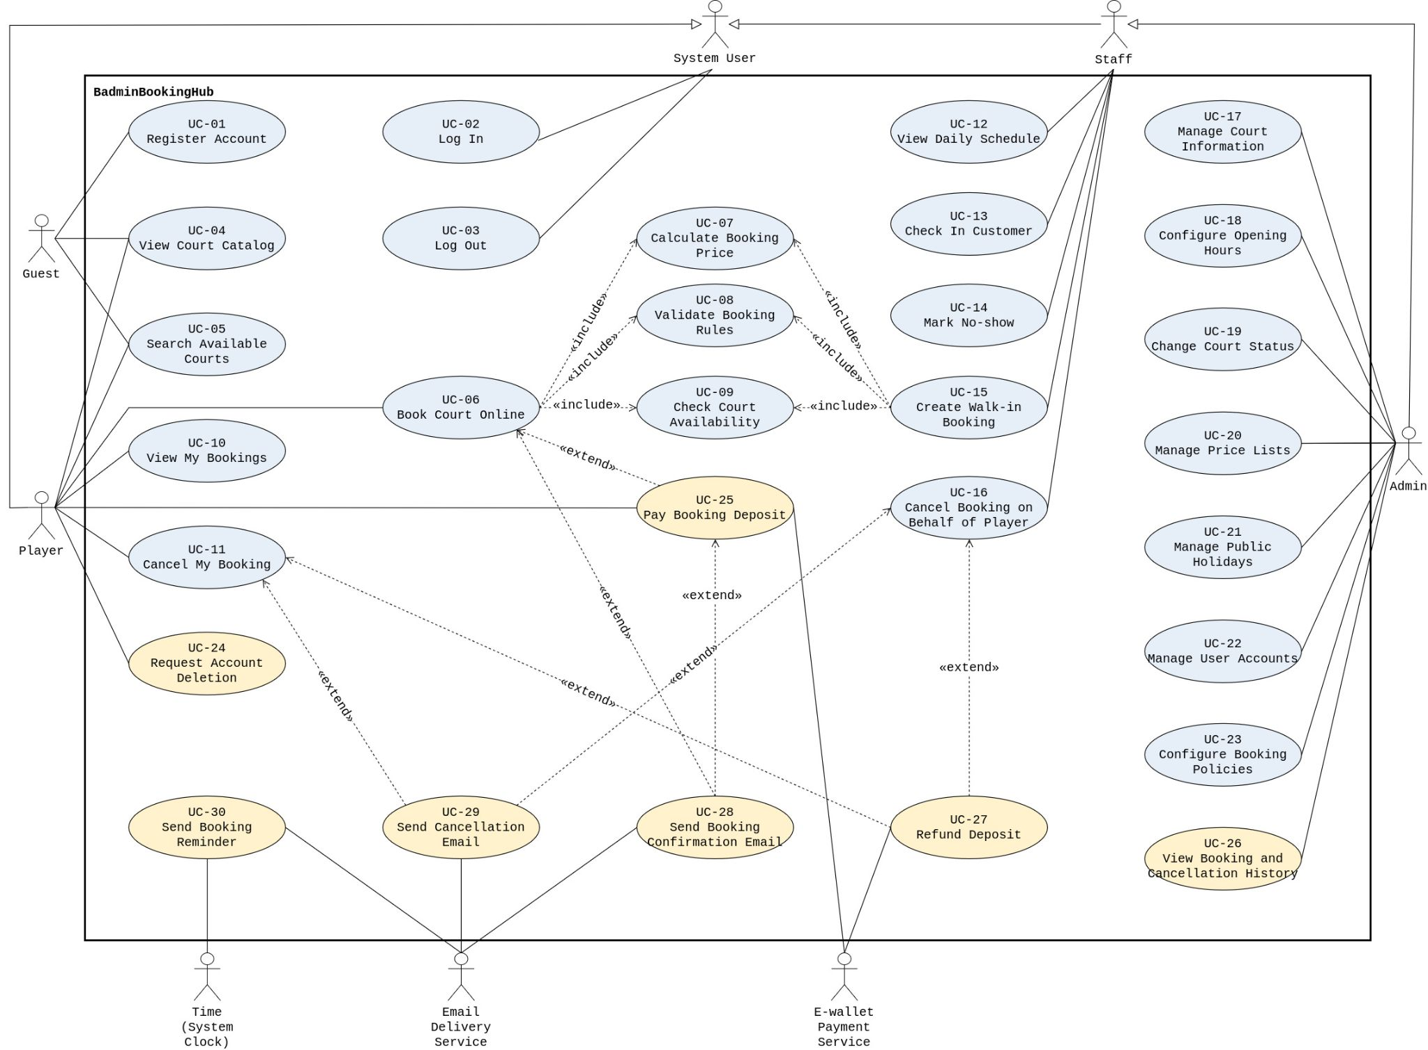
Use Case Diagram

Figure. BadminBookingHub Use Case Diagram — Must-have and Should-have Use Cases. Blue indicates Must-have use cases; yellow indicates Should-have use cases. Google Drive Link

Actors
Actor | Description
Guest | An unauthenticated visitor who can register a Player account, view the court catalog and search available time slots, but cannot create bookings.
Player | A registered badminton player who books courts online, views and cancels own bookings and, if the optional features are implemented, requests account deletion and pays booking deposits. Specialises System User.
Staff | A court employee who views the daily schedule, checks in customers, marks no-shows, creates walk-in bookings and cancels bookings on behalf of customers. Walk-in customers do not use the system; Staff act for them. Specialises System User.
Admin (Court Owner) | The venue owner who manages court information, opening hours, prices, public holidays, user accounts and booking policies, and can cancel bookings on behalf of customers. Specialises Staff, so the Admin can also perform all Staff use cases.
System User | Generalisation of Player, Staff and Admin. It is associated with Log In and Log Out, which all registered users share.
E-wallet Payment Service | An external sandbox payment service that processes deposit payments and refunds and returns the payment result to the system.
Email Delivery Service | An external service that delivers the booking confirmation, cancellation and reminder emails sent by the system.
Time (System Clock) | Represents the system clock event that triggers UC-30 – Send Booking Reminder before the scheduled booking start time.

Use Case List
ID | Use case | Primary actor | Priority | Related FR
UC-01 | Register Account | Guest | Must | FR-01
UC-02 | Log In | System User | Must | FR-02, FR-03
UC-03 | Log Out | System User | Must | FR-02
UC-04 | View Court Catalog | Guest, Player | Must | FR-05
UC-05 | Search Available Courts | Guest, Player | Must | FR-13, FR-14
UC-06 | Book Court Online | Player | Must | FR-06, FR-08, FR-10, FR-31
UC-07 | Calculate Booking Price | (included by UC-06, UC-15) | Must | FR-07
UC-08 | Validate Booking Rules | (included by UC-06, UC-15) | Must | FR-15, FR-16, FR-17
UC-09 | Check Court Availability | (included by UC-06, UC-15) | Must | FR-09
UC-10 | View My Bookings | Player | Must | FR-11
UC-11 | Cancel My Booking | Player | Must | FR-12, FR-18, FR-31
UC-12 | View Daily Schedule | Staff | Must | FR-26
UC-13 | Check In Customer | Staff | Must | FR-27, FR-31
UC-14 | Mark No-show | Staff | Must | FR-28, FR-31
UC-15 | Create Walk-in Booking | Staff | Must | FR-29, FR-31
UC-16 | Cancel Booking on Behalf of Player | Staff | Must | FR-30, FR-31
UC-17 | Manage Court Information | Admin | Must | FR-19
UC-18 | Configure Opening Hours | Admin | Must | FR-20
UC-19 | Change Court Status | Admin | Must | FR-21
UC-20 | Manage Price Lists | Admin | Must | FR-22
UC-21 | Manage Public Holidays | Admin | Must | FR-23
UC-22 | Manage User Accounts | Admin | Must | FR-03, FR-24; FR-04 (Should)
UC-23 | Configure Booking Policies | Admin | Must; F08 settings are Should | FR-25; FR-32 (F08)
UC-24 | Request Account Deletion | Player | Should | FR-04
UC-25 | Pay Booking Deposit | Player | Should | FR-33, FR-34, FR-35
UC-26 | View Booking and Cancellation History | Admin | Should | FR-36
UC-27 | Refund Deposit | (extends UC-11, UC-16) | Should | FR-37
UC-28 | Send Booking Confirmation Email | (extends UC-06, UC-25) | Should | FR-38
UC-29 | Send Cancellation Email | (extends UC-11, UC-16) | Should | FR-39
UC-30 | Send Booking Reminder | Time | Should | FR-40

Use Case Specifications

Use Case UC-01
Use case ID | UC-01
Use case name | Register Account
Brief description | A Guest registers a Player account in order to book courts online. The Guest provides a full name, phone number, email address and password and agrees to the personal data policy. The system validates the information, records the consent and creates an account with the Player role.
Primary actor | Guest
Secondary actors | None
Priority | Must
Related requirements | FR-01
Trigger | The Guest chooses to register a Player account.
Pre-conditions | 1. The Guest is not logged in.
Post-conditions | Success:  1. A new Player account exists with the submitted full name, phone number and email address.  2. The Guest's consent to the personal data policy is recorded for that account.  3. The password is stored only in hashed form.  4. The Guest is still not logged in and can log in with the new account.  Failure:  1. No account and no consent record are created.  2. Existing accounts are unchanged.
Main flow | 1. The use case starts when the Guest chooses to register a Player account.  2. The system displays the registration form and the personal data policy.  3. The Guest enters a full name, phone number, email address and password.  4. The Guest agrees to the personal data policy.  5. The Guest submits the registration.  6. The system validates the information: all fields are filled in, the phone number has 10 digits and starts with 0, and the password has at least 8 characters with at least one letter and one digit.  7. The system checks that the email address is not already registered.  8. The system creates the Player account, stores the password in hashed form and records the consent.  9. The system informs the Guest that the account has been created and offers to log in.  10. The use case ends.
Alternative flows | A1 (at step 6): Information is missing or invalid  A1.1 The system creates no account, shows next to each invalid field which rule is not met, and keeps the valid values.  A1.2 The use case continues at step 3.  Postconditions: no account is created.  A2 (at step 6): The Guest has not agreed to the personal data policy  A2.1 The system creates no account and informs the Guest, next to the consent option, that agreement is required. The entered values are kept.  A2.2 The use case continues at step 4.  Postconditions: no account is created.  A3 (at step 7 or 8): The email address is already registered  A3.1 The email address is used by an existing account, also when another registration took it after step 7. The system creates no account and informs the Guest, next to the email field, that the email address is already registered.  A3.2 The use case continues at step 3.  Postconditions: no new account is created; the existing account is unchanged.  A4 (before step 5): The Guest leaves  A4.1 The Guest leaves the registration form without submitting. The use case ends.  Postconditions: no account is created.
Exception flows | E1 (at step 8): The account cannot be saved  E1.1 The system informs the Guest that the registration cannot be completed now and can be tried again. No account or consent record is created. The use case ends.  Postconditions: no account is created.
Business rules | BR-32, BR-33, BR-36, BR-37, BR-38
Non-functional constraints | NFR-05, NFR-06, NFR-07, NFR-08, NFR-09, NFR-10

Use Case UC-02
Use case ID | UC-02
Use case name | Log In
Brief description | A System User (Player, Staff or Admin) enters an email address and password to use the functions that require login. The system verifies the credentials and opens a session in which the user can use only the functions permitted for the role of the account.
Primary actor | System User (Player, Staff, Admin)
Secondary actors | None
Priority | Must
Related requirements | FR-02, FR-03
Trigger | The System User chooses to log in, or opens a page that requires login.
Pre-conditions | 1. The System User is not logged in.
Post-conditions | Success:  1. A session is open for the account.  2. In this session the user can use only the functions permitted for the role of the account.  Failure:  1. No session is opened and the user stays logged out.
Main flow | 1. The use case starts when the System User chooses to log in.  2. The system displays the login form.  3. The System User enters an email address and password and submits them.  4. The system checks that both fields are filled in.  5. The system checks that the account is not temporarily locked.  6. The system verifies the email address and password.  7. The system opens a session with the role of the account.  8. The system displays the home page with the functions permitted for that role.  9. The use case ends.
Alternative flows | A1 (at step 1): The user opens a page that requires login  A1.1 The system takes the user to the login page.  A1.2 The use case continues at step 2.  Postconditions: as in the main flow.  A2 (at step 4): A field is empty  A2.1 The system opens no session, informs the user next to the empty field, and keeps the entered email address.  A2.2 The use case continues at step 3.  Postconditions: no session is opened.  A3 (at step 5): The account is temporarily locked  A3.1 The system rejects the login, also when the password is correct, and informs the user that login is temporarily locked and can be tried again later. The use case ends.  Postconditions: no session is opened.  A4 (at step 6): The email address or password is incorrect  A4.1 The email address is not registered or the password does not match. The system informs the user that the email address or password is incorrect, without saying which one.  A4.2 The system counts the failed attempt for the account. When the limit of failed attempts is reached, the account is locked temporarily.  A4.3 The use case continues at step 3.  Postconditions: no session is opened.
Exception flows | E1 (at step 6 or 7): The login cannot be completed  E1.1 The system informs the user that login is not possible now and can be tried again. No session is opened. The use case ends.  Postconditions: the user stays logged out.
Business rules | None
Non-functional constraints | NFR-04, NFR-05, NFR-06, NFR-07, NFR-08, NFR-09, NFR-10, NFR-16

Use Case UC-03
Use case ID | UC-03
Use case name | Log Out
Brief description | A logged-in System User ends the current session. After logging out, the user must log in again to use the functions that require login.
Primary actor | System User (Player, Staff, Admin)
Secondary actors | None
Priority | Must
Related requirements | FR-02
Trigger | The System User chooses to log out.
Pre-conditions | 1. The System User is logged in.
Post-conditions | Success:  1. The session is ended and can no longer be used.  2. Opening a page that requires login takes the user to the login page.  3. Accounts, roles and bookings are unchanged.  Failure:  1. The user stays logged in.  2. No data is changed.
Main flow | 1. The use case starts when the System User chooses to log out.  2. The system ends the current session.  3. The system displays the login page.  4. The use case ends.
Alternative flows | A1 (at step 2): The session has already expired  A1.1 The system treats the user as logged out.  A1.2 The use case continues at step 3.  Postconditions: as in the main flow.
Exception flows | E1 (at step 2): The session cannot be ended  E1.1 The system informs the user that logout could not be completed and can be tried again. The use case ends.  Postconditions: the user stays logged in; no data is changed.
Business rules | None
Non-functional constraints | NFR-05, NFR-07, NFR-08, NFR-10, NFR-16

Use Case UC-04
Use case ID | UC-04
Use case name | View Court Catalog
Brief description | The Guest or Player views the catalog of active courts. For each court the system shows its name, location, capacity, surface type, opening hours and price list, so that the user can compare the courts before booking. No login is required.
Primary actor | Guest, Player
Secondary actors | None
Priority | Must
Related requirements | FR-05
Trigger | The Guest or Player chooses to view the court catalog.
Pre-conditions | 1. The courts, their opening hours and their price lists have been set up by the Admin.
Post-conditions | Success:  1. The active courts are displayed with their current information and price lists.  2. No data is changed.  Failure:  1. No partial or outdated court information is displayed.  2. No data is changed.
Main flow | 1. The use case starts when the Guest or Player chooses to view the court catalog.  2. The system finds the courts whose status is Active. Inactive courts are not shown.  3. For each active court, the system displays:  a. name, location, capacity and surface type;  b. opening hours;  c. the current hourly rates of the Normal, Peak and Weekend bands, in VND.  4. The Guest or Player reviews the catalog.  5. The use case ends.
Alternative flows | A1 (at step 2): There is no active court  A1.1 The system displays an empty catalog and informs the user that no court is available. The use case ends.  Postconditions: no data is changed.
Exception flows | E1 (at step 2 or 3): The court information cannot be loaded  E1.1 The system informs the user that the catalog cannot be loaded now and shows no partial or outdated court information. The use case ends.  Postconditions: no data is changed.
Business rules | BR-01, BR-15, BR-16, BR-36
Non-functional constraints | NFR-01, NFR-07, NFR-08, NFR-10

Use Case UC-05
Use case ID | UC-05
Use case name | Search Available Courts
Brief description | The Guest or Player selects a date and views the availability calendar. For each active court, the calendar shows the 30-minute time slots of that date as Available, Booked or Closed. No login is required.
Primary actor | Guest, Player
Secondary actors | None
Priority | Must
Related requirements | FR-13, FR-14
Trigger | The Guest or Player chooses to check court availability for a date.
Pre-conditions | 1. The courts and their opening hours have been set up by the Admin.
Post-conditions | Success:  1. The availability calendar of the selected date is displayed for every active court.  2. The calendar shows only slot statuses; no personal data of any user is shown.  3. No data is changed.  Failure:  1. No partial calendar is displayed.  2. No data is changed.
Main flow | 1. The use case starts when the Guest or Player chooses to check court availability.  2. The Guest or Player selects a date.  3. The system finds the courts whose status is Active. Inactive courts are not shown.  4. For each active court, the system reads its opening hours and its bookings on that date that occupy the court: Pending payment, Booked or Checked-in. Cancelled, Completed and No-show bookings do not occupy the court.  5. The system divides the day into 30-minute slots and sets the status of each slot:  a. Closed if the slot is outside the court's opening hours;  b. Booked if the slot is occupied by a booking found in step 4;  c. Available otherwise.  6. The system displays the calendar of all active courts for that date.  7. The Guest or Player reviews the calendar.  8. The use case ends.
Alternative flows | A1 (at step 7): The Guest or Player selects another date  A1.1 The use case continues at step 3 with the new date.  Postconditions: no data is changed.  A2 (at step 7): Availability changes while the calendar is open  A2.1 A booking on the displayed date is created, cancelled or changes status, for example it is marked No-show.  A2.2 The system updates the affected slots on the open calendar without the user reloading the page. The use case continues at step 7.  Postconditions: the calendar shows the latest slot statuses.  A3 (at step 3): There is no active court  A3.1 The system displays an empty calendar and informs the user that no court is available. The use case ends.  Postconditions: no data is changed.
Exception flows | E1 (at step 3 or 4): The availability data cannot be loaded  E1.1 The system informs the user that availability cannot be loaded now and shows no partial calendar. The use case ends.  Postconditions: no data is changed.
Business rules | BR-01, BR-03, BR-31, BR-36
Non-functional constraints | NFR-01, NFR-03, NFR-07, NFR-08, NFR-10, NFR-15

Use Case UC-06
Use case ID | UC-06
Use case name | Book Court Online
Brief description | A logged-in Player books a court online by selecting an active court, a date, a start time and a duration. The system validates the booking rules, checks that the court is free, calculates and shows the price, and creates the booking after the Player confirms.
Primary actor | Player
Secondary actors | None
Priority | Must
Related requirements | FR-06, FR-08, FR-10, FR-31
Trigger | The Player chooses to book a court.
Pre-conditions | 1. The Player is logged in with the Player role.  2. The booking policies, opening hours and price lists have been configured.
Post-conditions | Success:  1. A new booking belongs to the Player with the selected court, date, start time, end time, duration and the price confirmed by the Player.  2. The booking keeps this price when the price list changes later.  3. The booking status is Booked when deposit payment is not in use, or Pending payment when it is in use.  4. The booking occupies the court for its time.  Failure:  1. No booking is created and no time is reserved.  2. Existing bookings are unchanged.
Main flow | 1. The use case starts when the Player chooses to book a court.  2. The system displays the booking form with the active courts.  3. The Player selects a court, a date, a start time and a duration.  4. The system validates the booking rules (include: Validate Booking Rules).  5. The system checks that the court is free for the selected time (include: Check Court Availability).  6. The system calculates the price (include: Calculate Booking Price).  7. The system displays the booking summary: court, date, start and end time, duration and total price in VND.  8. The Player confirms the booking.  9. The system validates the booking rules again, including the Player's remaining booking quota, and checks again that the court is still free (include: Validate Booking Rules, Check Court Availability).  10. The system recalculates the price (include: Calculate Booking Price) and checks that it equals the price shown in step 7.  11. The system creates the booking with the confirmed price and the initial status: Booked when deposit payment is not in use, or Pending payment when it is in use.  12. The system informs the Player that the booking has been created and shows its details. The selected time is shown as Booked in the availability calendar.  13. The use case ends.
Alternative flows | A1 (at step 7): The Player changes the selection  A1.1 Before confirming, the Player changes the court, date, start time or duration.  A1.2 The use case continues at step 4 with the new selection.  Postconditions: no booking is created.  A2 (at step 4 or 9): The booking rules are not satisfied  A2.1 The system informs the Player which booking rule is not met, for example the time is outside the opening hours, the start is too soon, the date is beyond the advance window or the booking quota would be exceeded.  A2.2 The use case continues at step 3.  Postconditions: no booking is created.  A3 (at step 5 or 9): The selected time is not available  A3.1 The selected time overlaps an active booking, also when another online or walk-in booking took it after step 5. When two requests for the same time arrive at the same moment, at most one booking is created.  A3.2 The system informs the Player that the selected time is no longer available.  A3.3 The use case continues at step 3.  Postconditions: no booking is created; existing bookings are unchanged.  A4 (at step 8): The Player does not confirm  A4.1 The Player leaves the booking form or goes back without confirming. The use case ends.  Postconditions: no booking is created and no time is reserved.  A5 (at step 10): The price has changed  A5.1 The system displays the updated booking summary and informs the Player that the price has changed.  A5.2 The Player confirms the new price. The use case continues at step 9. If the Player does not confirm, A4 applies.  Postconditions: no booking is created until the Player confirms the new price and all checks succeed.  A6 (after step 11): Extension point "Booking created"  A6.1 Pay Booking Deposit extends here when deposit payment is in use. Send Booking Confirmation Email extends here when booking emails are in use and the booking is Booked.  A6.2 The use case continues at step 12.  Postconditions: the booking keeps the status assigned in step 11.
Exception flows | E1 (at steps 3–11): The session has expired  E1.1 The system rejects the request and asks the Player to log in again. The use case ends.  Postconditions: no booking is created.  E2 (at steps 4–6 or 9–11): A check or the save cannot be completed  E2.1 The system creates no partial booking and informs the Player that the booking cannot be completed now. The use case ends.  Postconditions: no booking is created.
Business rules | BR-03, BR-04, BR-06, BR-18, BR-26, BR-36
Non-functional constraints | NFR-02, NFR-03, NFR-07, NFR-08, NFR-09, NFR-10, NFR-11, NFR-12

Use Case UC-07
Use case ID | UC-07
Use case name | Calculate Booking Price
Brief description | The system calculates the total price of a selected booking from the court's price list, the booking date and the booking time. It divides the booking into 30-minute blocks, finds the price band of each block and returns the total price.
Primary actor | None – included by Book Court Online (Player) and Create Walk-in Booking (Staff)
Secondary actors | None
Priority | Must
Related requirements | FR-07
Trigger | The online or walk-in booking flow needs the price of a selected booking.
Pre-conditions | 1. The calling booking flow has supplied the court, booking date, start time and end time.  2. The court has a configured price list.  3. The booking time has passed the booking rule and availability checks.
Post-conditions | Success:  1. The total price of the booking is returned.  2. No booking is created or changed.  Failure:  1. No price is returned, so no booking can be confirmed with an incomplete price.  2. No booking is created or changed.
Main flow | 1. The use case starts when the calling booking flow requests the price of a booking.  2. The system receives the court, booking date, start time and end time.  3. The system reads the court's current hourly rates for the Normal, Peak and Weekend bands and the list of public holidays.  4. The system divides the booking time into 30-minute blocks.  5. For each block, the system finds the price band in this order:  a. Weekend if the date is a Saturday, a Sunday or a public holiday;  b. otherwise Peak if the block is within the peak period (Monday–Friday, 17:00–21:00);  c. otherwise Normal.  6. The system sets the price of each block to half of the hourly rate of its band.  7. The system adds the prices of all blocks and returns the total price.  8. The use case ends.
Alternative flows | None.
Exception flows | E1 (at step 3): The price list or the public holiday list cannot be read  E1.1 The system returns no price, so no booking can be confirmed with an incomplete price. The use case ends.  Postconditions: no price is returned; no booking is created.
Business rules | BR-15, BR-16, BR-17, BR-36
Non-functional constraints | NFR-02

Use Case UC-08
Use case ID | UC-08
Use case name | Validate Booking Rules
Brief description | The system checks whether a selected booking meets the booking rules before it can continue: opening hours, start time, duration and, for an online booking, lead time, advance window and booking quota; for a walk-in booking, the date and the start time.
Primary actor | None – included by Book Court Online (Player) and Create Walk-in Booking (Staff)
Secondary actors | None
Priority | Must
Related requirements | FR-15, FR-16, FR-17
Trigger | The online or walk-in booking flow needs to check a selected booking.
Pre-conditions | 1. The calling booking flow has supplied the court, booking date, start time, end time, duration and booking type (online booking of a Player, or walk-in booking).  2. The selected court has Active status.  3. The opening hours and booking policies have been configured.
Post-conditions | Success:  1. The system returns valid and the booking can continue.  2. No data is changed.  Failure:  1. The system returns not valid with the rule that is not met, or states that the rules cannot be checked now; the booking cannot continue.  2. No data is changed.
Main flow | Online booking  1. The use case starts when an online booking of a Player is to be checked.  2. The system reads the court's opening hours and the advance window and booking quota in effect at this moment.  3. The system checks that the whole booking, from start time to end time, lies within the opening hours.  4. The system checks that the start time is on the hour or half hour.  5. The system checks that the duration is at least 60 minutes, in steps of 30 minutes.  6. The system checks that the start time is at least 30 minutes after the current time.  7. The system checks that the booking date is no later than today plus the advance window, in time zone Asia/Ho_Chi_Minh.  8. The system adds up the durations of the Player's upcoming bookings (Pending payment or Booked, not yet started) and checks that this total plus the requested duration does not exceed the booking quota.  9. The system returns valid.  10. The use case ends.
Alternative flows | A1 (at step 1): The booking is a walk-in booking  A1.1 The system reads the court's opening hours and performs steps 3–5.  A1.2 The system checks that the booking date is today.  A1.3 The system checks that the start time is not earlier than the current time.  A1.4 The lead time, the advance window and the booking quota are not checked. The system returns valid. The use case ends.  Postconditions: no data is changed.  A2 (at step 3 or A1.1): The booking is outside the opening hours  A2.1 The system returns not valid, stating that the booking time is outside the court's opening hours. The use case ends.  A3 (at step 4 or A1.1): The start time is not on the hour or half hour  A3.1 The system returns not valid, stating that the start time must be on the hour or half hour. The use case ends.  A4 (at step 5 or A1.1): The duration is not allowed  A4.1 The system returns not valid, stating that the duration must be at least 60 minutes in steps of 30 minutes. The use case ends.  A5 (at step 6): The start is less than 30 minutes away  A5.1 The system returns not valid, stating that a booking must be made at least 30 minutes before the start, together with the earliest start on the hour or half hour that is at least 30 minutes away. The use case ends.  A6 (at step 7): The date is beyond the advance window  A6.1 The system returns not valid, stating the advance window in effect in days. The use case ends.  A7 (at step 8): The booking quota would be exceeded  A7.1 If the Player still has hours left in the quota, the system returns not valid, stating how many hours the Player can still book.  A7.2 If no hours are left, the system returns not valid, stating that the Player has reached the booking quota. The use case ends.  A8 (at A1.2): The walk-in booking is not for today  A8.1 The system returns not valid, stating that a walk-in booking can only be made for today. The use case ends.  A9 (at A1.3): The walk-in booking starts before the current time  A9.1 The system returns not valid, stating that the start time cannot be earlier than the current time, together with the earliest start on the hour or half hour that is not earlier than now. The use case ends.  Postconditions for A2–A9: no data is changed.
Exception flows | E1 (at step 2, step 8 or A1.1): The required data cannot be read  E1.1 The system cannot read the opening hours, the booking policies or the Player's upcoming bookings.  E1.2 The system returns not valid, stating that the booking rules cannot be checked now. The use case ends.  Postconditions: no booking can continue on incomplete checks.
Business rules | BR-01, BR-02, BR-05, BR-06, BR-07, BR-11, BR-12, BR-13, BR-36
Non-functional constraints | NFR-02, NFR-09

Use Case UC-09
Use case ID | UC-09
Use case name | Check Court Availability
Brief description | The system checks whether a court is free for a requested time. It looks for active bookings of the court that overlap the requested time and returns Available or Unavailable. It is shared by online and walk-in booking.
Primary actor | None – included by Book Court Online (Player) and Create Walk-in Booking (Staff)
Secondary actors | None
Priority | Must
Related requirements | FR-09
Trigger | The online or walk-in booking flow needs to know whether a court is free for a requested time.
Pre-conditions | 1. The calling booking flow has supplied the court, booking date, start time and end time.
Post-conditions | Success:  1. The system returns Available or Unavailable.  2. No booking is created or changed.  Failure:  1. The system returns that availability cannot be determined; it never returns Available on incomplete data.  2. No booking is created or changed.
Main flow | 1. The use case starts when the free time of a court is requested for a time range.  2. The system reads the bookings of the court on that date that have an active status: Pending payment, Booked or Checked-in. Cancelled, Completed and No-show bookings do not occupy the court.  3. The system compares the requested range with each active booking as half-open ranges [start, end): two ranges overlap only if each one starts before the other ends. For example, 18:00–19:00 and 19:00–20:00 do not overlap.  4. The system finds no active booking that overlaps the requested range and returns Available.  5. The use case ends.
Alternative flows | A1 (at step 3): The requested range overlaps an active booking  A1.1 The system returns Unavailable. The use case ends.  Postconditions: no booking is created; existing bookings are unchanged.
Exception flows | E1 (at step 2 or 3): The bookings cannot be read  E1.1 The system cannot read or compare the bookings of the court.  E1.2 The system returns that availability cannot be determined now; it never returns Available on incomplete data. The use case ends.  Postconditions: no booking is created.
Business rules | BR-03, BR-04, BR-31
Non-functional constraints | NFR-02

Use Case UC-10
Use case ID | UC-10
Use case name | View My Bookings
Brief description | A logged-in Player views the list of their own bookings and the details and current status of each booking. Bookings of other Players are never shown.
Primary actor | Player
Secondary actors | None
Priority | Must
Related requirements | FR-11
Trigger | The Player chooses to view their bookings.
Pre-conditions | 1. The Player is logged in with the Player role.
Post-conditions | Success:  1. The Player's own bookings are displayed with their details and current statuses.  2. No booking of another Player is shown.  3. No data is changed.  Failure:  1. No booking information, and no partial list, is shown.  2. No data is changed.
Main flow | 1. The use case starts when the Player chooses to view their bookings.  2. The system identifies the logged-in Player.  3. The system reads the bookings of that Player.  4. The system displays the list of bookings. Each booking shows the court, date, start and end time, price and current status.  5. The Player reviews the list.  6. The use case ends.
Alternative flows | A1 (at step 3): The Player has no booking  A1.1 The system displays an empty list and informs the Player that there is no booking. The use case ends.  Postconditions: no data is changed.  A2 (at step 5): The Player views the details of a booking  A2.1 The Player selects a booking.  A2.2 The system checks that the booking belongs to the Player and displays its court, date, start and end time, duration, price and current status.  A2.3 The use case continues at step 5.  Postconditions: no data is changed.
Exception flows | E1 (at any step): The session has expired  E1.1 The system returns no booking and asks the Player to log in again. The use case ends.  Postconditions: no booking information is shown.  E2 (at A2.2): The booking belongs to another Player  E2.1 The system rejects the request and returns no booking data. The use case ends.  Postconditions: the other Player's booking is not shown and is unchanged.  E3 (at step 3 or A2.2): The bookings cannot be loaded  E3.1 The system informs the Player that the bookings cannot be loaded now and shows no partial list. The use case ends.  Postconditions: no data is changed.
Business rules | BR-36
Non-functional constraints | NFR-07, NFR-08, NFR-10, NFR-15

Use Case UC-11
Use case ID | UC-11
Use case name | Cancel My Booking
Brief description | A logged-in Player cancels one of their own bookings online when the cancellation policy allows it. The system changes the booking to Cancelled, records who cancelled and the reason, and releases the court's time.
Primary actor | Player
Secondary actors | None
Priority | Must
Related requirements | FR-12, FR-18, FR-31
Trigger | The Player chooses to cancel one of their bookings.
Pre-conditions | 1. The Player is logged in with the Player role.  2. The booking exists in the system.
Post-conditions | Success:  1. The booking status is Cancelled.  2. The Player is recorded as the canceller with the reason Player online.  3. The booking no longer occupies the court; its time is Available in the availability calendar.  4. The booking price and record are kept.  Failure:  1. The booking is unchanged and keeps occupying the court if its status still occupies it.
Main flow | 1. The use case starts when the Player selects one of their bookings and chooses to cancel it. The cancel action is offered only for Booked or Pending payment bookings that have not started.  2. The system checks that the booking belongs to the Player, has status Booked and has not started, and that its start time is at least the cancellation deadline in effect away. A booking exactly at the deadline can be cancelled.  3. The system asks the Player to confirm and shows the court, date, time and price of the booking.  4. The Player confirms the cancellation.  5. The system repeats the checks of step 2 using the latest booking status and the current time.  6. The system changes the status to Cancelled and records the Player as the canceller and Player online as the reason.  7. The system informs the Player that the booking is cancelled. The booking shows status Cancelled and its time becomes Available in the availability calendar.  8. The use case ends.
Alternative flows | A1 (at step 2 or 5): The booking is Pending payment  A1.1 The cancellation deadline does not apply. The system checks that the booking belongs to the Player and that its start time has not passed.  A1.2 The use case continues at step 3 if this happens at step 2, or at step 6 if it happens at step 5.  Postconditions: as in the main flow.  A2 (at step 2 or 5): The Booked booking starts within the cancellation deadline  A2.1 The system informs the Player that the online cancellation deadline has passed and that the Player must contact the venue. The use case ends.  Postconditions: the booking stays Booked.  A3 (at step 2 or 5): The booking has started  A3.1 The current time is equal to or later than the start time. The system rejects the cancellation. The cancel action is not offered for such a booking, and a request sent directly is also rejected. The use case ends.  Postconditions: the booking is unchanged.  A4 (at step 2 or 5): The status does not allow cancellation  A4.1 The booking is Checked-in, Completed, Cancelled or No-show. The system informs the Player that the booking cannot be cancelled in its current status. The use case ends.  Postconditions: the booking is unchanged.  A5 (at step 4): The Player does not confirm  A5.1 The Player closes the confirmation. The use case ends.  Postconditions: the booking is unchanged.  A6 (after step 6): Extension point "Booking cancelled"  A6.1 Send Cancellation Email extends here when booking emails are in use. Refund Deposit extends here when a deposit was paid.  A6.2 The use case continues at step 7.  Postconditions: the booking stays Cancelled.
Exception flows | E1 (at step 2): The booking belongs to another Player  E1.1 The system rejects the request and returns no booking data. The use case ends.  Postconditions: the booking is unchanged.  E2 (at step 6): The cancellation cannot be saved  E2.1 The system informs the Player that the booking cannot be cancelled now and can be tried again. The use case ends.  Postconditions: the booking is unchanged.  E3 (at any step): The session has expired  E3.1 The system changes nothing and asks the Player to log in again. The use case ends.  Postconditions: the booking is unchanged.
Business rules | BR-07, BR-08, BR-09, BR-10, BR-13, BR-25, BR-28
Non-functional constraints | NFR-03, NFR-07, NFR-08, NFR-10, NFR-15

Use Case UC-12
Use case ID | UC-12
Use case name | View Daily Schedule
Brief description | Staff views the booking schedule of a day and the current status of each active court. For each booking the system shows the court, time, customer name, phone number and booking status, so that Staff can prepare check-ins, no-shows and walk-in bookings.
Primary actor | Staff
Secondary actors | None
Priority | Must
Related requirements | FR-26
Trigger | Staff chooses to view the daily schedule.
Pre-conditions | 1. The user is logged in with the Staff or Admin role.  2. The courts and their opening hours have been set up by the Admin.
Post-conditions | Success:  1. The bookings of the selected date and the current status of each active court are displayed.  2. No data is changed.  Failure:  1. No partial or outdated schedule is displayed.  2. No data is changed.
Main flow | 1. The use case starts when Staff chooses to view the daily schedule.  2. The system selects today's date (Asia/Ho_Chi_Minh) and finds the courts whose status is Active.  3. For each active court, the system reads its bookings on that date, in any status.  4. The system determines the current status of each court: in use if a Checked-in booking covers the current time, otherwise free.  5. The system displays the schedule ordered by court and start time. Each booking shows the court, start and end time, customer name, phone number and status; each court shows its current status.  6. Staff reviews the schedule.  7. The use case ends.
Alternative flows | A1 (at step 6): Staff selects another date  A1.1 The use case continues at step 3 with the new date. The current status of the courts is shown only for today.  Postconditions: no data is changed.  A2 (at step 6): A booking changes while the schedule is open  A2.1 A booking on the displayed date is created, cancelled, checked in, marked No-show or becomes Completed.  A2.2 The system updates the affected rows and court statuses without the user reloading the page. The use case continues at step 6.  Postconditions: the schedule shows the latest data.  A3 (at step 3): A court has no booking on the date  A3.1 The system shows the court with no bookings. The use case continues at step 4.  A4 (at step 2): There is no active court  A4.1 The system displays an empty schedule and informs Staff that no court is available. The use case ends.  Postconditions: no data is changed.
Exception flows | E1 (at any step): The session has expired or the user does not have the Staff or Admin role  E1.1 The system rejects the request and changes no data. If the session has expired, the user is asked to log in again. The use case ends.  Postconditions: no data is changed.  E2 (at step 3 or 4): The schedule cannot be loaded  E2.1 The system informs Staff that the schedule cannot be loaded now and shows no partial or outdated schedule. The use case ends.  Postconditions: no data is changed.
Business rules | BR-25, BR-27, BR-31, BR-32, BR-36
Non-functional constraints | NFR-03, NFR-07, NFR-08, NFR-10

Use Case UC-13
Use case ID | UC-13
Use case name | Check In Customer
Brief description | Staff records the arrival of a customer for a Booked booking. Check-in is allowed from 15 minutes before to 25 minutes after the booking start time. The system changes the booking status to Checked-in.
Primary actor | Staff
Secondary actors | None
Priority | Must
Related requirements | FR-27, FR-31
Trigger | Staff chooses to check in a customer for a booking in the daily schedule.
Pre-conditions | 1. The user is logged in with the Staff or Admin role.  2. The booking exists in the system.
Post-conditions | Success:  1. The booking status is Checked-in.  2. The booking keeps its court, time and price and continues to occupy the court.  3. At the scheduled end time the booking becomes Completed automatically.  Failure:  1. The booking status and the schedule are unchanged.
Main flow | 1. The use case starts when Staff selects a booking in the daily schedule and chooses to check in the customer.  2. The system checks that the booking status is Booked.  3. The system checks that the current time is within the check-in window: from 15 minutes before the start time (inclusive) to 25 minutes after the start time (inclusive).  4. The system changes the booking status to Checked-in.  5. The system informs Staff that the customer is checked in and shows the booking as Checked-in.  6. The use case ends.
Alternative flows | A1 (at step 3): Check-in is too early  A1.1 The current time is earlier than 15 minutes before the start. The system rejects the check-in and informs Staff of the time when check-in opens. The use case ends.  Postconditions: the booking stays Booked.  A2 (at step 3): Check-in is too late  A2.1 The current time is later than 25 minutes after the start. The system rejects the check-in and informs Staff that the check-in time has passed. The use case ends.  Postconditions: the booking stays Booked and can be marked as No-show.  A3 (at step 2): The status does not allow check-in  A3.1 If the booking is Completed, Cancelled or No-show, the booking has ended: the check-in action is not offered, and a request sent directly is rejected.  A3.2 If the booking is already Checked-in or is Pending payment, the system rejects the request because this status change is not allowed. The use case ends.  Postconditions: the status does not change.
Exception flows | E1 (at any step): The session has expired or the user does not have the Staff or Admin role  E1.1 The system rejects the request and changes no data. If the session has expired, the user is asked to log in again. The use case ends.  Postconditions: no data is changed.  E2 (at step 4): The status cannot be saved  E2.1 The system informs Staff that the check-in cannot be completed now and can be tried again. The use case ends.  Postconditions: the booking stays Booked.
Business rules | BR-25, BR-26, BR-27, BR-29
Non-functional constraints | NFR-03, NFR-07, NFR-08, NFR-10

Use Case UC-14
Use case ID | UC-14
Use case name | Mark No-show
Brief description | Staff marks a Booked booking as No-show when the customer has not checked in more than 25 minutes after the start time. The system never marks a No-show by itself. A No-show booking no longer occupies the court, so its remaining time can be offered for walk-in bookings.
Primary actor | Staff
Secondary actors | None
Priority | Must
Related requirements | FR-28, FR-31
Trigger | Staff chooses to mark a booking that has not been checked in as No-show.
Pre-conditions | 1. The user is logged in with the Staff or Admin role.  2. The booking exists in the system.
Post-conditions | Success:  1. The booking status is No-show.  2. The booking no longer occupies the court. Its remaining time, from the next half hour after the current time, is Available in the availability calendar and can be given to a walk-in booking.  3. The booking record is kept.  Failure:  1. The booking status is unchanged and the booking keeps occupying the court.
Main flow | 1. The use case starts when Staff selects a Booked booking and chooses to mark it as No-show.  2. The system checks that the booking status is Booked.  3. The system checks that the current time is more than 25 minutes after the booking start time.  4. The system changes the booking status to No-show.  5. The system releases the remaining time of the booking, from the next half hour after the current time, in the availability calendar.  6. The system informs Staff that the booking is marked as No-show and shows the updated schedule.  7. The use case ends.
Alternative flows | A1 (at step 3): The No-show time has not been reached  A1.1 The current time is not later than 25 minutes after the start. The system rejects the request and informs Staff of the time after which the booking can be marked as No-show. The use case ends.  Postconditions: the booking stays Booked.  A2 (at step 2): The status does not allow No-show  A2.1 If the booking is Completed, Cancelled or No-show, the booking has ended: the No-show action is not offered, and a request sent directly is rejected.  A2.2 If the booking is Checked-in or Pending payment, the system rejects the request because this status change is not allowed. The use case ends.  Postconditions: the status does not change.
Exception flows | E1 (at any step): The session has expired or the user does not have the Staff or Admin role  E1.1 The system rejects the request and changes no data. If the session has expired, the user is asked to log in again. The use case ends.  Postconditions: no data is changed.  E2 (at step 4 or 5): The status cannot be saved  E2.1 The system informs Staff that the booking cannot be marked now and saves nothing. The use case ends.  Postconditions: the booking stays Booked and keeps occupying the court.
Business rules | BR-25, BR-30, BR-31
Non-functional constraints | NFR-03, NFR-07, NFR-08, NFR-10

Use Case UC-15
Use case ID | UC-15
Use case name | Create Walk-in Booking
Brief description | Staff creates a booking for today for a Walk-in Customer who arrives without a reservation. Staff selects an available court, a start time and a duration, enters the customer's name and phone number, and records that the customer agreed to the personal data policy. The system validates the booking, calculates the price and creates the booking directly in Checked-in status.
Primary actor | Staff
Secondary actors | None
Priority | Must
Related requirements | FR-29, FR-31
Trigger | Staff chooses to create a walk-in booking.
Pre-conditions | 1. The user is logged in with the Staff or Admin role.  2. The opening hours and price lists have been configured.
Post-conditions | Success:  1. A walk-in booking is created in Checked-in status for today, with the selected court, start time, end time, duration and the price confirmed by Staff.  2. The booking stores the customer's full name and phone number and the consent record.  3. The booking occupies the court and is shown as Booked in the availability calendar.  4. The booking does not count toward any Player's booking quota.  5. At the scheduled end time the booking becomes Completed automatically.  Failure:  1. No booking is created and no time is reserved.  2. Existing bookings are unchanged.
Main flow | 1. The use case starts when Staff chooses to create a walk-in booking.  2. The system displays the walk-in booking form. The date is fixed to today and the earliest start time offered is the next hour or half hour that is not earlier than the current time.  3. Staff selects an active court, a start time and a duration.  4. Staff enters the customer's full name and phone number and confirms that the customer agreed to the personal data policy.  5. Staff submits the form.  6. The system validates the booking rules for a walk-in booking (include: Validate Booking Rules).  7. The system checks that the court is free for the selected time (include: Check Court Availability).  8. The system calculates the price (include: Calculate Booking Price).  9. The system displays the booking summary: court, date, start and end time, duration, price in VND and customer.  10. Staff confirms the booking.  11. The system validates the booking rules again, checks again that the court is still free, recalculates the price and checks that it equals the price shown in step 9 (include: Validate Booking Rules, Check Court Availability, Calculate Booking Price).  12. The system creates the booking in Checked-in status with the confirmed price and records the customer's consent.  13. The system informs Staff that the booking has been created. The selected time is shown as Booked in the availability calendar.  14. The use case ends.
Alternative flows | A1 (at step 6 or 11): The booking rules are not satisfied  A1.1 The system informs Staff, next to the related field, which rule is not met: the time is outside the opening hours, the start time is not on the hour or half hour, the duration is not allowed, the date is not today, or the start time is earlier than the current time. The entered values are kept.  A1.2 The use case continues at step 3.  Postconditions: no booking is created.  A2 (at step 7 or 11): The selected time is not available  A2.1 The selected time overlaps an active booking, also when another booking took it after step 7. When two requests for the same time arrive at the same moment, at most one booking is created. The system informs Staff that the selected time is no longer available.  A2.2 The use case continues at step 3.  Postconditions: no overlapping booking is created; existing bookings are unchanged.  A3 (at step 5): The customer's agreement is not confirmed  A3.1 The system creates no booking and informs Staff, next to the consent option, that the customer's agreement must be confirmed. The entered values are kept.  A3.2 The use case continues at step 4.  Postconditions: no booking is created.  A4 (at step 5): The customer information is missing or invalid  A4.1 The system shows next to each invalid field which rule is not met, for example the phone number must have 10 digits and start with 0, and keeps the valid values.  A4.2 The use case continues at step 4.  Postconditions: no booking is created.  A5 (at step 11): The price has changed  A5.1 The system displays the updated booking summary and informs Staff that the price has changed.  A5.2 Staff confirms the new price. The use case continues at step 11. If Staff does not confirm, A6 applies.  Postconditions: no booking is created until Staff confirms the new price and all checks succeed.  A6 (at step 10): Staff does not confirm  A6.1 Staff closes the summary or leaves the form. The use case ends.  Postconditions: no booking is created and no time is reserved.
Exception flows | E1 (at any step): The session has expired or the user does not have the Staff or Admin role  E1.1 The system rejects the request and changes no data. If the session has expired, the user is asked to log in again. The use case ends.  Postconditions: no data is changed.  E2 (at steps 6–8, 11 or 12): A check or the save cannot be completed  E2.1 The system creates no partial booking and informs Staff that the booking cannot be completed now. The use case ends.  Postconditions: no booking is created.
Business rules | BR-01, BR-02, BR-03, BR-04, BR-11, BR-12, BR-15, BR-16, BR-17, BR-18, BR-20, BR-26, BR-27, BR-32, BR-33, BR-36
Non-functional constraints | NFR-02, NFR-07, NFR-08, NFR-09, NFR-10, NFR-12

Use Case UC-16
Use case ID | UC-16
Use case name | Cancel Booking on Behalf of Player
Brief description | Staff or Admin cancels a booking that has not started, at the customer's request or because the venue cannot provide the court. The system changes the booking to Cancelled, records who cancelled and the reason, and releases the court's time.
Primary actor | Staff
Secondary actors | None
Priority | Must
Related requirements | FR-30, FR-31
Trigger | Staff or Admin chooses to cancel a booking.
Pre-conditions | 1. The user is logged in with the Staff or Admin role.  2. The booking exists in the system.
Post-conditions | Success:  1. The booking status is Cancelled.  2. The Staff or Admin user is recorded as the canceller with the selected reason (customer request, or venue closed / court problem).  3. The booking no longer occupies the court; its time is Available in the availability calendar.  4. The booking price and record are kept.  Failure:  1. The booking is unchanged.
Main flow | 1. The use case starts when Staff or Admin selects a booking and chooses to cancel it. The cancel action is offered only for bookings that have not started.  2. The system checks that the booking status is Booked, or Pending payment when deposit payment is in use, and that the current time is earlier than the start time.  3. The system asks the user to select a reason (customer request, or venue closed / court problem) and shows the court, date, time, customer and price.  4. The user selects the reason and confirms.  5. The system repeats the checks of step 2 using the latest status and the current time.  6. The system changes the status to Cancelled and records the user as the canceller and the selected reason.  7. The system informs the user that the booking is cancelled and shows the court's time as Available.  8. The use case ends.
Alternative flows | A1 (at step 4): No reason is selected  A1.1 The system saves nothing and asks the user to select a reason. The use case continues at step 3.  Postconditions: the booking is unchanged.  A2 (at step 4): The user does not confirm  A2.1 The user closes the confirmation. The use case ends.  Postconditions: the booking is unchanged.  A3 (at step 2 or 5): The booking has started  A3.1 The current time is equal to or later than the start time. The system rejects the cancellation. The cancel action is not offered for such a booking, and a request sent directly is also rejected. The use case ends.  Postconditions: the booking is unchanged.  A4 (at step 2 or 5): The status does not allow cancellation  A4.1 If the booking is Completed, Cancelled or No-show, the booking has ended: the cancel action is not offered, and a request sent directly is rejected.  A4.2 If the booking is Checked-in, the system rejects the request because this status change is not allowed. The use case ends.  Postconditions: the status does not change.  A5 (after step 6): Extension point "Booking cancelled"  A5.1 Refund Deposit extends here when a deposit was paid. Send Cancellation Email extends here when booking emails are in use.  A5.2 The use case continues at step 7.  Postconditions: the booking stays Cancelled.
Exception flows | E1 (at any step): The session has expired or the user does not have the Staff or Admin role  E1.1 The system rejects the request, also for a Player, and changes no data. If the session has expired, the user is asked to log in again. The use case ends.  Postconditions: no data is changed.  E2 (at step 6): The cancellation cannot be saved  E2.1 The system informs the user that the booking cannot be cancelled now and can be tried again. The use case ends.  Postconditions: the booking is unchanged.
Business rules | BR-08, BR-10, BR-25, BR-28
Non-functional constraints | NFR-03, NFR-07, NFR-08, NFR-10

Use Case UC-17
Use case ID | UC-17
Use case name | Manage Court Information
Brief description | The Admin views the list of courts, adds a new court and updates the information of an existing court: name, location, capacity and surface type.
Primary actor | Admin
Secondary actors | None
Priority | Must
Related requirements | FR-19
Trigger | The Admin chooses to manage courts.
Pre-conditions | 1. The Admin is logged in with the Admin role.
Post-conditions | Success:  1. A new court is saved with Active status, the default opening hours and the default hourly rates; it is shown in the court catalog and can be booked.  2. Updated information of an Active court is shown in the court catalog.  3. Changing court information does not change the time, price or status of any existing booking.  Failure:  1. No court is created or changed.
Main flow | Add a new court  1. The use case starts when the Admin chooses to manage courts.  2. The system displays the list of courts, each with name, location, capacity, surface type and status (Active or Inactive).  3. The Admin chooses to add a new court.  4. The system displays the court form with the fields name, location, capacity (number of players) and surface type.  5. The Admin fills in the form and submits it.  6. The system validates the data: all fields are filled in.  7. The system creates the court with Active status, the default opening hours and the default hourly rates.  8. The system informs the Admin that the court has been added and shows the new court in the list with status Active.  9. The use case ends.
Alternative flows | A1 (at step 3): Update the information of a court  A1.1 The Admin selects a court in the list and chooses to edit its information.  A1.2 The system displays the court form filled in with the current name, location, capacity and surface type.  A1.3 The Admin changes one or more fields and submits the form.  A1.4 The system validates the data as in step 6.  A1.5 The system saves the changes and informs the Admin that the court information has been updated. The use case continues at step 2.  Postconditions: the court has the new information; if it is Active, the court catalog shows the new information. The bookings of the court keep their time, price and status.  A2 (at step 6 or A1.4): A field is empty  A2.1 The system saves nothing and shows which field is missing next to that field. The entered values are kept.  A2.2 The use case continues at step 5 (or A1.3).  Postconditions: no data is changed.  A3 (at step 5 or A1.3): The Admin cancels the form  A3.1 The system closes the form without saving. The use case continues at step 2.  Postconditions: no data is changed.  A4 (at any step): The Admin leaves the screen  A4.1 The Admin leaves the court management screen without saving. The use case ends.  Postconditions: no data is changed.
Exception flows | E1 (at step 7 or A1.5): The court cannot be saved  E1.1 The system informs the Admin that the court information could not be saved and asks the Admin to try again. Nothing is saved. The use case continues at step 2.  Postconditions: no data is changed.  E2 (at any step): The user no longer has the Admin role  E2.1 The system rejects the request and changes no data. The use case ends.  Postconditions: no data is changed.
Business rules | BR-01, BR-16
Non-functional constraints | NFR-07, NFR-08, NFR-09, NFR-10

Use Case UC-18
Use case ID | UC-18
Use case name | Configure Opening Hours
Brief description | The Admin views and changes the opening time and closing time of a court. New opening hours apply only to bookings created after they are saved; existing bookings are kept, also when they fall outside the new hours.
Primary actor | Admin
Secondary actors | None
Priority | Must
Related requirements | FR-20
Trigger | While managing courts, the Admin selects a court and chooses to configure its opening hours.
Pre-conditions | 1. The Admin is logged in with the Admin role.  2. The court exists in the system.
Post-conditions | Success:  1. The new opening hours are saved and are used to validate every online and walk-in booking requested after the save; time slots outside the new hours are shown as Closed in the availability calendar.  2. Bookings created before the change keep their court, time, price and status, also when they fall outside the new hours.  Failure:  1. The opening hours in force are not changed.
Main flow | Change the opening hours of a court  1. The use case starts when the Admin chooses to configure the opening hours of a court.  2. The system displays the court's current opening time and closing time.  3. The Admin enters a new opening time and/or closing time and submits them.  4. The system validates the values: the closing time is later than the opening time on the same day.  5. The system finds the court's active bookings (Pending payment, Booked or Checked-in) from today onward that fall partly or fully outside the new hours.  6. The system shows the old and new hours, states that the change applies only to bookings created after saving, and lists the bookings found in step 5, if any, which will be kept.  7. The Admin confirms.  8. The system saves the new opening hours, effective immediately.  9. The system informs the Admin that the opening hours have been updated and shows the saved hours.  10. The use case ends.
Alternative flows | A1 (at step 4): A value is invalid  A1.1 The system saves nothing and informs the Admin, next to the field, that the closing time must be later than the opening time. The entered values are kept.  A1.2 The use case continues at step 3.  Postconditions: the opening hours in force are not changed.  A2 (at step 7): The Admin does not confirm  A2.1 The Admin cancels the confirmation.  A2.2 The system returns to the form and keeps the values the Admin entered. The use case continues at step 3.  Postconditions: the opening hours in force are not changed.  A3 (at any step): The Admin leaves the screen  A3.1 The Admin leaves the opening hours screen without saving. The use case ends.  Postconditions: the opening hours in force are not changed.
Exception flows | E1 (at step 8): The opening hours cannot be saved  E1.1 The system informs the Admin that the opening hours could not be saved and asks the Admin to try again. The previous hours stay in force. The use case continues at step 2.  Postconditions: the opening hours in force are not changed.  E2 (at any step): The user no longer has the Admin role  E2.1 The system rejects the request and changes no data. The use case ends.  Postconditions: no data is changed.
Business rules | BR-01, BR-13
Non-functional constraints | NFR-07, NFR-08, NFR-09, NFR-10

Use Case UC-19
Use case ID | UC-19
Use case name | Change Court Status
Brief description | The Admin deactivates an Active court so that it is hidden from Guests and Players and can no longer be booked, or activates an Inactive court so that it can be seen and booked. A court cannot be deactivated while it still has future active bookings.
Primary actor | Admin
Secondary actors | None
Priority | Must
Related requirements | FR-21
Trigger | While managing courts, the Admin selects a court and chooses to deactivate it (Active court) or to activate it (Inactive court).
Pre-conditions | 1. The Admin is logged in with the Admin role.  2. The court exists in the system.
Post-conditions | Success:  1. After deactivation, the court has Inactive status; it is not shown in the court catalog or the availability calendar, and no new online or walk-in booking can be made for it. Its past bookings, information, opening hours and price list are kept.  2. After activation, the court has Active status; it is shown in the court catalog and the availability calendar with its saved information, opening hours and price list, and can be booked.  Failure:  1. The court status is not changed.
Main flow | Deactivate a court  1. The use case starts when the Admin chooses to deactivate an Active court.  2. The system checks whether the court has future active bookings, that is, bookings in Pending payment, Booked or Checked-in status whose end time has not passed.  3. The system finds no such booking and asks the Admin to confirm, stating that the court will be hidden from Guests and Players and can no longer be booked.  4. The Admin confirms.  5. The system checks again that the court has no future active bookings, so that a booking created after step 2 is not missed, and changes the court status to Inactive.  6. The system informs the Admin that the court has been deactivated and shows the court as Inactive in the court list.  7. The use case ends.
Alternative flows | A1 (at step 1): Activate an Inactive court  A1.1 The Admin chooses to activate an Inactive court.  A1.2 The system shows the court's information, opening hours and price list, and asks the Admin to confirm that the court will be shown to Guests and Players and can be booked.  A1.3 The Admin confirms.  A1.4 The system changes the court status to Active.  A1.5 The system informs the Admin that the court has been activated and shows the court as Active in the court list. The use case ends.  Postconditions: the court has Active status and can be booked from this moment.  A2 (at step 2 or 5): The court still has future active bookings  A2.1 The system refuses the deactivation, informs the Admin that the court still has bookings, and lists those bookings with date, time, customer name and status. The use case ends.  Postconditions: the court stays Active. The listed bookings that have not started must be cancelled before the court can be deactivated; a booking that has already started cannot be cancelled, so the Admin waits until it ends.  A3 (at step 4 or A1.3): The Admin does not confirm  A3.1 The Admin cancels the confirmation. The use case ends.  Postconditions: the court status is not changed.  A4 (at any step before confirming): The Admin leaves the screen  A4.1 The Admin leaves the screen. The use case ends.  Postconditions: the court status is not changed.
Exception flows | E1 (at step 5 or A1.4): The court status cannot be saved  E1.1 The system informs the Admin that the court status could not be updated and asks the Admin to try again. The use case ends.  Postconditions: the court status is not changed.  E2 (at any step): The user no longer has the Admin role  E2.1 The system rejects the request and changes no data. The use case ends.  Postconditions: no data is changed.
Business rules | BR-10, BR-14
Non-functional constraints | NFR-07, NFR-08, NFR-10

Use Case UC-20
Use case ID | UC-20
Use case name | Manage Price Lists
Brief description | The Admin views and changes the hourly rates of the three price bands (Normal, Peak and Weekend) of a court. New rates apply only to bookings created after they are saved; existing bookings keep the price fixed when they were created.
Primary actor | Admin
Secondary actors | None
Priority | Must
Related requirements | FR-22
Trigger | While managing courts, the Admin selects a court and chooses to manage its price list.
Pre-conditions | 1. The Admin is logged in with the Admin role.  2. The court exists in the system.
Post-conditions | Success:  1. The new rates are saved; the court catalog shows them, and they are used to calculate the price of every booking created after the save.  2. Bookings created before the change keep their price.  Failure:  1. The rates in force are not changed.
Main flow | Change the rates of a court  1. The use case starts when the Admin chooses to manage the price list of a court.  2. The system displays the court's price list: for each price band, its period and its hourly rate in VND. The periods are shown for reference only and cannot be changed on this screen.  3. The Admin changes one or more hourly rates and submits them.  4. The system validates each rate: it is a whole number of VND greater than 0.  5. The system shows the old and new rates and states that the new rates apply only to bookings created after saving, while existing bookings keep their price.  6. The Admin confirms.  7. The system saves the new rates, effective immediately.  8. The system informs the Admin that the price list has been updated and shows the saved rates.  9. The use case ends.
Alternative flows | A1 (at step 4): A rate is invalid  A1.1 The system saves nothing and informs the Admin, next to the field, that the rate must be a positive whole number of VND. The entered values are kept.  A1.2 The use case continues at step 3.  Postconditions: the rates in force are not changed.  A2 (at step 6): The Admin does not confirm  A2.1 The Admin cancels the confirmation.  A2.2 The system returns to the form and keeps the values the Admin entered. The use case continues at step 3.  Postconditions: the rates in force are not changed.  A3 (at any step): The Admin leaves the screen  A3.1 The Admin leaves the price list screen without saving. The use case ends.  Postconditions: the rates in force are not changed.
Exception flows | E1 (at step 7): The rates cannot be saved  E1.1 The system informs the Admin that the price list could not be saved and asks the Admin to try again. The previous rates stay in force. The use case continues at step 2.  Postconditions: the rates in force are not changed.  E2 (at any step): The user no longer has the Admin role  E2.1 The system rejects the request and changes no data. The use case ends.  Postconditions: no data is changed.
Business rules | BR-13, BR-15, BR-16, BR-17, BR-18, BR-36
Non-functional constraints | NFR-07, NFR-08, NFR-09, NFR-10

Use Case UC-21
Use case ID | UC-21
Use case name | Manage Public Holidays
Brief description | The Admin views, adds and removes the public holidays of the venue. A public holiday is charged at the Weekend rate all day. Changes to the list apply to bookings created after the change; existing bookings keep their price.
Primary actor | Admin
Secondary actors | None
Priority | Must
Related requirements | FR-23
Trigger | The Admin chooses to manage public holidays.
Pre-conditions | 1. The Admin is logged in with the Admin role.
Post-conditions | Success:  1. The saved list is used to find the price band of every booking created after the change: a booking on a listed date is charged at the Weekend rate all day.  2. Bookings created before the change keep their price.  Failure:  1. The list of public holidays is not changed.
Main flow | Add a public holiday  1. The use case starts when the Admin chooses to manage public holidays.  2. The system displays the list of public holidays (DD/MM/YYYY), sorted by date.  3. The Admin chooses to add a public holiday.  4. The system displays the form with the field date.  5. The Admin enters the date and submits it.  6. The system validates the data: the date is a valid date in DD/MM/YYYY format and it is not already in the list.  7. The system states that bookings on that date created after saving will be charged at the Weekend rate, while existing bookings on that date keep their price.  8. The Admin confirms.  9. The system saves the public holiday, effective immediately.  10. The system informs the Admin that the public holiday has been added and shows the date in the list.  11. The use case ends.
Alternative flows | A1 (at step 3): Remove a public holiday  A1.1 The Admin selects a public holiday in the list and chooses to remove it.  A1.2 The system asks the Admin to confirm and states that bookings on that date created after the removal will be charged by the usual weekday and weekend price bands, while existing bookings keep their price.  A1.3 The Admin confirms.  A1.4 The system removes the date and informs the Admin that it has been removed. The use case continues at step 2.  Postconditions: the date no longer counts as a public holiday for new bookings; existing bookings keep their price.  A2 (at step 6): The date is empty or invalid  A2.1 The system saves nothing and informs the Admin, next to the date field, that the date must be a valid date in DD/MM/YYYY format. The entered value is kept.  A2.2 The use case continues at step 5.  Postconditions: the list of public holidays is not changed.  A3 (at step 6): The date is already in the list  A3.1 The system saves nothing and informs the Admin, next to the date field, that the date is already in the list.  A3.2 The use case continues at step 5.  Postconditions: the list of public holidays is not changed.  A4 (at step 8 or A1.3): The Admin does not confirm  A4.1 The Admin cancels the confirmation. The use case continues at step 2.  Postconditions: the list of public holidays is not changed.  A5 (at any step): The Admin leaves the screen  A5.1 The Admin leaves the public holiday screen without saving. The use case ends.  Postconditions: the list of public holidays is not changed.
Exception flows | E1 (at step 9 or A1.4): The list cannot be saved  E1.1 The system informs the Admin that the list could not be saved and asks the Admin to try again. The previous list is kept. The use case continues at step 2.  Postconditions: the list of public holidays is not changed.  E2 (at any step): The user no longer has the Admin role  E2.1 The system rejects the request and changes no data. The use case ends.  Postconditions: no data is changed.
Business rules | BR-13, BR-15, BR-18, BR-36
Non-functional constraints | NFR-07, NFR-08, NFR-09, NFR-10

Use Case UC-22
Use case ID | UC-22
Use case name | Manage User Accounts
Brief description | The Admin views the user accounts, creates an account with a role (Player, Staff or Admin) and changes the role of an account. When account deletion is in use, the Admin also processes the deletion requests sent by Players.
Primary actor | Admin
Secondary actors | None
Priority | Must
Related requirements | FR-03; FR-24; FR-04 (Should)
Trigger | The Admin chooses to manage user accounts.
Pre-conditions | 1. The Admin is logged in with the Admin role.
Post-conditions | Success:  1. A new account is saved with the selected role, and the user can log in with that role; for a Player account, the user's consent to the personal data policy is recorded.  2. After a role change, the new role applies from the user's next request, also within a session that is already open.  3. After an account deletion, the Player's full name, phone number and email are removed and the past bookings are kept without them.  Failure:  1. No account is created, changed or deleted.
Main flow | Create an account  1. The use case starts when the Admin chooses to manage user accounts.  2. The system displays the list of user accounts with full name, email, phone number and role.  3. The Admin chooses to create an account.  4. The system displays the account form: full name, phone number, email, initial password and role (Player, Staff or Admin).  5. The Admin fills in the form, selects a role and, for a Player account, confirms that the user agreed to the personal data policy, then submits.  6. The system checks that all fields are filled in, the phone number has 10 digits and starts with 0, and the password has at least 8 characters with at least one letter and one digit.  7. The system checks that the email address is not already registered.  8. The system creates the account with the selected role, stores the password only in hashed form and, for a Player account, records the consent.  9. The system informs the Admin that the account is created and shows it in the list.  10. The use case ends.
Alternative flows | A1 (at step 3): The Admin changes the role of an account  A1.1 The Admin selects an account and chooses to change its role.  A1.2 The system displays the current role and the roles Player, Staff and Admin.  A1.3 The Admin selects the new role and confirms.  A1.4 The system saves the new role. From the user's next request, also within an open session, the system allows only the functions of the new role.  A1.5 The system informs the Admin that the role is updated. The use case continues at step 2.  Postconditions: the account has the new role; a user changed from Staff to Player is refused access to Staff functions.  A2 (at step 3): The Admin processes an account deletion request (Should)  A2.1 The Admin opens the list of account deletion requests and selects one.  A2.2 The system checks that the Player has no booking in Pending payment, Booked or Checked-in status.  A2.3 The system asks the Admin to confirm and warns that the deletion cannot be undone.  A2.4 The Admin confirms.  A2.5 The system checks again that the Player has no booking in Pending payment, Booked or Checked-in status.  A2.6 The system stops the account from logging in and booking, ends its open sessions, removes the Player's full name, phone number and email, and keeps the past bookings without those details.  A2.7 The system closes the deletion request.  A2.8 The system informs the Admin that the account has been deleted. The use case continues at step 2.  Postconditions: no personal data of the Player remains in the system; the past bookings are kept without it.  A3 (at step 6): A field is missing or invalid  A3.1 The system informs the Admin, next to each invalid field, which rule is not met, and keeps the valid values. The use case continues at step 5.  Postconditions: no account is created.  A4 (at step 7): The email address is already registered  A4.1 The system informs the Admin, next to the email field, that the email address is already registered, and keeps the other values. The use case continues at step 5.  Postconditions: no account is created.  A5 (at step 5): The Player's agreement is not confirmed  A5.1 For a Player account, the system creates no account and informs the Admin, next to the consent option, that the user's agreement must be confirmed. The entered values are kept. The use case continues at step 5.  Postconditions: no account is created.  A6 (at A2.2 or A2.5): The Player still has active bookings  A6.1 The system refuses the deletion and informs the Admin that the Player still has bookings in Pending payment, Booked or Checked-in status. The request stays open. The use case continues at step 2.  Postconditions: the account is unchanged.  A7 (at step 5, A1.3 or A2.4): The Admin cancels  A7.1 The Admin cancels the form or the confirmation. The system closes it without saving. The use case continues at step 2.  Postconditions: no data is changed.  A8 (at any step): The Admin leaves the screen  A8.1 The Admin leaves the account screen without saving. The use case ends.  Postconditions: no data is changed.  A9 (at A1.3): The account is the last Admin account  A9.1 The new role is not Admin and no other account has the Admin role. The system refuses the change and informs the Admin that at least one Admin account must remain. The use case continues at step 2.  Postconditions: the role is unchanged.
Exception flows | E1 (at step 8, A1.4 or A2.6): The change cannot be saved  E1.1 The system informs the Admin that the change cannot be saved now and saves nothing. The use case continues at step 2.  Postconditions: no data is changed.  E2 (at any step): The user no longer has the Admin role  E2.1 The system rejects the request and changes no data. The use case ends.  Postconditions: no data is changed.
Business rules | BR-32, BR-33, BR-34, BR-35, BR-36, BR-37, BR-38, BR-39
Non-functional constraints | NFR-06, NFR-07, NFR-08, NFR-09, NFR-10

Use Case UC-23
Use case ID | UC-23
Use case name | Configure Booking Policies
Brief description | The Admin views and changes the advance booking window, the booking quota and the online cancellation deadline. When deposit payment is in use, the Admin also changes the deposit rate and the payment-holding period. New values apply only to requests made after they are saved.
Primary actor | Admin
Secondary actors | None
Priority | Must; the deposit settings are Should
Related requirements | FR-25; FR-32 (Should)
Trigger | The Admin chooses to configure the booking policies.
Pre-conditions | 1. The Admin is logged in with the Admin role.  2. The booking policies have values in effect.
Post-conditions | Success:  1. The new values are saved and apply to booking and cancellation requests made after the save.  2. Bookings created before the change keep their status, time and price.  Failure:  1. The values in effect are unchanged.
Main flow | Change the booking policy values  1. The use case starts when the Admin chooses to configure the booking policies.  2. The system displays the values in effect: advance window (days), booking quota (hours) and online cancellation deadline (hours).  3. The Admin changes one or more values and submits.  4. The system checks that each value is filled in and is a number in its unit.  5. The system shows the old and new values and states that the change applies only to requests made after saving.  6. The Admin confirms.  7. The system saves the new values, which take effect immediately.  8. The system informs the Admin that the policies are updated and shows the saved values.  9. The use case ends.
Alternative flows | A1 (at step 2): Deposit payment is in use (Should)  A1.1 The system also displays the deposit rate (%) and the payment-holding period (minutes).  A1.2 The Admin may change these values together with, or instead of, the other values; they are checked in step 4 in the same way. The use case continues at step 3.  Postconditions: online bookings created after the save use the new deposit rate and holding period.  A2 (at step 4): A value is invalid  A2.1 The system saves nothing, informs the Admin next to each invalid field what is wrong, and keeps the entered values. The use case continues at step 3.  Postconditions: the values in effect are unchanged.  A3 (at step 6): The Admin does not confirm  A3.1 The Admin cancels the confirmation.  A3.2 The system returns to the form and keeps the values the Admin entered. The use case continues at step 3.  Postconditions: the values in effect are unchanged.  A4 (at any step): The Admin leaves without saving  A4.1 The Admin leaves the policy screen. The use case ends.  Postconditions: the values in effect are unchanged.
Exception flows | E1 (at step 7): The values cannot be saved  E1.1 The system informs the Admin that the policies cannot be saved now and keeps using the previous values. The use case continues at step 2.  Postconditions: the values in effect are unchanged.  E2 (at any step): The user no longer has the Admin role  E2.1 The system rejects the request and changes no data. The use case ends.  Postconditions: no data is changed.
Business rules | BR-05, BR-06, BR-08, BR-13, BR-19, BR-21
Non-functional constraints | NFR-07, NFR-08, NFR-09, NFR-10

Prototype / Mockups
Link: BadminBookingHub – PA2 §8 Mockups
Screen | Related use case(s) | Mockup / links
SCR-01 | UC-01 | Figure 8.1
SCR-02 | UC-02, UC-03 | Figure 8.2
SCR-03 | UC-04 | Figure 8.3
SCR-04 | UC-05, UC-06 | Figure 8.4
SCR-05 | UC-06, UC-07, UC-08, UC-09 | Figure 8.5
SCR-06 | UC-10, UC-11 | Figure 8.6
SCR-07 | UC-03, UC-24 (Should) | Figure 8.7
SCR-08 | UC-12, UC-13, UC-14, UC-16 | Figure 8.8
SCR-09 | UC-15, UC-07, UC-08, UC-09 | Figure 8.9
SCR-10 | UC-17, UC-18, UC-19 | Figure 8.10
SCR-11 | UC-20, UC-21 | Figure 8.11
SCR-12 | UC-22 | Figure 8.12
SCR-13 | UC-23 | Figure 8.13
SCR-14 | UC-25 (Should, F08) | Figure 8.14
SCR-15 | UC-26, UC-27(Should, F09) | Figure 8.15
Accessibility check (WCAG 2.1 AA). Contrast ratios were calculated from the colours of the exported screens with the WCAG 2.1 relative-luminance formula (the same formula as the WebAIM Contrast Checker), with special attention to grey text and status badges. Field labels were reviewed on every screen, and keyboard use was reviewed on the prototype flows.
Check | Result | Action for PA3
Contrast  (WCAG 2.1 AA: text ≥ 4.5:1) | Pass. All text pairs meet 4.5:1; the lowest is the secondary grey #6B7280 on white (4.8:1).  Primary button: white on #1D4ED8, 6.7:1. Status badges: 8.3–8.5:1. Calendar slots "Đã đặt" 6.2:1, "Trống" 9.1:1, "Đang chọn" ≥ 5.5:1. Error text #B42318 on white: 6.6:1. Focus ring #111827 on white: 17.7:1.  Status is never shown by colour alone: every slot and badge has a text label, and booked slots also have the time struck through. | Keep these colours as design-system tokens; no text lighter than #6B7280.  Disabled fields (deposit settings on SCR-13) are exempt.
Labels | Pass, 2 fixes. Every input has a visible label above it, not only a placeholder. Errors appear next to the field and valid values are kept (NFR-09). The consent checkbox uses its full sentence as the label, and buttons name the action ("Xác nhận đặt sân", "Đánh dấu vắng mặt").  To fix: icon-only controls have no text (show-password icon on SCR-01/SCR-02, back arrow on mobile screens), and the holiday date field on SCR-11 has only the placeholder "DD/MM/YYYY". | Give icon-only controls an accessible name ("Hiện mật khẩu", "Quay lại").  Add the visible label "Ngày lễ" to the SCR-11 field.  Link each error message to its field (aria-describedby).
Keyboard use | Defined; to be tested in PA4. Penpot prototypes are operated by mouse, so the keyboard behaviour was reviewed screen by screen and set as a convention in Figure 8.16:  • Tab order follows the visual order (numbered 1–8 in the figure).  • The focused element has a 3 px dark ring.  • Enter activates a button or submits a form; Esc closes a dialog.  • On SCR-04 the arrow keys move between slots and Enter selects the start and end slot, so booking does not need a mouse. | Use native buttons and links.  Keep focus inside open dialogs (SCR-06, SCR-08, SCR-10, SCR-12, SCR-13) and return it to the trigger when the dialog closes.  Test every Must-have workflow with the keyboard only.

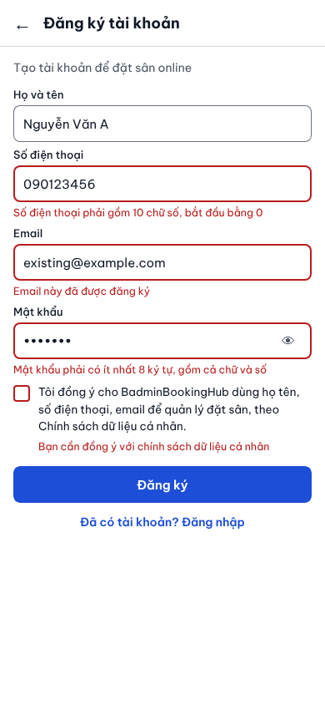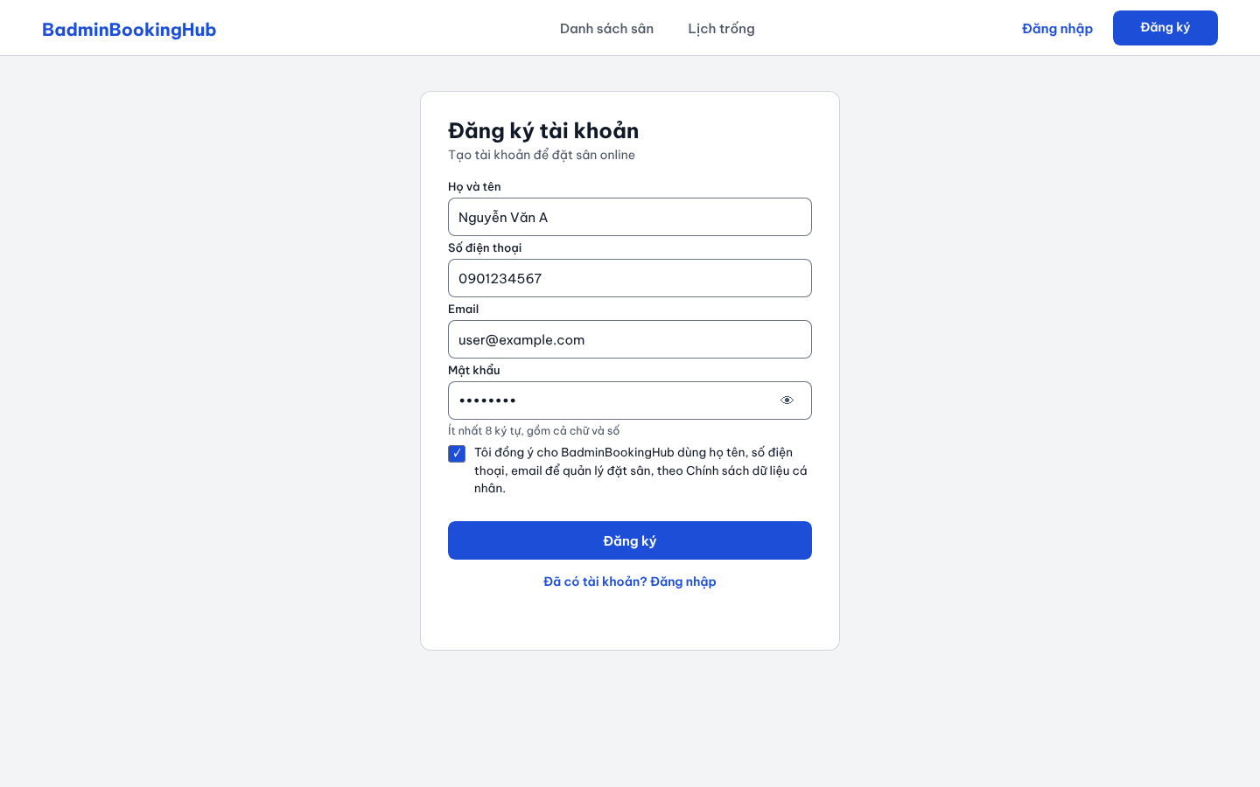
Figure 8.1a. SCR 1 - Register
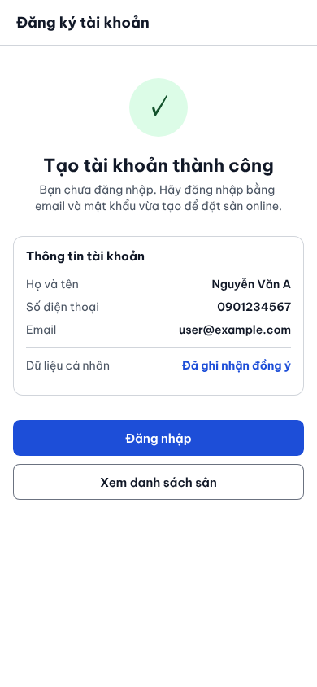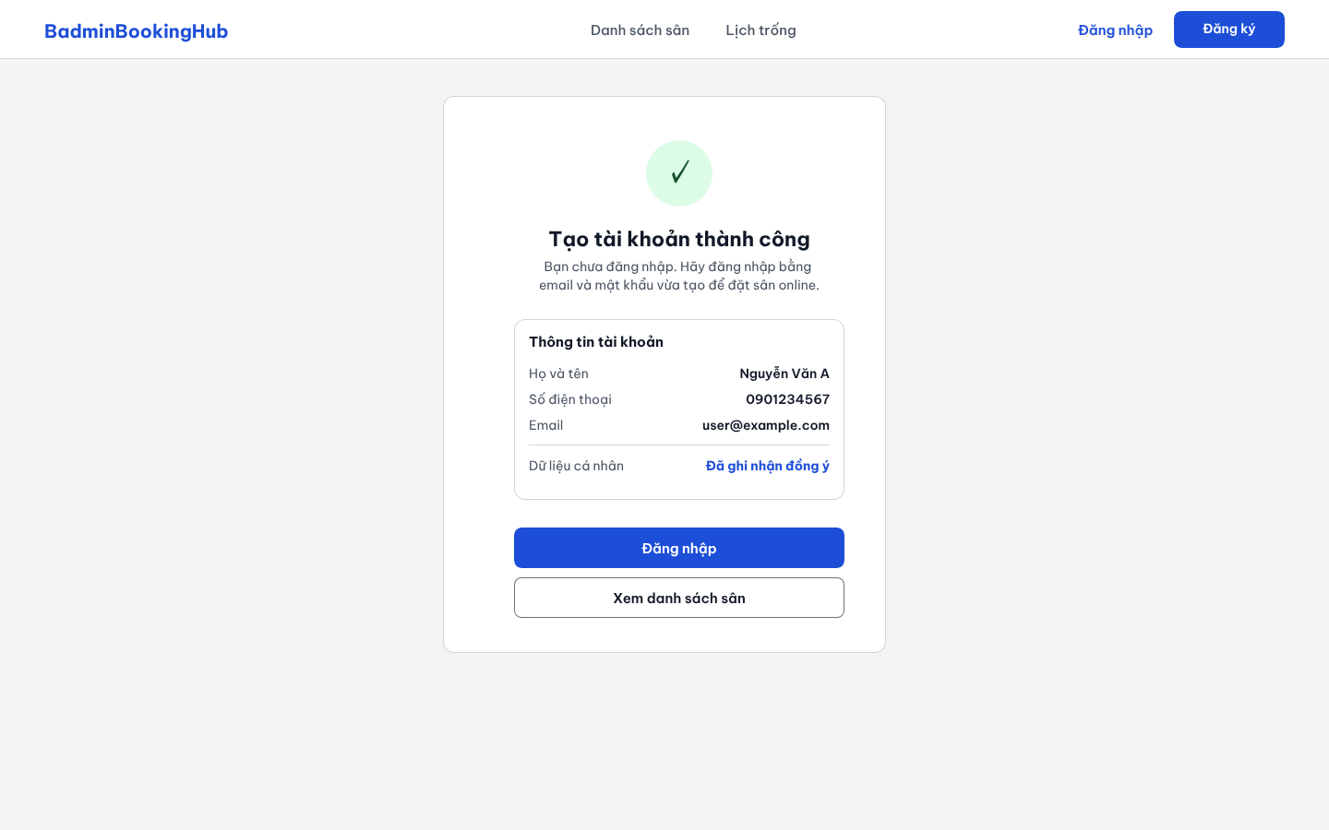
Figure 8.1b. SCR 1 - Register (Successful)
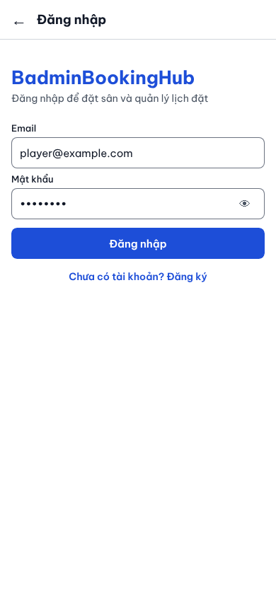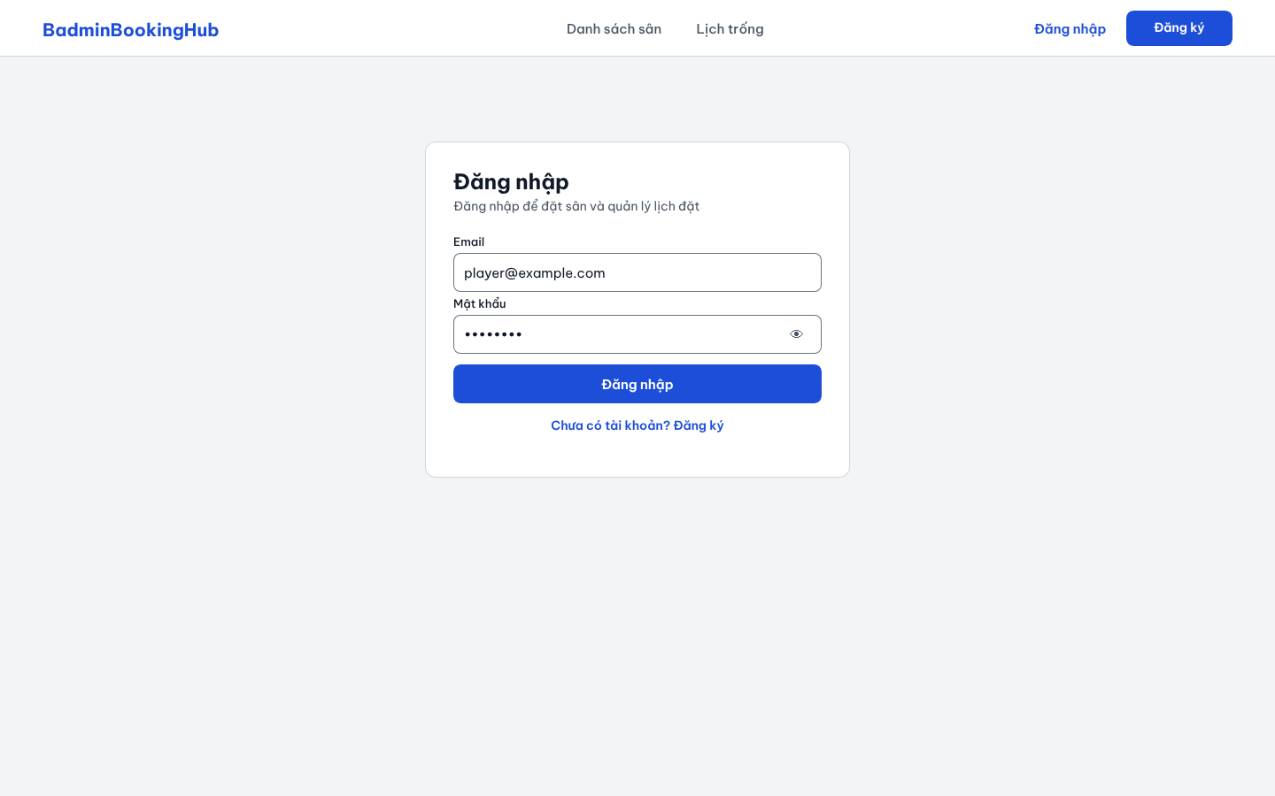
Figure 8.2. SCR 2 - Log in
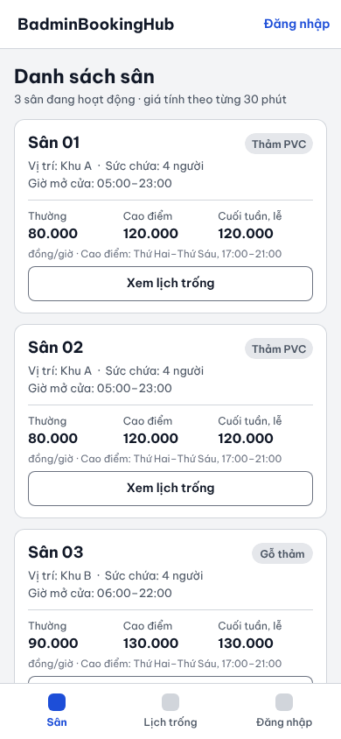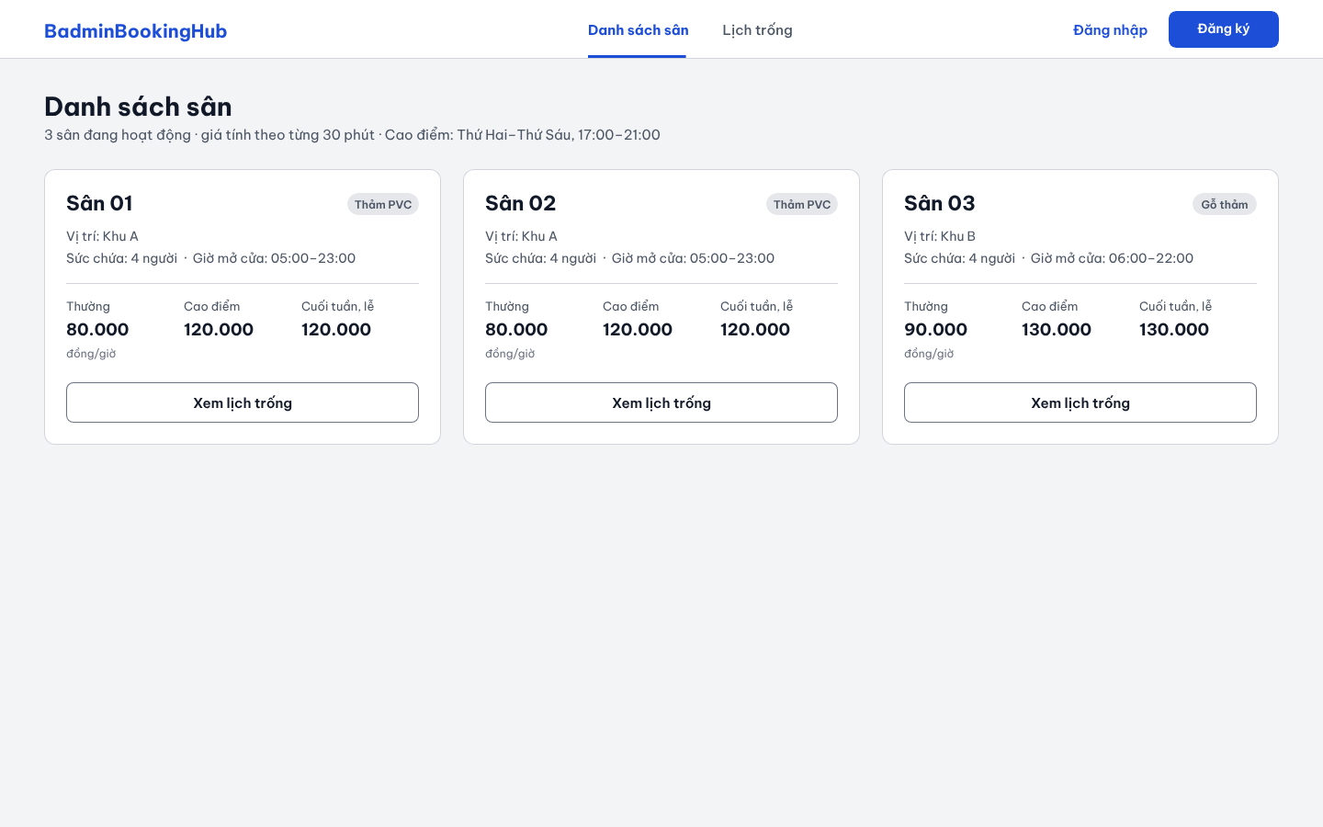
Figure 8.3. SCR 3 - Court Catalog
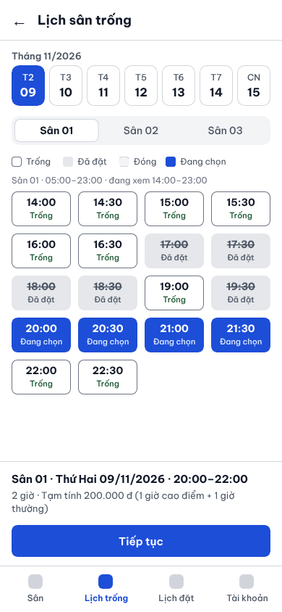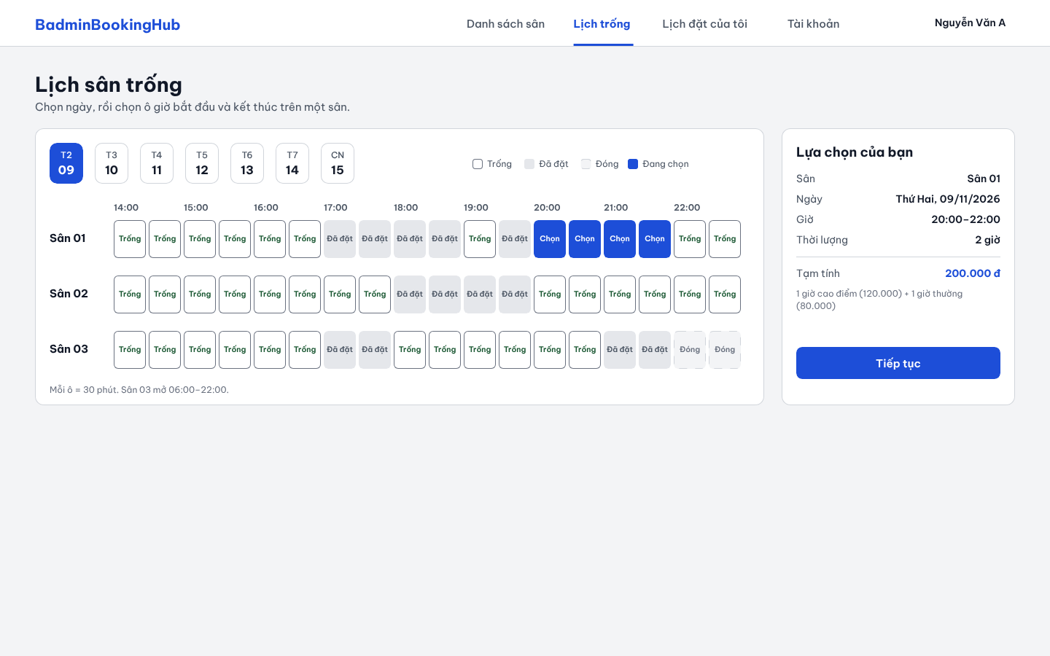
Figure 8.4. SCR 4 - Availability Calendar
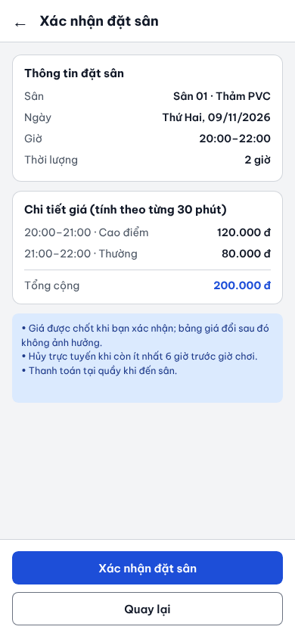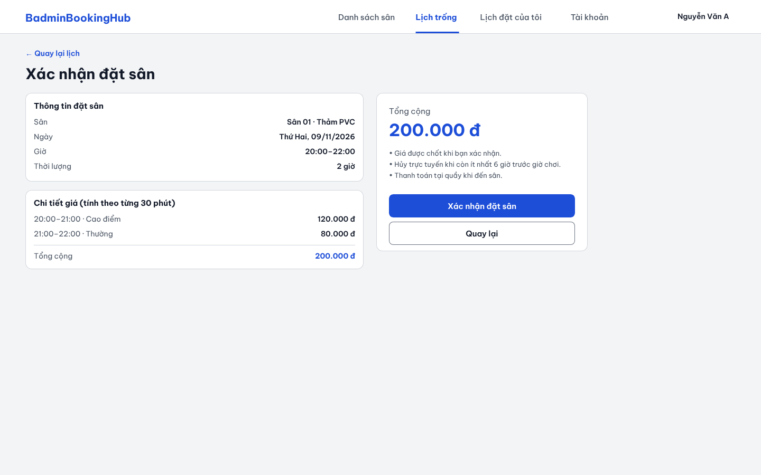
Figure 8.5. SCR 5 - Booking Confirmation
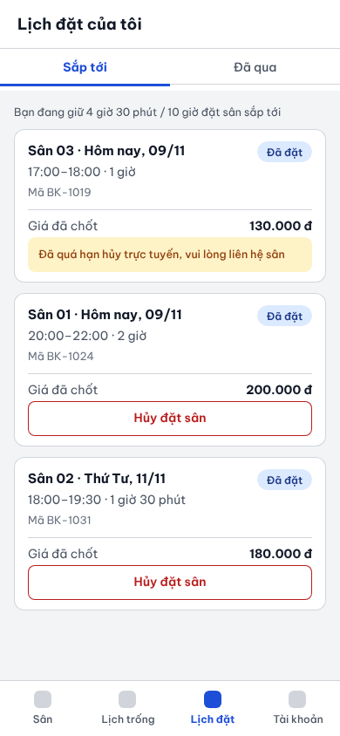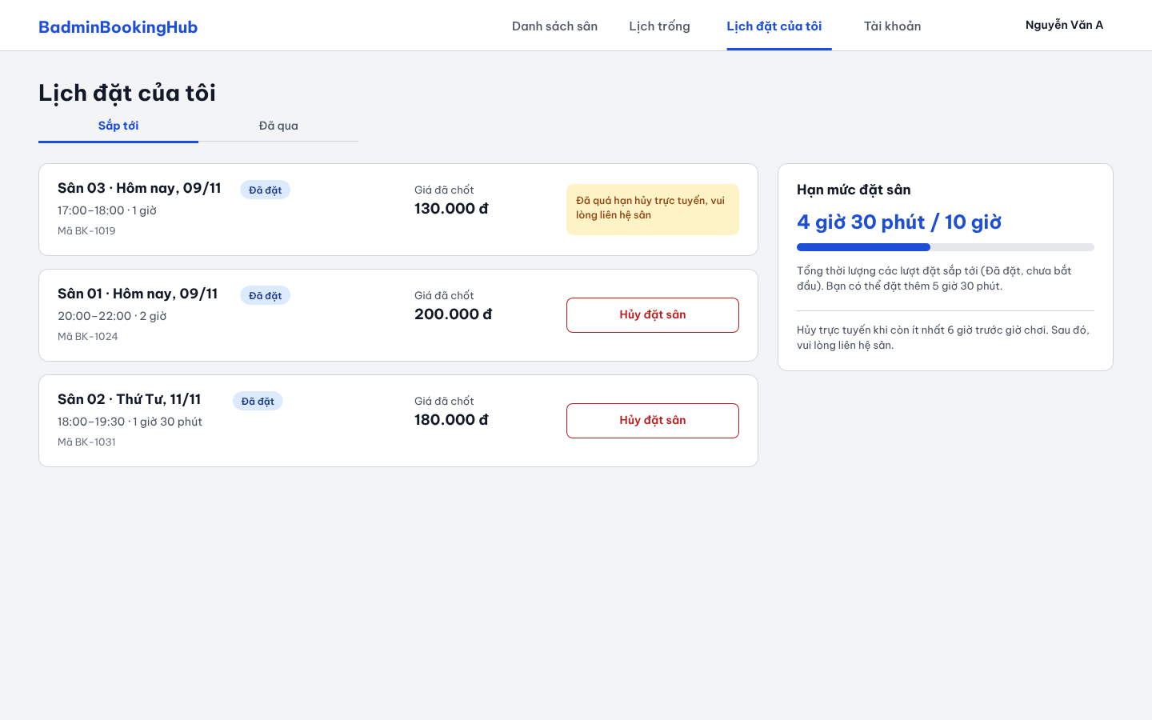
Figure 8.6. SCR 6 - My Bookings
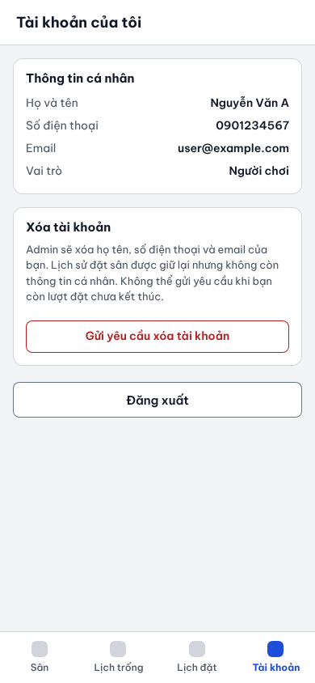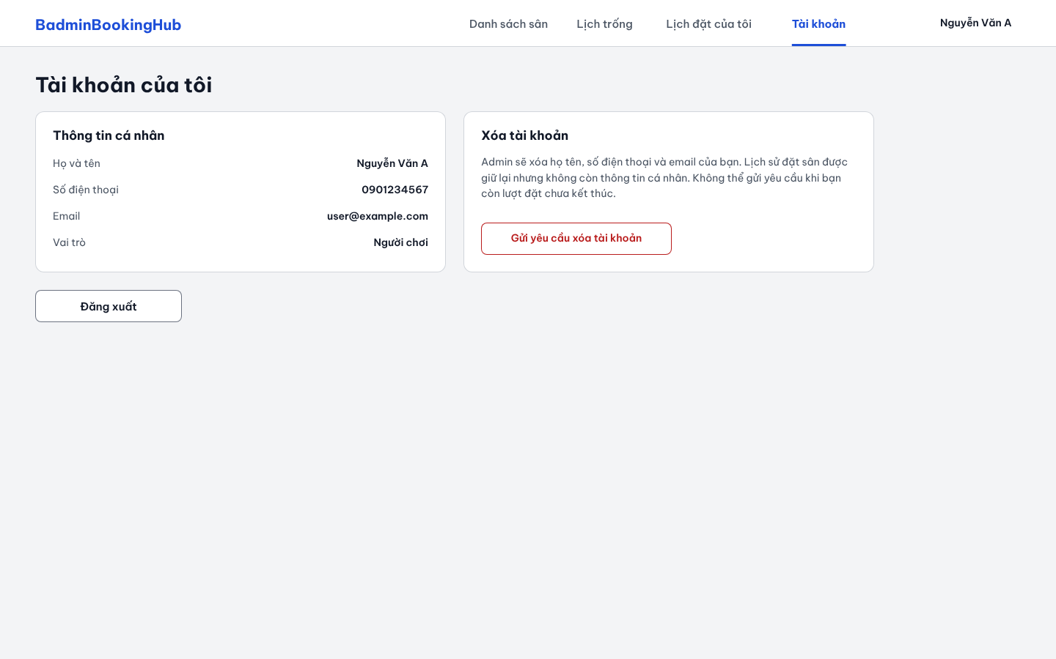
Figure 8.7. SCR 7 - My Account
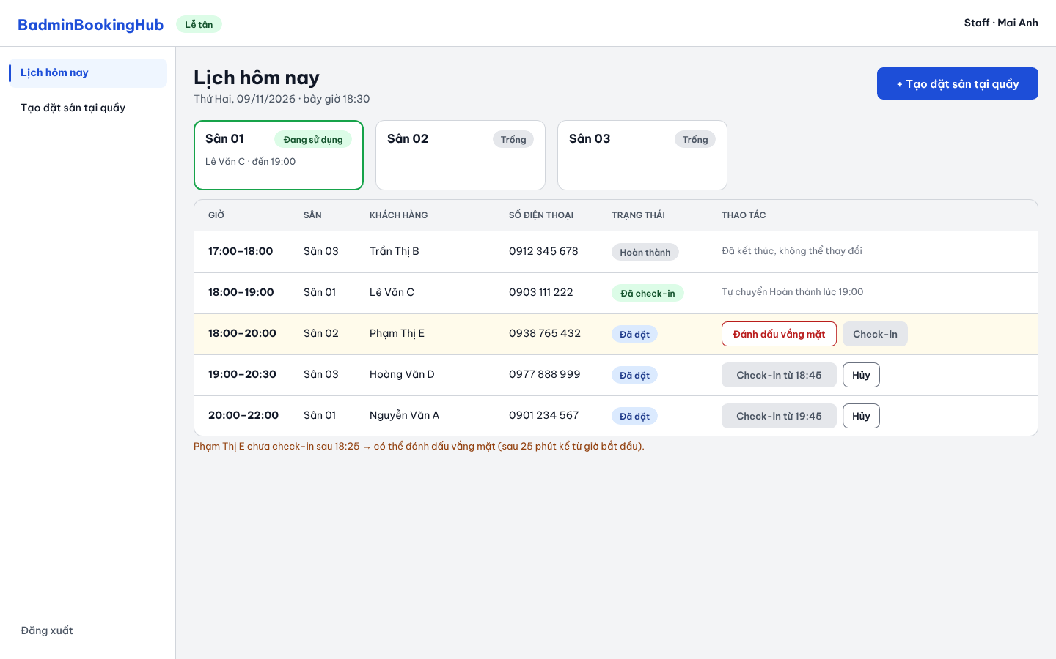
Figure 8.8. SCR 8 - Daily Schedule
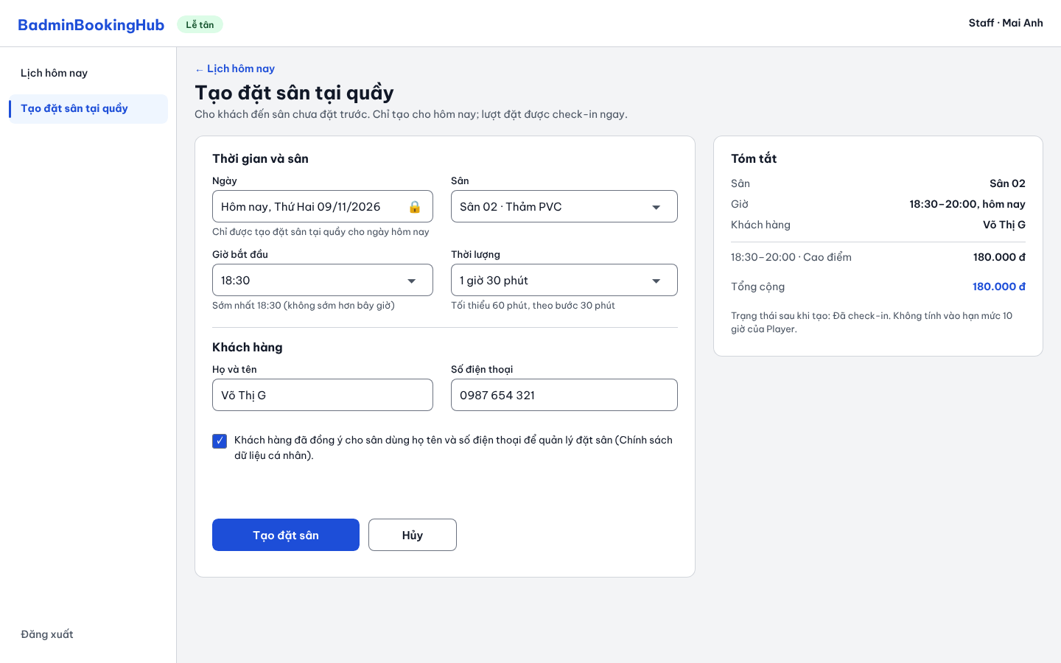
Figure 8.9. SCR 9 - Walk-in Booking
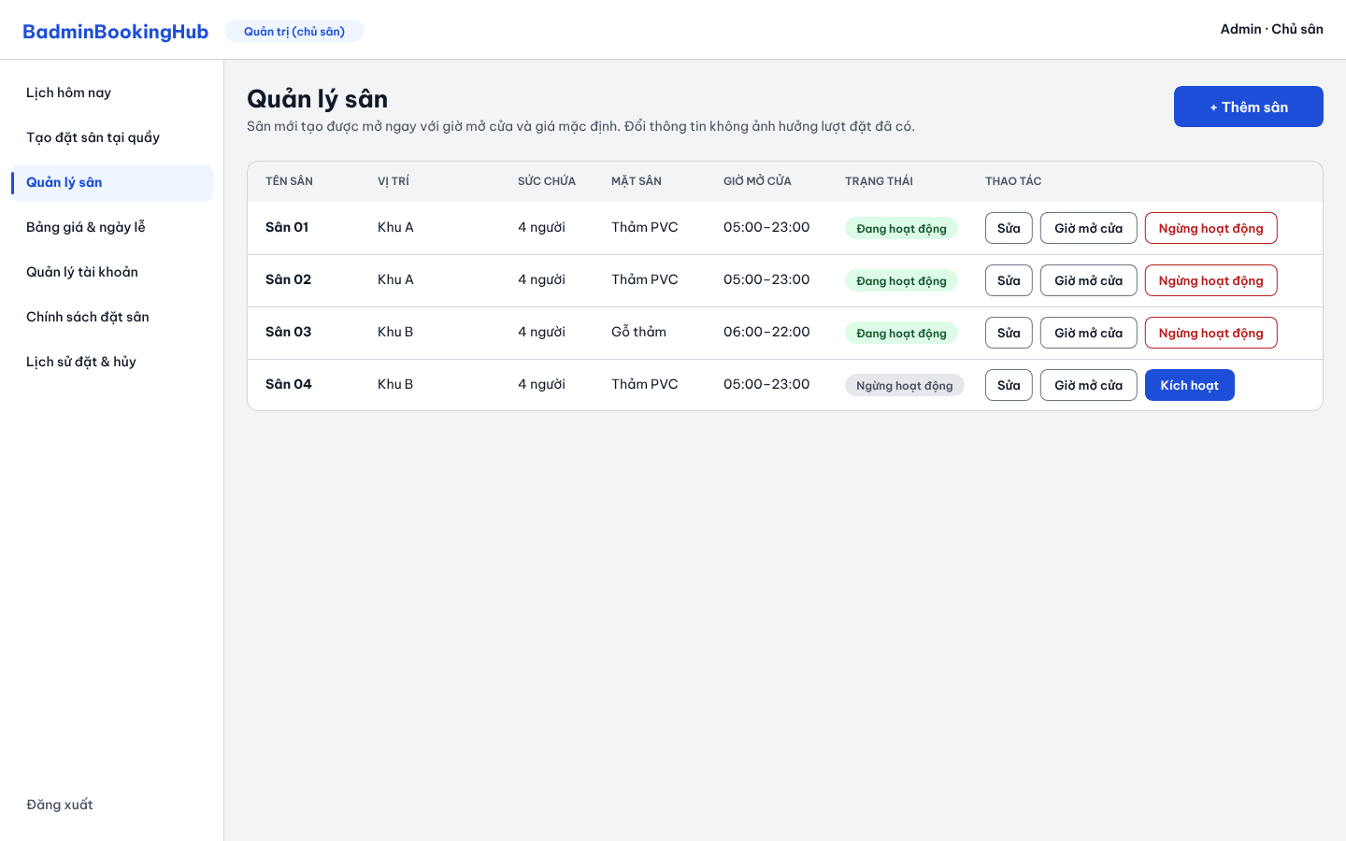
Figure 8.10. SCR 10 - Court Management
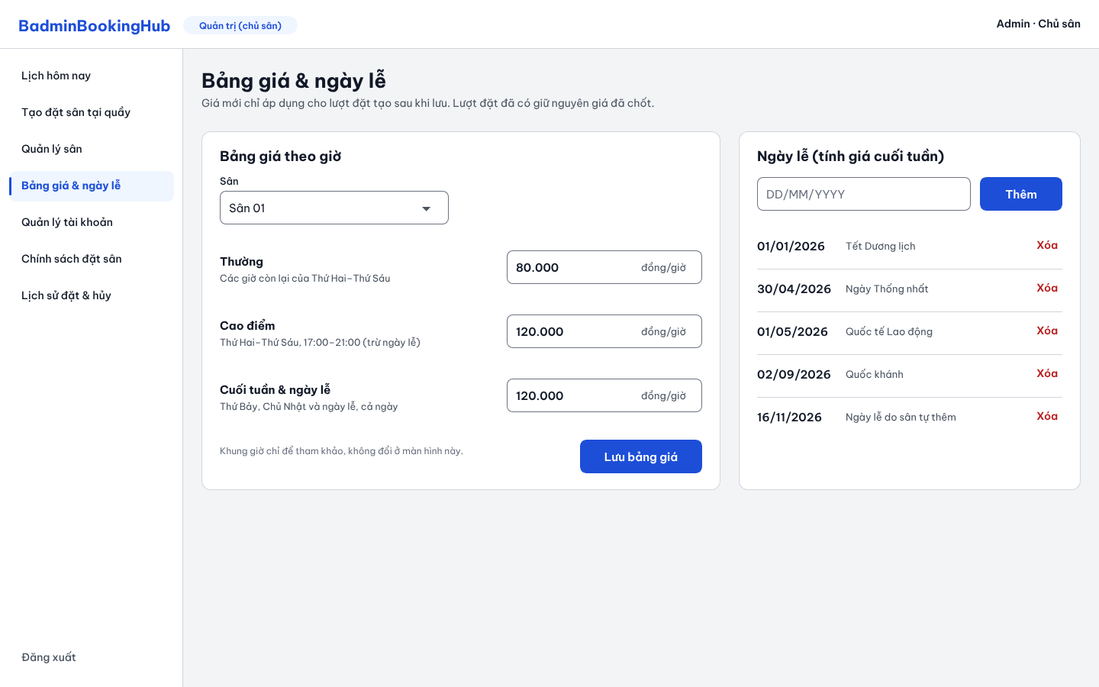
Figure 8.11. SCR 11 - Price List & Public Holidays
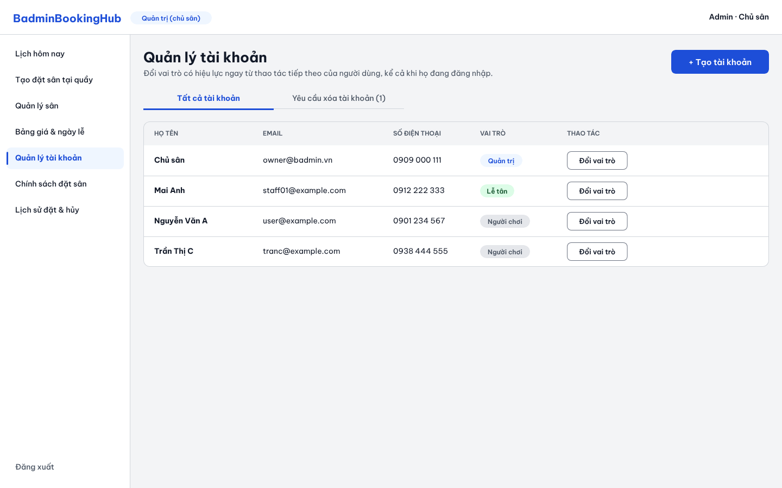
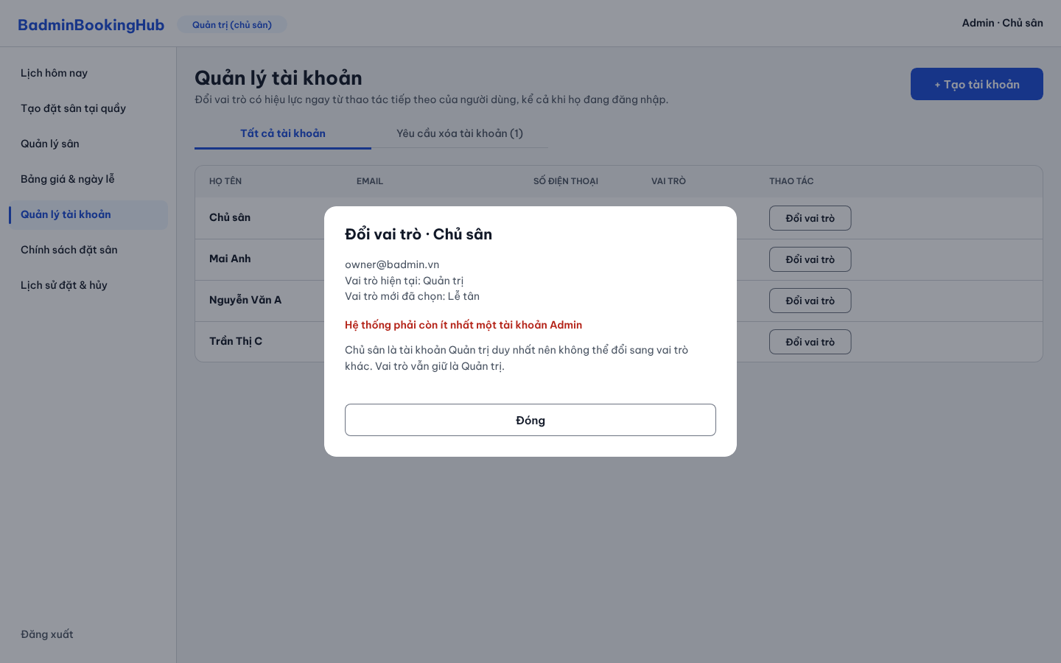
Figure 8.12. SCR 12 - User Account Management
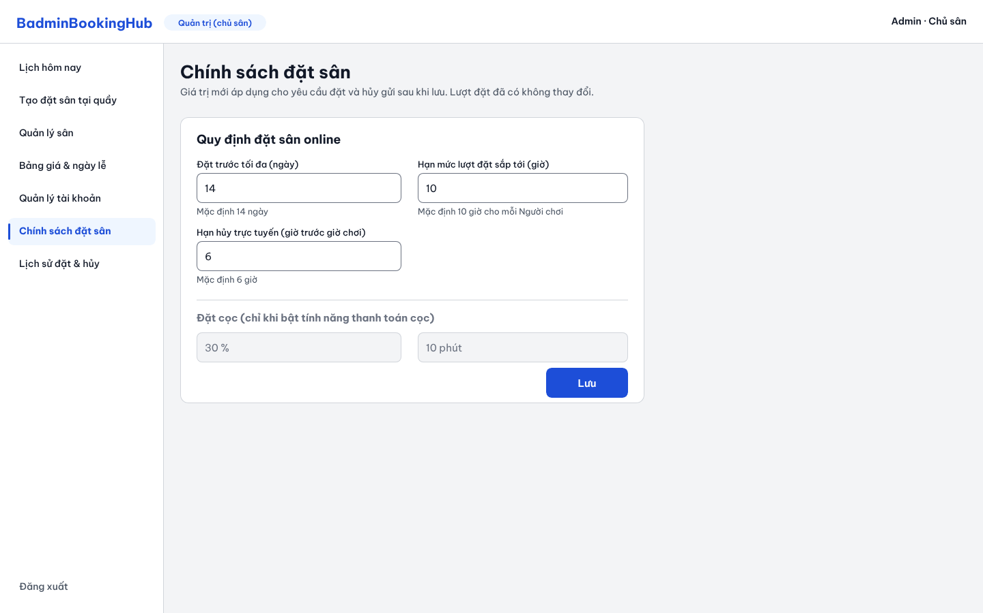
Figure 8.13. SCR 13 - Booking Policies
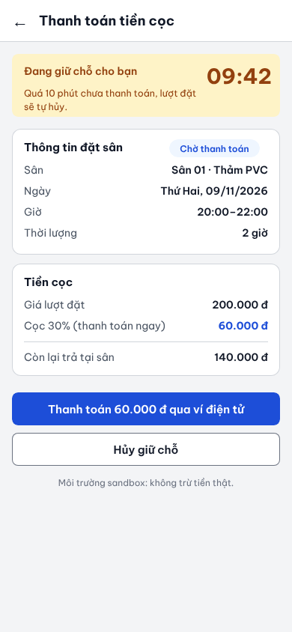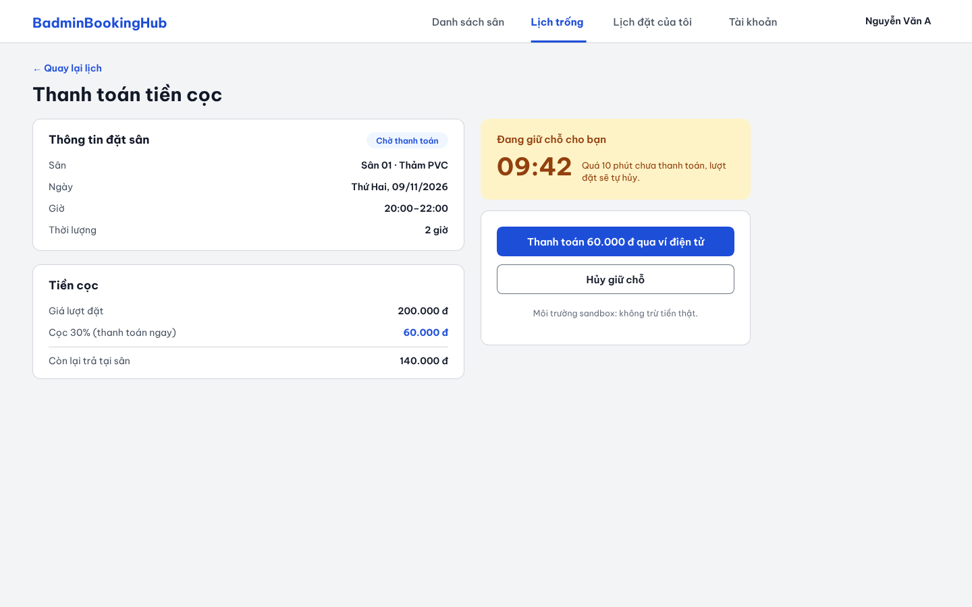
Figure 8.14. SCR 14 - Deposit Payment
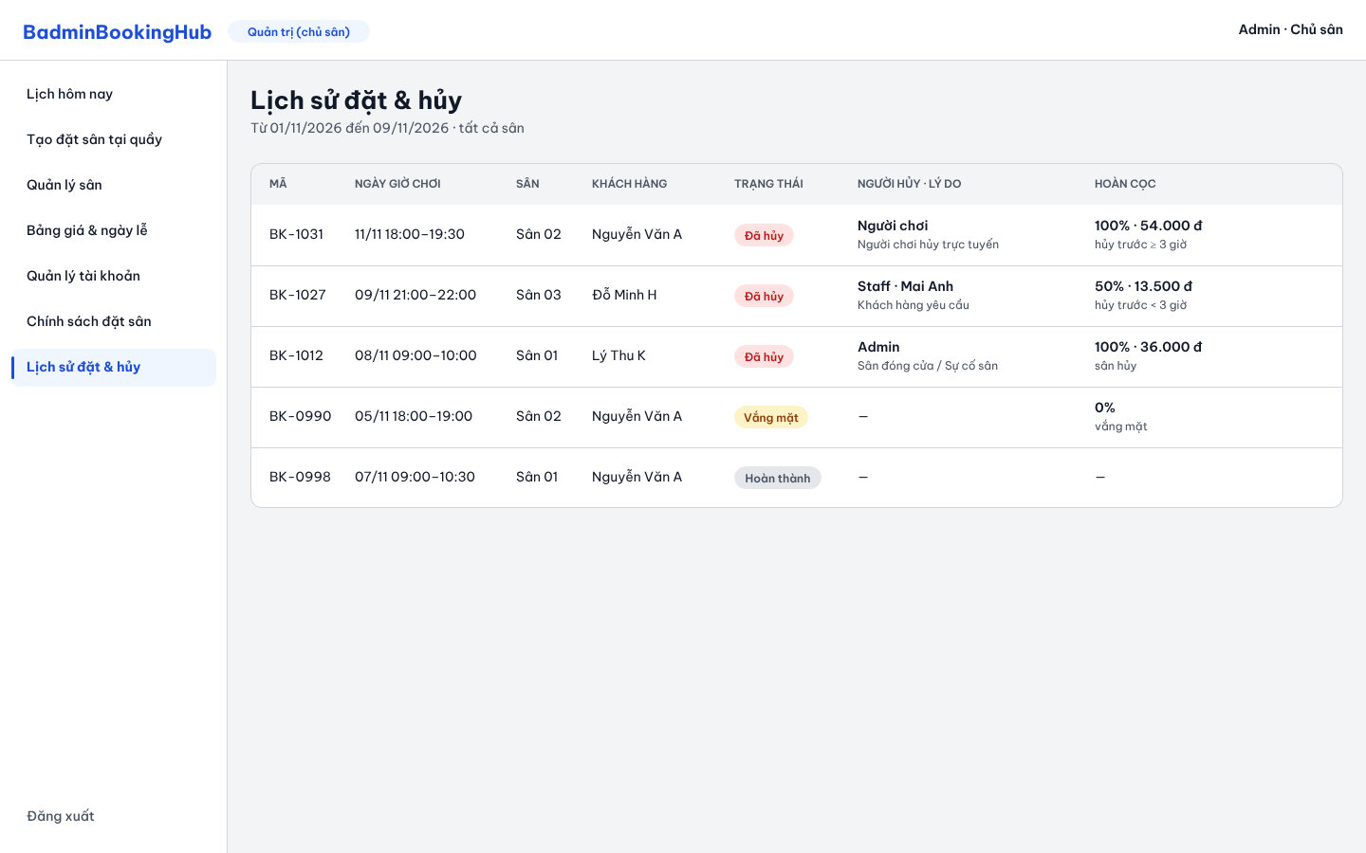
Figure 8.15. SCR 15 - Booking & Cancellation History
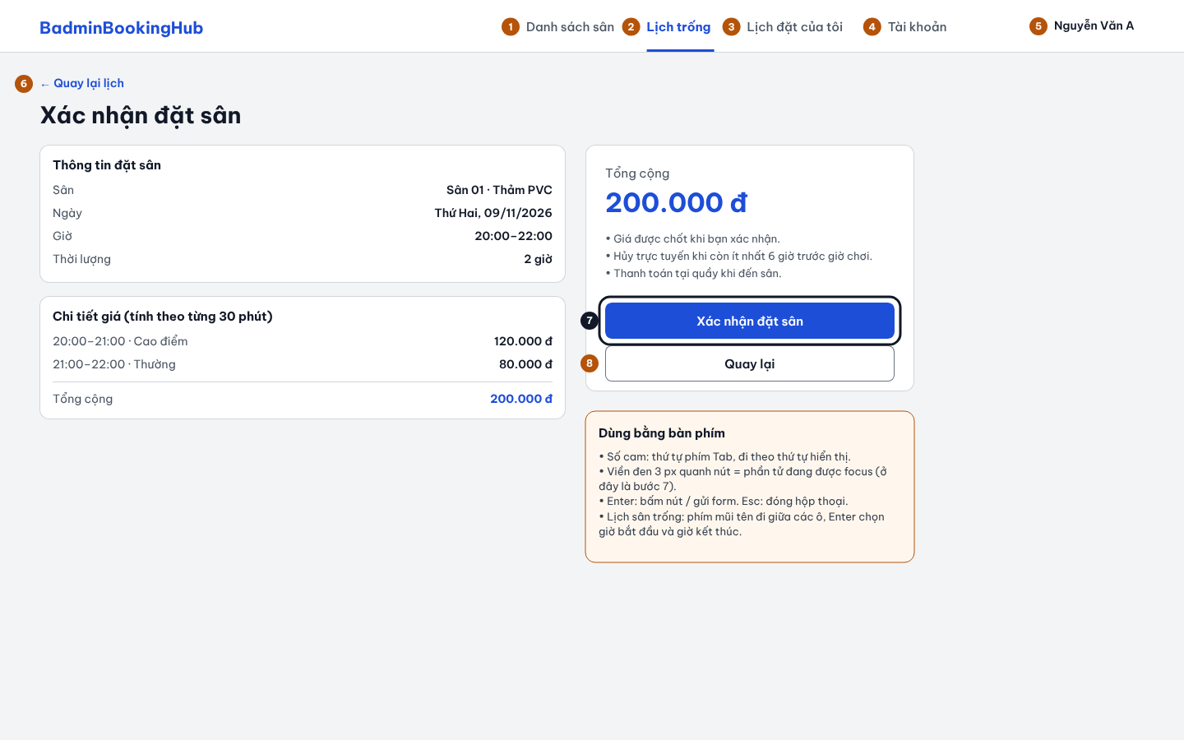
Figure 8.16. SCR 5 - Keyboard focus and Tab order (desktop)

Requirements Traceability Matrix
Req. ID | Use case | Screen | Design element (PA3) | Test cases (PA4)
FR-01 | UC-01 | SCR-01
FR-02 | UC-02, UC-03 | SCR-02, SCR-07
FR-03 | UC-02, UC-22 | SCR-02, SCR-12
FR-04 | UC-22, UC-24 | SCR-07, SCR-12
FR-05 | UC-04 | SCR-03
FR-06 | UC-06 | SCR-04, SCR-05
FR-07 | UC-07 | SCR-05, SCR-09
FR-08 | UC-06 | SCR-05
FR-09 | UC-09 | SCR-05, SCR-09
FR-10 | UC-06 | SCR-05
FR-11 | UC-10 | SCR-06
FR-12 | UC-11 | SCR-06
FR-13 | UC-05 | SCR-04
FR-14 | UC-05 | SCR-04
FR-15 | UC-08 | SCR-05, SCR-09
FR-16 | UC-08 | SCR-05
FR-17 | UC-08 | SCR-05
FR-18 | UC-11 | SCR-06
FR-19 | UC-17 | SCR-10
FR-20 | UC-18 | SCR-10
FR-21 | UC-19 | SCR-10
FR-22 | UC-20 | SCR-11
FR-23 | UC-21 | SCR-11
FR-24 | UC-22 | SCR-12
FR-25 | UC-23 | SCR-13
FR-26 | UC-12 | SCR-08
FR-27 | UC-13 | SCR-08
FR-28 | UC-14 | SCR-08
FR-29 | UC-15 | SCR-09
FR-30 | UC-16 | SCR-08
FR-31 | UC-06, UC-11, UC-13, UC-14, UC-15, UC-16 | SCR-05, SCR-06, SCR-08, SCR-09
FR-32 | UC-23 | SCR-13
FR-33 | UC-25 | SCR-14
FR-34 | UC-25 | SCR-14
FR-35 | UC-25 | SCR-14
FR-36 | UC-26 | SCR-15
FR-37 | UC-27 | SCR-15
FR-38 | UC-28 | — (email)
FR-39 | UC-29 | — (email)
FR-40 | UC-30 | — (email)
NFR-01 | UC-04, UC-05 | SCR-03, SCR-04
NFR-02 | UC-06, UC-07, UC-08, UC-09, UC-15 | SCR-05, SCR-09
NFR-03 | UC-05, UC-06, UC-11, UC-12, UC-13, UC-14, UC-16 | SCR-04, SCR-06, SCR-08
NFR-04 | UC-02 | SCR-02
NFR-05 | UC-01, UC-02, UC-03 | SCR-01, SCR-02, SCR-07
NFR-06 | UC-01, UC-02, UC-22 | SCR-01, SCR-02, SCR-12
NFR-07 | UC-01 – UC-06, UC-10 – UC-23 | SCR-01 – SCR-13
NFR-08 | UC-01 – UC-06, UC-10 – UC-23 | SCR-01 – SCR-13
NFR-09 | UC-01, UC-02, UC-06, UC-08, UC-15, UC-17, UC-18, UC-20, UC-21, UC-22, UC-23 | SCR-01, SCR-02, SCR-05, SCR-09 – SCR-13
NFR-10 | UC-01 – UC-06, UC-10 – UC-23 | SCR-01 – SCR-13
NFR-11 | UC-06 | SCR-04, SCR-05
NFR-12 | UC-06, UC-15 | SCR-05, SCR-09
NFR-13 | N/A – backend code | N/A – backend code
NFR-14 | N/A – development process | N/A – development process
NFR-15 | UC-05, UC-10, UC-11 | SCR-04, SCR-06
NFR-16 | UC-02, UC-03 | SCR-02, SCR-07

Requirements Review
Review meeting: 11/11/2026, online on Discord. Participants: Lê Trọng Hiếu (PM, moderator), Huỳnh Mạnh Tú (BA), Trần Duy Khang (Designer), Nguyễn Đại Phúc (Developer), Phan Phú Trọng (Tester).
Input: the SRS draft and the review comments posted on each PA2 task on GitHub between 28/10/2026 and 11/11/2026. Issues found in those task reviews are listed together with the issues raised at the meeting.
# | Issue found | Requirement(s) | Resolution
1 | Searching courts by area (PA1 F04) does not fit a system that serves one venue. | FR-05, FR-13, FR-19 | Area search removed; Players search by date. A court's location now means its position inside the venue. Agreed by the team on 31/10/2026.
2 | Rentable equipment in F02 had no agreed rules for price, stock or return. | FR-05 | Equipment removed from the release; F02 covers courts only (team decision, 28/10/2026).
3 | A Player had no way to have their personal data removed. | FR-04 | Account deletion added as a Should requirement; it is refused while the Player has an active booking, and past bookings are kept without personal data (28/10/2026).
4 | The weekly booking-hour limit in PA1 did not say which week or which bookings count. | FR-17, FR-25 | Replaced by a quota on the total length of upcoming bookings (10 hours by default, set by the Admin); BR-06 and BR-07 define what counts.
5 | The 180-minute maximum booking length overlapped with the booking quota and made long sessions impossible. | FR-15 | Maximum removed (31/10/2026): a booking lasts at least 60 minutes in steps of 30 minutes; the quota is the only upper limit. BR-02 and the Glossary updated.
6 | After the business rules were renumbered, the Source column of many FRs pointed to wrong BR numbers. | FR-01 – FR-31 | BR numbers removed from the Source column; each FR now cites its stakeholder and PA1 feature.
7 | Several FRs disagreed with the business rules on check-in time, No-show, walk-in bookings and the first status of a booking. | FR-27, FR-28, FR-29, FR-31 | FRs rewritten to the BR values: check-in from 15 minutes before to 25 minutes after the start, No-show marked only by Staff, walk-in bookings start as Checked-in.
8 | The Glossary defined No-show with 15 minutes while the requirements use 25 minutes. | FR-28 | Glossary changed to 25 minutes and states that the system never marks No-show by itself.
9 | BR-27 said a booking is only shown as Completed, while FR-31 changes the status automatically. | FR-31 | BR-27 aligned with FR-31: the status changes to Completed when the end time is reached.
10 | The Admin could deactivate a court but could not activate it again. | FR-21 | FR-21 covers both activation and deactivation; UC-19 renamed "Change Court Status"; AC-06.13 added (07/11/2026).
11 | The court owner also works at the front desk, but the front-desk requirements allowed Staff only. | FR-26 – FR-29 | Changed to "Staff and Admin"; in the use case diagram the Admin specialises Staff (11/11/2026).
12 | NFR-10 allowed a bilingual interface and the NFR-09 example message was in English. | NFR-09, NFR-10 | All system text is Vietnamese only; the NFR-09 example rewritten in Vietnamese.
13 | Use Case List: Priority and Related FR columns were swapped, included use cases had primary actors, and FR-03 was not traced to any use case. | FR-03 | Columns and actors corrected; FR-03 is traced at UC-02 Log In and UC-22 Manage User Accounts.
14 | Use case specifications contained trace IDs inside flows, interface labels and messages, steps of other use cases, and constraints that no business rule supports. | UC-01 – UC-23 | These were removed. IDs appear only in the Related requirements, Business rules and Non-functional constraints rows, and Related requirements lists the FRs given in the Use Case List.
15 | The last Admin could change their own role and leave the system without any Admin. | FR-24 | BR-39 added; UC-22 refuses to change the role of the last Admin account.
Result: all issues above are resolved. This version of the SRS (11/11/2026) is the requirements baseline for PA3. Changes after this date will be recorded in PA3 under "Changes to the Requirements Since PA2".

AI Usage Log
# | Member | Tool | Task / purpose | How the output was verified and changed
1 | Lê Trọng Hiếu | Claude | Map lecture 04 (Requirements Engineering) to the PA2 template to list the outputs of each section before splitting tasks. | Checked the list against the template and rubric. The WBS tasks, owners and estimates were decided by the team; I then set reviewers on GitHub Projects myself.
1 | Lê Trọng Hiếu | Claude | Business rules (my task 2.2.3): list the values left open in PA0/PA1 and give options for each rule. | Rule values were decided by the team as the court owner's policy. I rejected several options (Peak price until closing time, 15-minute No-show, automatic No-show) and wrote the final rules myself, one idea per rule.
1 | Lê Trọng Hiếu | Claude | Second opinion on a classmate's 16-point review of the business rules. | I decided agree / disagree for each point and wrote the replies; corrected places where the AI mixed up which suggestions came from the reviewer.
1 | Lê Trọng Hiếu | Claude | Cross-check the FR table against BRs, PA0 and PA1 before reviewing Tú's section. | Confirmed every finding in the document myself. The scope questions went to the team (decisions 28/10 and 31/10); I wrote the review comments to Tú in my own words.
1 | Lê Trọng Hiếu | Claude | Consistency check of §1–§5 and draft boundary-value scenarios for the acceptance criteria. | Recalculated prices and time limits against FR/BR; the open questions (area search, 180-minute limit, Vietnamese-only UI) were decided by the team, not by the tool.
1 | Lê Trọng Hiếu | Claude | Reschedule WBS 2.3–2.6 after the deadline moved to 11/11/2026. | Used the proposal as a starting point and changed it several times: spread work across days, one owner per task, one 2.3.2.x prefix, more use cases for the BA, reviewers balanced by workload.
1 | Lê Trọng Hiếu | Claude | First draft of my use cases UC-17 – UC-21 in the agreed UC-17 format. | Decided the court status rules myself (Active on creation, reactivation flow). Removed constraints that no BR supports, trace IDs and interface text; reviewed by teammates on GitHub.
1 | Lê Trọng Hiếu | Claude | Check teammates' UC-06 – UC-11 and UC-22 – UC-23 against FR, BR and AC before my review. | Gave my own wording for UC-06 and UC-11; dropped points that relied on rules outside the agreed BR section; posted the reviews on the task issues.
1 | Lê Trọng Hiếu | Claude | Summarise PA0–PA2 for the PA2 progress meeting and list PA1 feedback to fix. | Corrected the venue / branch wording; the fixes and owners were agreed in the meeting.
1 | Lê Trọng Hiếu | Claude | Final consistency check of §1–§7 before the baseline. | I chose which issues to fix in my own sections and sent the rest to section owners; the outcome is recorded in §10.
1 | Lê Trọng Hiếu | Claude | Build the FR → use case → screen mapping (§9) from §6.3 and §8 and format the review table (§10). | Checked each row against the Use Case List and the screen table; the review issues come from our task reviews and meetings.
1 | Lê Trọng Hiếu | Claude | Suggest reviewers for tasks 2.1.1 – 2.2.4 and explain how to connect GitHub to our Discord #review channel. | Changed the proposed list to balance workload, then set the final reviewers on GitHub Projects and set up the webhook myself.
1 | Lê Trọng Hiếu | Claude | Explain how to link a GitHub Projects view filtered by assignee for the Member Contribution evidence. | Created the links for each member and tested them; this also fixes the PA1 feedback on identical evidence links.
1 | Lê Trọng Hiếu | Claude | Check Tú's revised Use Case List (§6.2, §6.3) against the FRs and the lecture on use case modeling. | Confirmed each issue in the table myself and wrote the review comment to Tú; the fix is recorded in §10 issue 14.
1 | Lê Trọng Hiếu | Claude | List fixes for the teacher's PA1 feedback. | Decided with the team which PA1 points to fix; the changes are listed in the "Changes from PA1" parts of PA2.
v2 | Huỳnh Mạnh Tú | ChatGPT | Stakeholders: Assisted in identifying, classifying, and describing stakeholders for the BadminBookingHub project. Reviewed their roles, interests, expectations, and relationships with the system. | Compared the suggestions with the project scope, PA1 materials, and the team's project decisions. Revised stakeholder descriptions and classifications to reflect the actual responsibilities of each stakeholder.
v2 | Huỳnh Mạnh Tú | ChatGPT | Functional Requirements (FRs): Assisted in understanding, drafting, organizing, and refining the FRs relevant to the project, including requirement wording, feature grouping, identifiers, priorities, and scope. | Checked proposed requirements against project objectives, stakeholder needs, agreed features, and the latest PA2 version. Revised wording and mappings, and flagged requirements that needed team confirmation.
v2 | Huỳnh Mạnh Tú | ChatGPT | Use Case Actors: Assisted in identifying and reviewing Actors for the Use Case Model, including Guest, Player, Staff, Admin, abstract System User, and external services. Discussed the distinction between stakeholders and Actors. | Compared the proposed Actors with the Stakeholders section, FRs, and actual system interaction flows. Reviewed whether each Actor directly interacts with the system and retained unresolved modeling decisions for team discussion.
v2 | Huỳnh Mạnh Tú | ChatGPT | Assisted in identifying, formulating, and organizing Business Rules (BRs) governing booking policies, availability, pricing, booking quotas, cancellation, check-in, no-show, deposits, refunds, and account management. | Assisted in identifying, formulating, and organizing Business Rules (BRs) governing booking policies, availability, pricing, booking quotas, cancellation, check-in, no-show, deposits, refunds, and account management.
v2 | Huỳnh Mạnh Tú | ChatGPT | Assisted in developing and reviewing Acceptance Criteria (ACs) for functional features using Given–When–Then format, including normal scenarios, alternative scenarios, validation, and boundary cases. | Checked whether each criterion was specific, observable, and testable. Cross-checked the criteria against corresponding FRs and BRs and revised scenarios to cover important business conditions.
v2 | Huỳnh Mạnh Tú | ChatGPT | Assisted in developing the Use Case Model in Section 6, including identifying actors, defining use cases, organizing the Use Case List, and reviewing relationships such as <<include>>, <<extend>>, and actor generalization. | Compared the model with the approved requirements, stakeholder roles, and course materials. Revised actor responsibilities, use case names, mappings, and relationships to avoid unnecessary or unsupported interactions.
v2 | Huỳnh Mạnh Tú | ChatGPT | Use Case List: Assisted in defining, naming, organizing, and reviewing the Use Case List. Checked whether use cases represented meaningful actor goals and whether they were supported by the FRs. | Cross-checked Use Case names, IDs, Actors, priorities, and Related FRs against the latest PA2 requirements. Revised the list where necessary and checked consistency with the Use Case Diagram and Specifications..
v2 | Huỳnh Mạnh Tú | ChatGPT | Use Case Specifications (UC-04 to UC-11 and related use cases): Assisted in drafting, understanding, and reviewing detailed specifications, including brief descriptions, Actors, triggers, preconditions, postconditions, Main Flows, Alternative Flows, Exception Flows, Business Rules, and NFRs. | Checked the flows against the relevant FRs, BRs, NFRs, and ACs. Reviewed business logic, status transitions, boundary conditions, step references, and consistency between included or extending use cases. Revised suggestions that were unsupported or inconsistent with the PA2 source.
v2 | Huỳnh Mạnh Tú | ChatGPT | AI Usage Log: Assisted in preparing and refining the AI Usage Log for Section 11 to disclose the AI support used during Tú's PA2 work. | Checked that the log described the actual tasks ChatGPT supported and distinguished Tú's own contributions from sections authored by other team members.
v2 | Huỳnh Mạnh Tú | ChatGPT | Review and checking: Assisted in reviewing Tú's assigned PA2 sections and teammate feedback. Identified wording issues, missing or incorrect requirement references, duplicated behavior, unclear flows, and possible inconsistencies across sections. | Rechecked findings against the latest PA2 document and review comments. Classified suggestions as corrections, items needing clarification, or decisions requiring PM/team confirmation instead of accepting every AI suggestion automatically.
v2 | Huỳnh Mạnh Tú | ChatGPT | Understanding and summarizing other members' work: Assisted in reading, explaining, and summarizing PA2 content prepared by other team members so Tú could understand the overall system and review cross-section consistency. This included connecting other members' requirements, business rules, acceptance criteria, prototype, and related material to Tú's assigned work. | Used the team's PA2 document and supplied review materials as the source. Kept summaries separate from Tú's authorship and checked how the information related to Stakeholders, FRs, Actors, Use Cases, and Specifications. Raised unclear or conflicting points for discussion with the responsible member or PM.
3 | Trần Duy Khang | Claude | Review §5.4 Acceptance Criteria against FR/NFR/BR and apply the fixes | Each comment was checked against PA2. Edits were saved to a new file and reviewed before use, and unclear points were sent to the team.
3 | Trần Duy Khang | Claude | Re-check §2 Introduction and §4 Stakeholders after revision | Compared with the earlier review. The result was a report for the team; PA2 was not edited.
3 | Trần Duy Khang | Claude | Write use case specifications for UC-22 and UC-23 | Followed the lecture template and checked against PA2. Revised after Hiếu’s peer review.
3 | Trần Duy Khang | Claude | Review the use case diagram (§6.1) and Hiếu’s UC-17 to UC-21 specifications | Checked against the use case list, requirements and team conventions. Feedback was sent to the authors and re-checked after their fixes.
3 | Trần Duy Khang | Claude | Design the §8 mockups and clickable prototype in Penpot | Screens were reviewed visually and checked against the requirements. Undecided points were sent to the team, and the mockups were updated to match the final PA2.
3 | Trần Duy Khang | Claude | Insert the mockup figures into §8 of PA2 | Only §8 was changed, and this was checked against the original. The layout was reviewed in PDF.
3 | Trần Duy Khang | Claude (Penpot MCP) | Check basic accessibility of the mockups (contrast, labels, keyboard use) | Contrast was calculated with a script using the WCAG formula, not judged by eye. Issues found were noted as actions for PA3, and the results were added to §8 based on the lecturer’s feedback.
4 | Nguyễn Đại Phúc | ChatGPT | Draft and review Non-Functional Requirements (NFRs) for BadminBookingHub. | Cross-checked with PA0, PA1, and PA2; refined measurable criteria, verification methods, classifications, and removed overlaps with FRs and Business Rules.
5 | Phan Phú Trọng | Claude | Look at all the PAs to list all the UC and then write most of the flow | Fact check to make sure all the logic are true and the flow fit the use case intended by the group
5 | Phan Phú Trọng | Gemini | Change my work based on the review of reviewer | Have to add in something Gemini forget to add back from my old work to make sure we have all the AC

